

Owner’s Manual

NDVI Sensors
Models S2-111 and S2-112
Rev: 31-Aug-2022
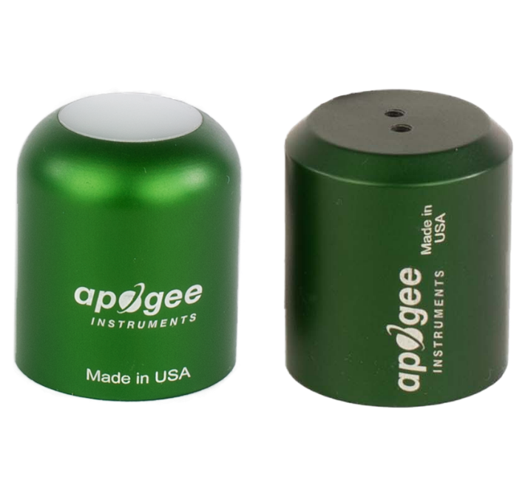
Downward (model S2-112)

Upward (model S2-111)

Table of Contents
Owner’s Manual 1
Certificates of Compliance 3
Introduction 5
Sensor Models 6
Specifications 7
Deployment and Installation 10
Cable Connectors 12
Operation and Measurement 10
Maintenance and Recalibration 15
Troubleshooting and Customer Support 16
Return and Warranty Policy 17

Certificate of Compliance

EU Declaration of Conformity
This declaration of conformity is issued under the sole responsibility of the manufacturer:
Apogee Instruments, Inc.
721 W 1800 N
Logan, Utah 84321
USA
for the following product(s):

Models: S2-111, S2-112
Type: NDVI Sensors

The object of the declaration described above is in conformity with the relevant Union harmonization legislation:

2014/30/EU Electromagnetic Compatibility (EMC) Directive
2011/65/EU Restriction of Hazardous Substances (RoHS 2) Directive
2015/863/EU Amending Annex II to Directive 2011/65/EU (RoHS 3)

Standards referenced during compliance assessment:

EN 61326-1:2013 Electrical equipment for measurement, control, and laboratory use – EMC requirements
EN 63000:2018 Technical documentation for the assessment of electrical and electronic products with respect to the restriction of hazardous substances

Please be advised that based on the information available to us from our raw material suppliers, the products manufactured by us do not contain, as intentional additives, any of the restricted materials including lead (see note below), mercury, cadmium, hexavalent chromium, polybrominated biphenyls (PBB), polybrominated diphenyls (PBDE), bis (2-ethylhexyl) phthalate (DEHP), butyl benzyl phthalate (BBP), dibutyl phthalate (DBP), and diisobutyl phthalate (DIBP). However, please note that articles containing greater than 0.1 % lead concentration are RoHS 3 compliant using exemption 6c.

Further note that Apogee Instruments does not specifically run any analysis on our raw materials or end products for the presence of these substances, but we rely on the information provided to us by our material suppliers.

Signed for and on behalf of:
Apogee Instruments, August 2022


Bruce Bugbee
President
Apogee Instruments, Inc.

Certificate of Compliance

UK Declaration of Conformity
This declaration of conformity is issued under the sole responsibility of the manufacturer:
Apogee Instruments, Inc.
721 W 1800 N
Logan, Utah 84321
USA
for the following product(s):

Models: S2-111, S2-112
Type: NDVI Sensors

The object of the declaration described above is in conformity with the relevant UK Statutory Instruments and their amendments:

2016 No. 1091 The Electromagnetic Compatibility Regulations 2016
2012 No. 3032 The Restriction of the Use of Certain Hazardous Substances in Electrical and Electronic Equipment Regulations 2012

Standards referenced during compliance assessment:

BS EN 61326-1:2013 Electrical equipment for measurement, control, and laboratory use – EMC requirements
BS EN 63000:2018 Technical documentation for the assessment of electrical and electronic products with respect to the restriction of hazardous substances

Please be advised that based on the information available to us from our raw material suppliers, the products manufactured by us do not contain, as intentional additives, any of the restricted materials including lead (see note below), mercury, cadmium, hexavalent chromium, polybrominated biphenyls (PBB), polybrominated diphenyls (PBDE), bis (2-ethylhexyl) phthalate (DEHP), butyl benzyl phthalate (BBP), dibutyl phthalate (DBP), and diisobutyl phthalate (DIBP). However, please note that articles containing greater than 0.1 % lead concentration are RoHS 3 compliant using exemption 6c.

Further note that Apogee Instruments does not specifically run any analysis on our raw materials or end products for the presence of these substances, but we rely on the information provided to us by our material suppliers.

Signed for and on behalf of:
Apogee Instruments, August 2022

Bruce Bugbee
President
Apogee Instruments, Inc.

Introduction
Radiation reflected from surfaces (e.g., plant canopies, soil) provides information about the state of the surface. Reflectance is the ratio of radiation reflected by the surface to radiation incident on the surface.
A common index calculated from reflectance measurements is normalized difference vegetation index (NDVI). NDVI is calculated from red and near infrared (NIR) reflectance and provides a measure of surface greenness.
The typical application of NDVI sensors is monitoring plant canopies. NDVI is related to leaf area of the plant canopy and canopy chlorophyll content of leaves and is often used to monitor green up in the spring and senescence in the fall.
Apogee Instruments S2 series two-band sensors consist of a cast acrylic diffuser (upward-looking sensor) or acrylic window (downward-looking sensor), pair of photodiodes that measure specific wavelength ranges, and signal processing circuitry mounted in an anodized aluminum housing. A cable to connect the sensor to a measurement device is also included. S2 series sensors are designed for continuous irradiance (upward-looking sensor) or radiance (downward-looking sensor) measurements in indoor and outdoor environments. Reflectance derived from paired upward-looking and downward-looking sensors can be used to calculate NDVI. Apogee NDVI sensors are offered with digital SDI-12 output or with analog voltage output (this manual).

Sensor Models
This manual covers the analog output models S2-111 and S2-112 (in bold below). Digital models are covered in their respective manuals.
Model | Signal | Description
S2-111 | Voltage | Measures red and NIR irradiance (upward-looking) for NDVI
S2-112 | Voltage | Measures red and NIR radiance (downward-looking) for NDVI
S2-411 | SDI-12 | Measures red and NIR irradiance (upward-looking) for NDVI
S2-412 | SDI-12 | Measures red and NIR radiance (downward-looking) for NDVI

An upward-looking (S2-111) sensor’s model number and serial number are located on the bottom of the sensor. If the manufacturing date of a specific sensor is required, please contact Apogee Instruments with the serial number of the sensor.

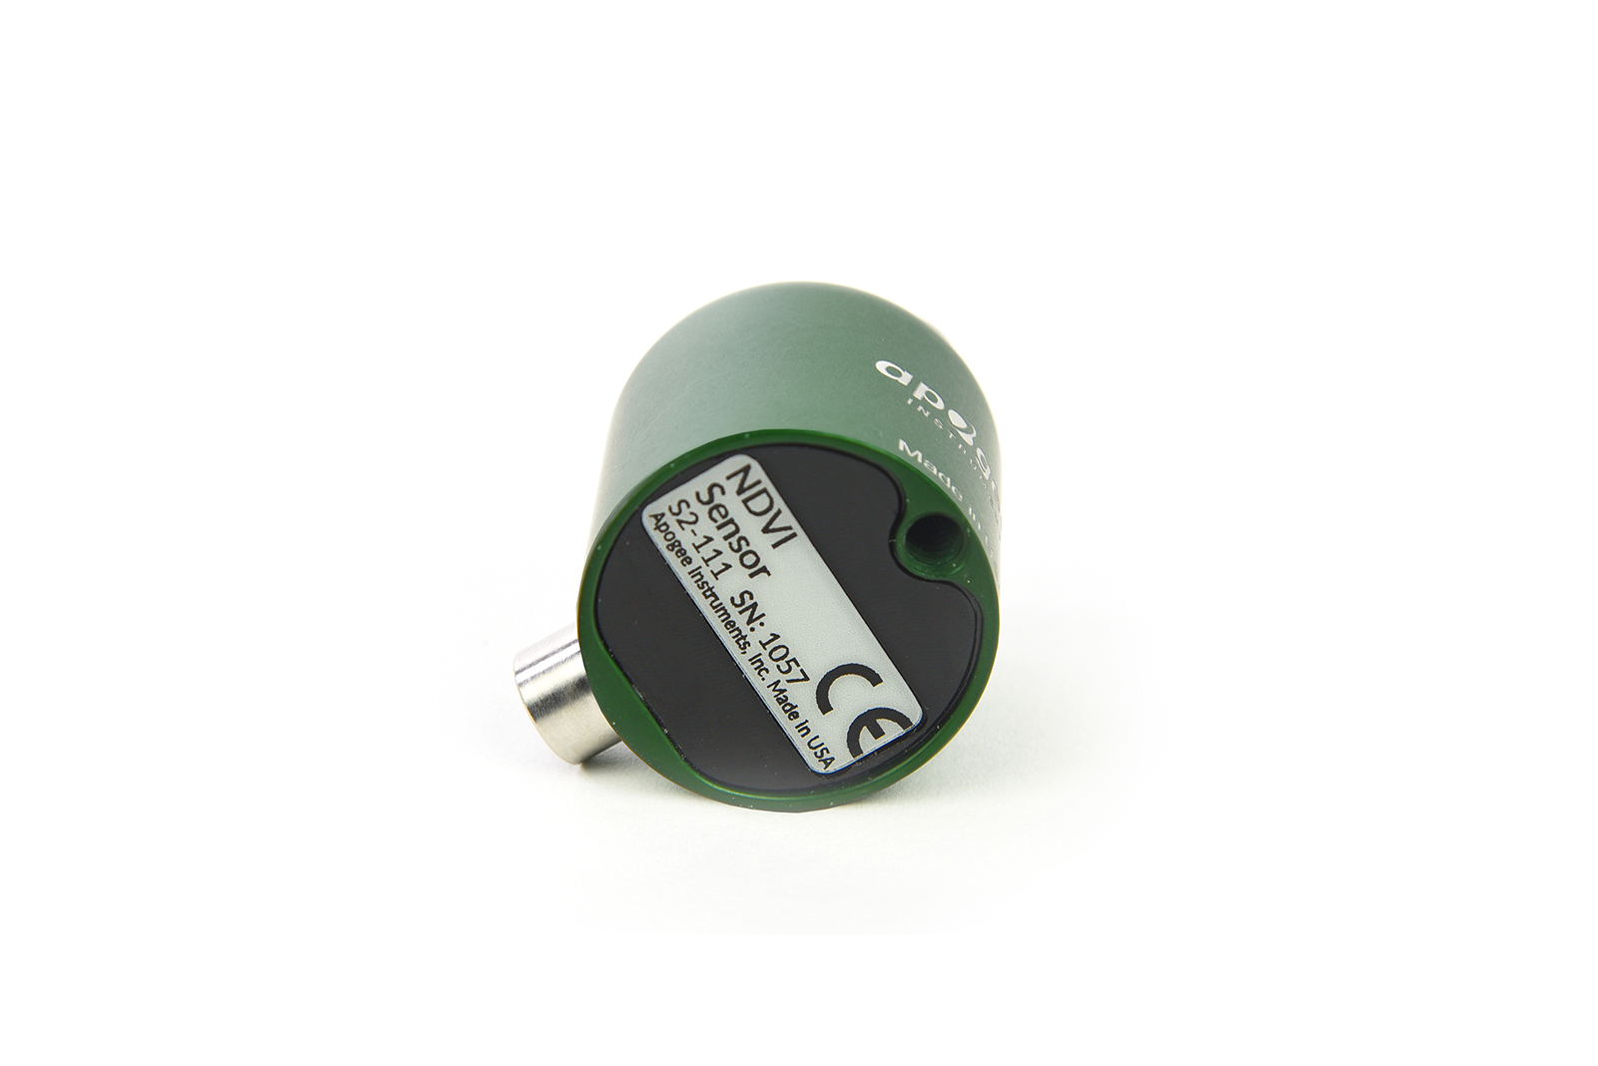

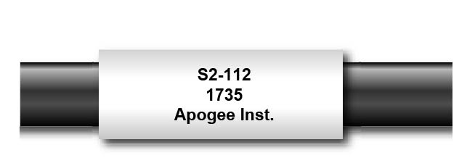
A downward-looking (S2-112) sensor’s model number and serial number are located near the connector on the sensor cable. If the manufacturing date of a specific sensor is required, please contact Apogee Instruments with the serial number of the sensor.

Specifications
 | NDVI
 | S2-111  (upward-looking) | S2-112  (downward-looking)
Power Supply | Self-powered
Output (sensitivity)** | 14 mV per W m⁻² (Red)  20 mV per W m⁻² (NIR) | 12.5 mV per W m⁻² nm⁻¹ sr⁻¹ (Red)  25 mV per W m⁻² nm⁻¹ sr⁻¹ (NIR)
Calibration Factor (reciprocal of sensitivity)** | 0.07 W m⁻² nm⁻¹ per mV (Red)  0.05 W m⁻² nm⁻¹ per mV (NIR) | 0.08 W m⁻² nm⁻¹ sr⁻¹ per mV (Red)  0.04 W m⁻² nm⁻¹ sr⁻¹ per mV (NIR)
Calibration Uncertainty | ± 5 %
Output Range** | 40 mV (Red)  40 mV (NIR) | 15 mV (Red)  15 mV (NIR)
Wavelength Ranges | Red detector = 650 nm ± 5 nm with 65 nm FWHM*  NIR detector = 810 nm ± 5 nm with 65 nm FWHM*
Measurement Range | 2x full sunlight
Measurement Repeatability | Less than 1 %
Long-term Drift  (Non-stability) | Less than 2 % per year
Response Time | Less than 1 ms
Field of View | 180° | 30°
Directional (Cosine) Response | ± 2 % at 45°; ± 5 % at 75° zenith angle
Temperature Response | Less than 0.1 % per C
Housing | Anodized aluminum body with acrylic diffuser
IP Rating | IP68
Operating Environment | -40 to 70 C; 0 to 100 % relative humidity
Dimensions | 30.5 mm diameter,  37 mm height | 30.5 mm diameter,  34.5 mm height
Mass (with 5 m of cable) | 140 g
Cable | 5 m of shielded, twisted-pair wire; TPR jacket (high water resistance, high UV stability, flexibility in cold conditions); pigtail lead wires; stainless steel (316), M8 connector
*FWHM = full-width half-maximum
** The Output (sensitivity), Calibration Factor (reciprocal of sensitivity), and Output Range are all approximations and variable from sensor to
sensor
Calibration Traceability
Apogee S2 series NDVI sensors are calibrated through side-by-side comparison to the mean of three transfer standard sensors under sunlight. The transfer standard NDVI sensors are calibrated through side-by-side comparison to the mean of six replicate direct and diffuse solar spectra collected in Logan, Utah, using an Apogee PS-300 spectroradiometer. The Apogee PS-300 spectroradiometer is calibrated with a quartz halogen lamp traceable to the National Institute of Standards and Technology (NIST).

Cosine Response
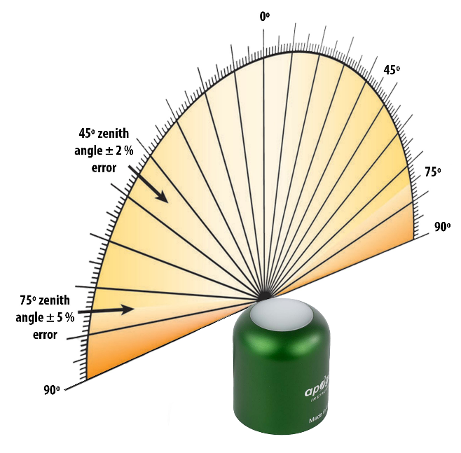
Directional, or cosine, response is defined as the measurement error at a specific angle of radiation incidence. Error for Apogee S2 series upward-looking sensors is approximately ± 2 % and ± 5 % at solar zenith angles of 45° and 75°, respectively.

Upward- and Downward-looking Two-band Sensors
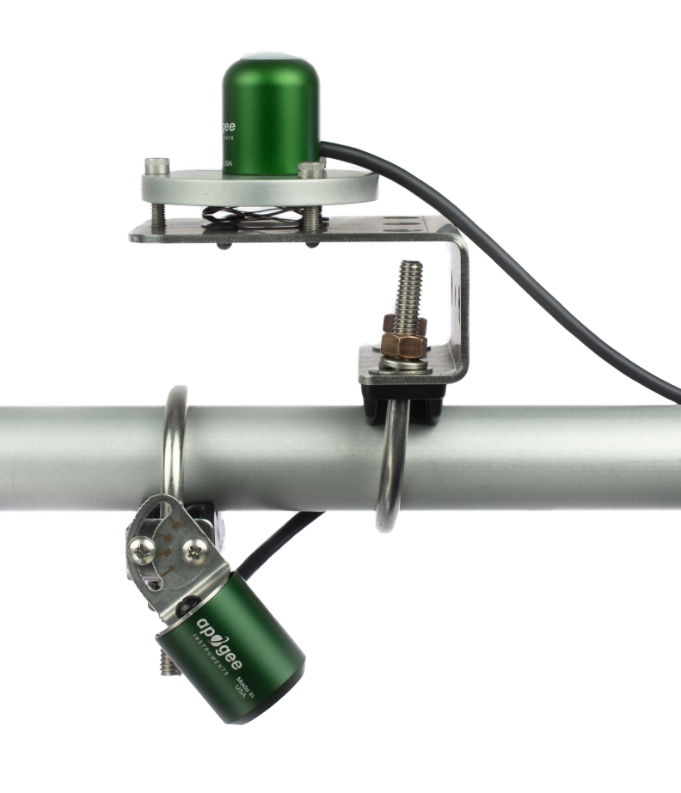
Downward (model S2-112)
Upward (model S2-111)
Spectral Response Graph of NDVI
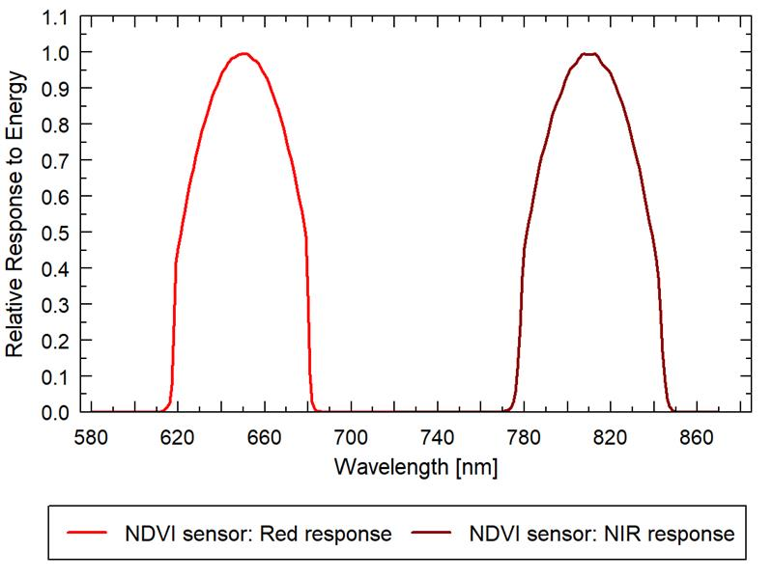
The spectral range of the NDVI sensors is defined by a center wavelength of 650 nm ± 5 nm with 65 nm full-width half-maximum (Red) and 810 nm ± 5 nm with 65 nm full-width half-maximum (NIR). Measured spectral responses are plotted in the graph.

Deployment and Installation
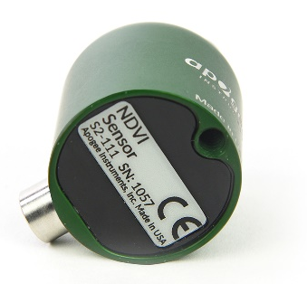
Mount the upward-looking sensor to a solid surface with the nylon mounting screw provided to prevent galvanic corrosion. To accurately measure irradiance incident on a horizontal surface, the sensor must be level. An Apogee Instruments model AL-100 Leveling Plate is recommended to level the sensor when used on a flat surface or being mounted to surfaces such as wood. To facilitate mounting on a mast or pipe, the Apogee Instruments model AL-120 Solar Mounting Bracket with AL-100 Leveling Plate is recommended.

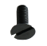
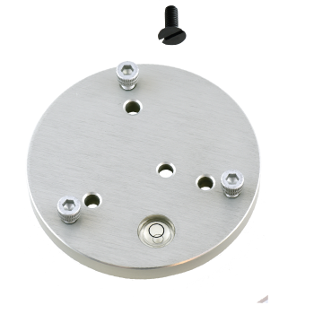
Nylon Screw: 10-32x5/8

Nylon Screw: 10-32x5/8
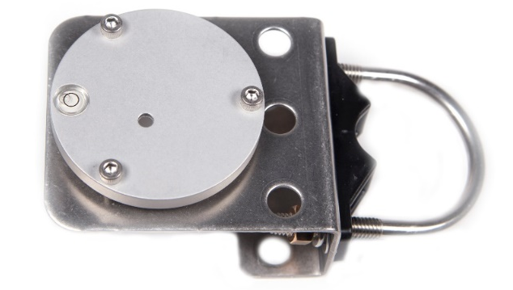
Model AL-120

Model AL-100

To minimize azimuth error, the sensor should be mounted with the cable pointing toward true north in the northern hemisphere or true south in the southern hemisphere. Azimuth error is typically less than 1 %, but it is easy to minimize by proper cable orientation.
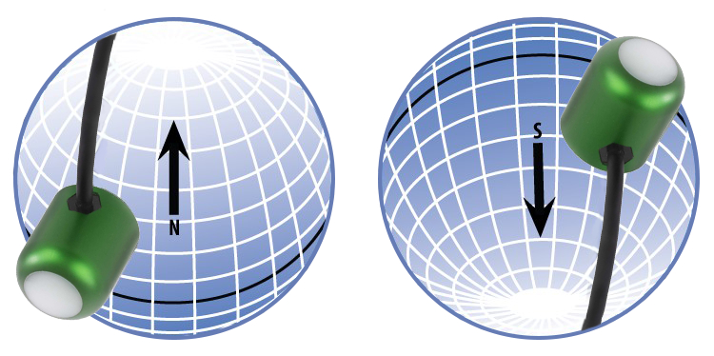
In addition to orienting the cable to point toward the nearest pole, the sensor should also be mounted such that obstructions (e.g., weather station tripod/tower or other instrumentation) do not shade the sensor. Once mounted, the blue cap should be removed from the sensor. The green cap can be used as a protective covering for the sensor when it is not in use.
Downward-looking sensor mounting
Mount the sensor to a solid surface with the nylon mounting screw provided to prevent galvanic corrosion. To facilitate mounting on a mast or pipe, the Apogee Instruments model SM-400 Two Band Radiometer Downward-looking Mounting Bracket is recommended. The bracket can be adjusted to any angle between 0° (sensor pointed straight down) and 90° (sensor horizontal).
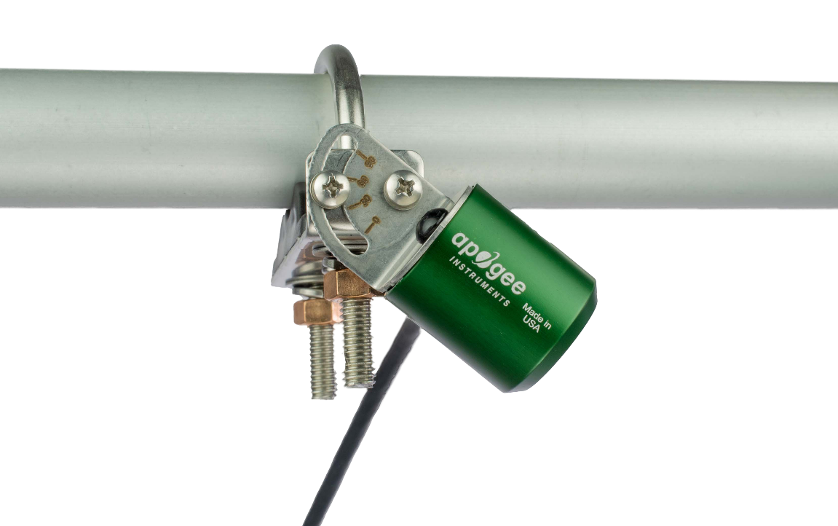

Cable Connectors
Apogee sensors offer cable connectors to simplify the process of removing sensors from weather stations for calibration (the entire cable does not have to be removed from the station and shipped with the sensor).  The ruggedized M8 connectors are rated IP68, made of corrosion-resistant marine-grade stainless-steel, and designed for extended use in harsh environmental conditions. | 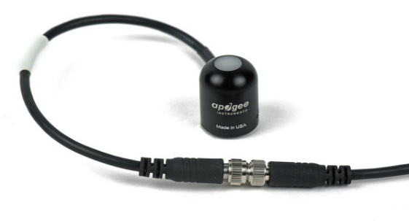  Inline cable connectors are installed 30 cm from the head (pyranometer pictured above)
Instructions
Pins and Wiring Colors: All Apogee connectors have six pins, but not all pins are used for every sensor. There may also be unused wire colors inside the cable. To simplify datalogger connection, we remove the unused pigtail lead colors at the datalogger end of the cable.  If you ever need a replacement cable, please contact us directly to ensure ordering the proper pigtail configuration.  Alignment: When reconnecting your sensor, arrows on the connector jacket and an aligning notch ensure proper orientation.  Disconnection for extended periods: When disconnecting the sensor for an extended period of time from a station, protect the remaining half of the connector still on the station from water and dirt with electrical tape or other method. | 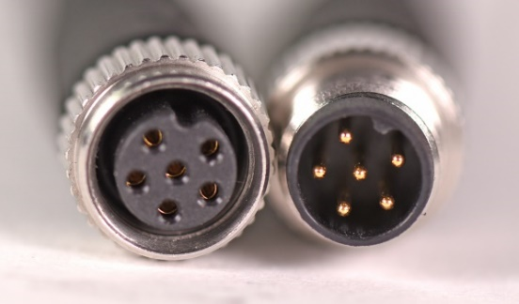  A reference notch inside the connector ensures  proper alignment before tightening.  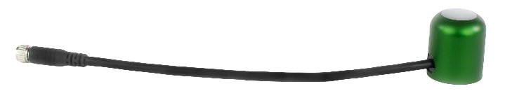  When sending sensors in for calibration, only send the  short end of the cable and half the connector.
Tightening: Connectors are designed to be firmly finger-tightened only. There is an o-ring inside the connector that can be overly compressed if a wrench is used. Pay attention to thread alignment to avoid cross-threading. When fully tightened, 1-2 threads may still be visible.  WARNING: Do not tighten the connector by twisting the black cable or sensor head, only twist the metal connector. | 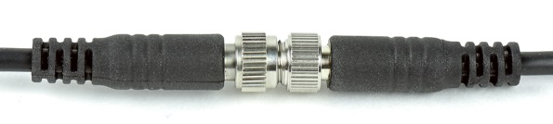  Finger-tighten firmly

Operation and Measurement

Connect the sensor to a measurement device (meter, datalogger, controller) capable of measuring and displaying or recording a millivolt signal (an input measurement range of approximately 0-25 mV is required to cover the sensor output ranges). In order to maximize measurement resolution and signal-to-noise ratio, the input range of the measurement device should closely match the output range of the sensor. DO NOT connect the sensor to a power source. The sensor is self-powered and applying voltage will damage the sensor.

Wiring for S2-100 series
White: Positive (signal from NIR (NDVI))
Black: Negative (signal from NIR (NDVI))
Yellow: Positive (signal from Red (NDVI))
Blue: Negative (signal from Red (NDVI))
Clear: Shield
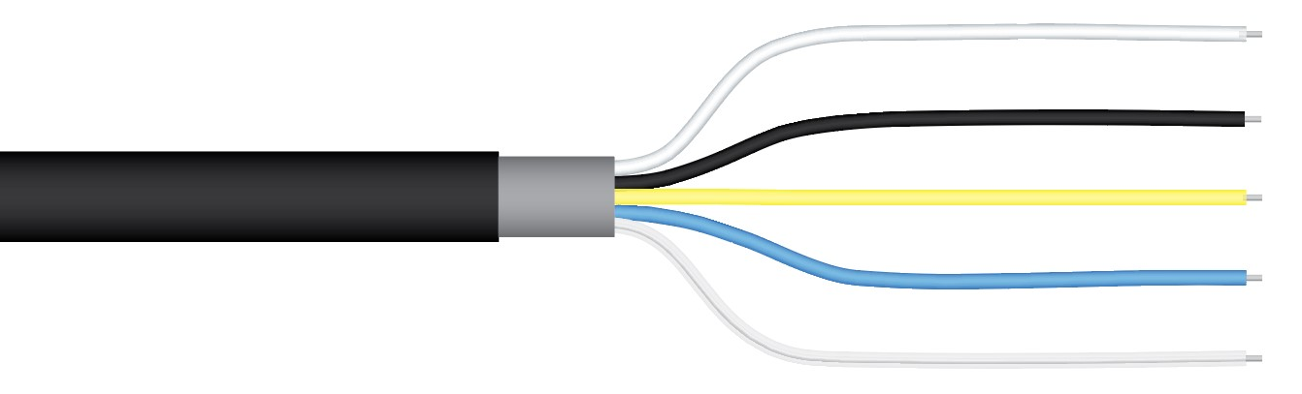

Reflectance and Reflectance Indices (NDVI)
Reflectance (ρ) is the ratio of radiance, the calibrated signal returned by the downward-looking sensor, to irradiance, the calibrated signal returned by the upward-looking sensor, for a specific wavelength range:
ρ = radiance reflected from the surface / irradiance incident on the surface
Typically, a measurement of radiance is used in the numerator of the equation above to determine reflectance. Theoretically, when ρ is determined from radiance reflected from the surface it is called directional reflectance, which approximates the bidirectional reflectance factor. When ρ is determined from irradiance reflected from the surface it is called hemispherical reflectance. Both terms are referred to as reflectance herein.
NDVI is calculated as the difference between near infrared (NIR) and red reflectance divided by the sum of NIR and red reflectance:
$$NDVI=\frac{ρ_{NIR}-ρ_{Red}}{ρ_{NIR}+ρ_{Red}}$$
It is important to ensure that paired upward-looking and downward-looking sensors make measurements at the same time, otherwise temporal changes in sky conditions can result in errors in reflectance and calculated NDVI values.
A single upward-looking sensor can be deployed with multiple downward-looking sensors, and irradiance from the single upward-looking sensor can be used to calculate NDVI at the location of all the downward-looking sensors, if the downward-looking sensors are in close proximity to each other (e.g., within a research plot).
While paired upward-looking and downward-looking sensors provide the most accurate measurements of NDVI, radiance measurements from downward-looking sensors can also be used to approximate NDVI without calculating reflectance from paired upward-looking and downward-looking sensors. The equation has a similar form to the NDVI equation above, but uses radiances (R) in the calculation:
$$NDVI= \frac{αR_{NIR}-R_{Red}}{αR_{NIR}+R_{Red}}$$
where α (alpha) is the ratio of red irradiance to NIR irradiance (the values measured by an upward-looking sensor). Data from multiple solar spectra indicate α ranges from about 1.1 to 1.4, with lower values occurring at high solar zenith angles or under overcast sky and higher values occurring under clear sky at low solar zenith angles. Approximations of NDVI from the equation above are least sensitive to the value of α when the difference between NIR and Red radiances are relatively large (e.g., measurements over green vegetation) and most sensitive to the value of α when the difference between NIR and Red radiances are relatively small (e.g., measurements over senesced vegetation or soil).

Maintenance and Recalibration
Blocking of the optical path between the target and detector can cause low readings. Occasionally, accumulated materials on the diffusers of the upward-looking sensor and in the apertures of the downward-looking sensor can block the optical path in three common ways:
- Moisture or debris on the diffusers (upward-looking) or in the apertures (downward-looking).
- Dust during periods of low rainfall.
- Salt deposit accumulation from evaporation of sea spray or sprinkler irrigation water.
Apogee Instruments upward-looking sensors have domed diffusers and housing for improved self-cleaning from rainfall, but active cleaning may be necessary. Dust or organic deposits are best removed using water, or window cleaner, and a soft cloth or cotton swab. Salt deposits should be dissolved with vinegar and removed with a cloth or cotton swab. Salt deposits cannot be removed with solvents such as alcohol or acetone. Use only gentle pressure when cleaning the diffuser with a cotton swab or soft cloth, to avoid scratching the outer surface. The solvent should be allowed to do the cleaning, not mechanical force. Never use an abrasive material or cleaner on the diffuser.
It is recommended that two-band sensors be recalibrated every two years. See the Apogee webpage for details regarding return of sensors for recalibration (http://www.apogeeinstruments.com/tech-support-recalibration-repairs/).

Troubleshooting and Customer Support
Independent Verification of Functionality
Apogee S2 series NDVI sensors are self-powered devices and output a voltage signal proportional to irradiance (upward-looking sensors) and radiance (downward-looking sensors). A quick and easy check of sensor functionality can be determined using a voltmeter with millivolt resolution. Connect the positive lead wire from the voltmeter to the yellow wire from the sensor and the negative (or common) lead wire from the voltmeter to the blue wire from the sensor. Direct the sensor head toward a light source and verify the sensor provides a signal. Increase and decrease the distance from the sensor head to the light source to verify that the signal changes proportionally (decreasing signal with increasing distance and increasing signal with decreasing distance). Blocking all radiation from the sensor should force the sensor signal to zero. Repeat the process by connecting the positive lead wire from the voltmeter to the white wire from the sensor and the negative (or common) lead wire from the voltmeter to the black wire from the sensor.
Compatible Measurement Devices (Dataloggers/Controllers/Meters)
S2-100 series NDVI sensors have small sensitivities, outputting a few mV per W m⁻². Typical irradiance from the sun on a clear day is between 1-2 W m⁻² at the center wavelengths measured by the sensors. It is recommended that the measurement device (e.g., datalogger or controller) have resolution of at least 0.001 mV.
Example datalogger programs for Campbell Scientific dataloggers can be found on the Apogee webpage at: https://www.apogeeinstruments.com/content/NDVI-Analog.CR1
Cable Length
When the sensor is connected to a measurement device with high input impedance, sensor output signals are not changed by shortening the cable or splicing on additional cable in the field. Tests have shown that if the input impedance of the measurements device is greater than 1 mega-ohm there is negligible effect on the calibration, even after adding up to 100 m of cable. All Apogee sensors use shielded, twisted pair cable to minimize electromagnetic interference. For best measurements, the shield wire must be connected to an earth ground. This is particularly important when using the sensor with long lead lengths in electromagnetically noisy environments.
Modifying Cable Length
See Apogee webpage for details on how to extend sensor cable length: (http://www.apogeeinstruments.com/how-to-make-a-weatherproof-cable-splice/).

Return and Warranty Policy

RETURN POLICY
Apogee Instruments will accept returns within 30 days of purchase as long as the product is in new condition (to be determined by Apogee). Returns are subject to a 10 % restocking fee.

WARRANTY POLICY
What is Covered
All products manufactured by Apogee Instruments are warranted to be free from defects in materials and craftsmanship for a period of four (4) years from the date of shipment from our factory. To be considered for warranty coverage an item must be evaluated by Apogee.
Products not manufactured by Apogee (spectroradiometers, chlorophyll content meters, EE08-SS probes) are covered for a period of one (1) year.
What is Not Covered
The customer is responsible for all costs associated with the removal, reinstallation, and shipping of suspected warranty items to our factory.
The warranty does not cover equipment that has been damaged due to the following conditions:
1. Improper installation, use, or abuse.
2. Operation of the instrument outside of its specified operating range.
3. Natural occurrences such as lightning, fire, etc.
4. Unauthorized modification.
5. Improper or unauthorized repair.
Please note that nominal accuracy drift is normal over time. Routine recalibration of sensors/meters is considered part of proper maintenance and is not covered under warranty.
Who is Covered
This warranty covers the original purchaser of the product or other party who may own it during the warranty period.
What Apogee Will Do
At no charge Apogee will:
1. Either repair or replace (at our discretion) the item under warranty.
2. Ship the item back to the customer by the carrier of our choice.
Different or expedited shipping methods will be at the customer’s expense.

How To Return An Item
1. Please do not send any products back to Apogee Instruments until you have received a Return Merchandise Authorization (RMA) number from our technical support department by submitting an online RMA form at www.apogeeinstruments.com/tech-support-recalibration-repairs/. We will use your RMA number for tracking of the service item. Call (435) 245-8012 or email techsupport@apogeeinstruments.com with questions.
2. For warranty evaluations, send all RMA sensors and meters back in the following condition: Clean the sensor’s exterior and cord. Do not modify the sensors or wires, including splicing, cutting wire leads, etc. If a connector has been attached to the cable end, please include the mating connector – otherwise the sensor connector will be removed in order to complete the repair/recalibration. Note: When sending back sensors for routine calibration that have Apogee’s standard stainless-steel connectors, you only need to send the sensor with the 30 cm section of cable and one-half of the connector. We have mating connectors at our factory that can be used for calibrating the sensor.
3. Please write the RMA number on the outside of the shipping container.
4. Return the item with freight pre-paid and fully insured to our factory address shown below. We are not responsible for any costs associated with the transportation of products across international borders.
Apogee Instruments, Inc.
721 West 1800 North Logan, UT
84321, USA
5. Upon receipt, Apogee Instruments will determine the cause of failure. If the product is found to be defective in terms of operation to the published specifications due to a failure of product materials or craftsmanship, Apogee Instruments will repair or replace the items free of charge. If it is determined that your product is not covered under warranty, you will be informed and given an estimated repair/replacement cost.

Products Beyond the Warranty Period
For issues with sensors beyond the warranty period, please contact Apogee at techsupport@apogeeinstruments.com to discuss repair or replacement options.

Other Terms
The available remedy of defects under this warranty is for the repair or replacement of the original product, and Apogee Instruments is not responsible for any direct, indirect, incidental, or consequential damages, including but not limited to loss of income, loss of revenue, loss of profit, loss of data, loss of wages, loss of time, loss of sales, accruement of debts or expenses, injury to personal property, or injury to any person or any other type of damage or loss.
This limited warranty and any disputes arising out of or in connection with this limited warranty ("Disputes") shall be governed by the laws of the State of Utah, USA, excluding conflicts of law principles and excluding the Convention for the International Sale of Goods. The courts located in the State of Utah, USA, shall have exclusive jurisdiction over any Disputes.
This limited warranty gives you specific legal rights, and you may also have other rights, which vary from state to state and jurisdiction to jurisdiction, and which shall not be affected by this limited warranty. This warranty extends only to you and cannot by transferred or assigned. If any provision of this limited warranty is unlawful, void, or unenforceable, that provision shall be deemed severable and shall not affect any remaining provisions. In case of any inconsistency between the English and other versions of this limited warranty, the English version shall prevail.
This warranty cannot be changed, assumed, or amended by any other person or agreement
APOGEE INSTRUMENTS, INC. | 721 WEST 1800 NORTH, LOGAN, UTAH 84321, USA
TEL: (435) 792-4700 | FAX: (435) 787-8268 | WEB: APOGEEINSTRUMENTS.COM
Copyright © 2022 Apogee Instruments, Inc.

