

Owner’s Manual

Guardian CEA multi-sensor monitor
Models SM-500 and SM-600
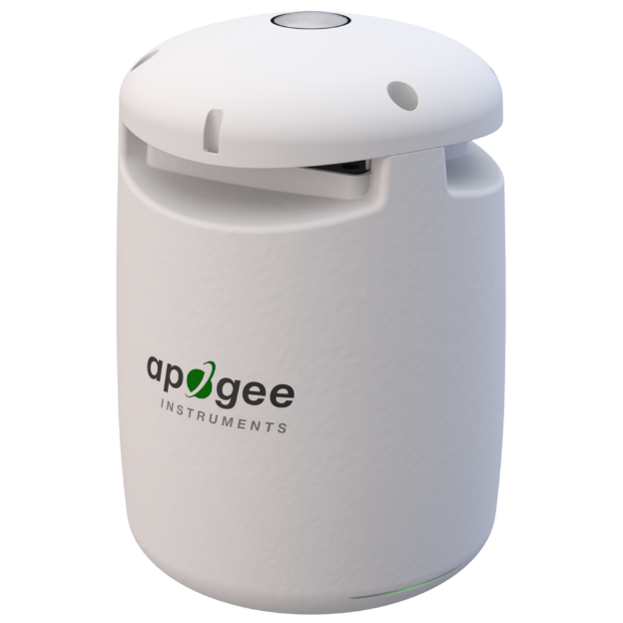
Rev: 28-February-2025

Table of Contents
Owner’s Manual 1
Certificates of Compliance 3
Introduction 5
Sensor Models 6
Specifications 7
Deployment and Installation 10
General Operation 13
Apogee Connect Software 14
Modbus Connectivity 16
Maintenance and Recalibration 21
Troubleshooting and Customer Support 22
Return and Warranty Policy 23

Certificates of Compliance

EU Declaration of Conformity
This declaration of conformity is issued under the sole responsibility of the manufacturer:
Apogee Instruments, Inc.
721 W 1800 N
Logan, Utah 84321
USA
for the following product(s):

Models: SM-500 & SM-600
Type: CEA Multi-Sensor Monitor

The object of the declaration described above is in conformity with the relevant Union harmonization legislation:

2014/30/EU Electromagnetic Compatibility (EMC) Directive
2011/65/EU Restriction of Hazardous Substances (RoHS 2) Directive
2015/863/EU Amending Annex II to Directive 2011/65/EU (RoHS 3)

Standards referenced during compliance assessment:

EN 61326-1:2013 Electrical equipment for measurement, control, and laboratory use – EMC requirements
EN 63000:2018 Technical documentation for the assessment of electrical and electronic products with respect to the restriction of hazardous substances

Please be advised that based on the information available to us from our raw material suppliers, the products manufactured by us do not contain, as intentional additives, any of the restricted materials including lead (see note below), mercury, cadmium, hexavalent chromium, polybrominated biphenyls (PBB), polybrominated diphenyls (PBDE), bis (2-ethylhexyl) phthalate (DEHP), butyl benzyl phthalate (BBP), dibutyl phthalate (DBP), and diisobutyl phthalate (DIBP). However, please note that articles containing greater than 0.1 % lead concentration are RoHS 3 compliant using exemption 6c.

Further note that Apogee Instruments does not specifically run any analysis on our raw materials or end products for the presence of these substances, but we rely on the information provided to us by our material suppliers.

Signed for and on behalf of:
Apogee Instruments, October 2024


Bruce Bugbee
President
Apogee Instruments, Inc.

UK Declaration of Conformity
This declaration of conformity is issued under the sole responsibility of the manufacturer:
Apogee Instruments, Inc.
721 W 1800 N
Logan, Utah 84321
USA
for the following product(s):

Models: SM-500 & SM-600
Type: CEA Multi-Sensor Monitor

The object of the declaration described above is in conformity with the relevant UK Statutory Instruments and their amendments:

2016 No. 1091 The Electromagnetic Compatibility Regulations 2016
2012 No. 3032 The Restriction of the Use of Certain Hazardous Substances in Electrical and Electronic Equipment Regulations 2012

Standards referenced during compliance assessment:

BS EN 61326-1:2013 Electrical equipment for measurement, control, and laboratory use – EMC requirements
BS EN 63000:2018 Technical documentation for the assessment of electrical and electronic products with respect to the restriction of hazardous substances

Please be advised that based on the information available to us from our raw material suppliers, the products manufactured by us do not contain, as intentional additives, any of the restricted materials including lead (see note below), mercury, cadmium, hexavalent chromium, polybrominated biphenyls (PBB), polybrominated diphenyls (PBDE), bis (2-ethylhexyl) phthalate (DEHP), butyl benzyl phthalate (BBP), dibutyl phthalate (DBP), and diisobutyl phthalate (DIBP). However, please note that articles containing greater than 0.1 % lead concentration are RoHS 3 compliant using exemption 6c.

Further note that Apogee Instruments does not specifically run any analysis on our raw materials or end products for the presence of these substances, but we rely on the information provided to us by our material suppliers.

Signed for and on behalf of:
Apogee Instruments, May 2024

Bruce Bugbee
President
Apogee Instruments, Inc.

Introduction
Controlled environments, such as greenhouses and growth chambers, provide favorable year-round growing conditions as temperature and light intensity can be adjusted to suit the plants inside. However, improper management can negatively affect plant growth and crop yield. Accurate environmental measurements in these conditions are important to aid in decision making and environment management.
The Apogee Guardian is an elegant device that provides accurate measurements of important indoor environmental parameters. The Guardian is a user-friendly datalogger with multiple integrated sensors to measure PAR (SM-500) or ePAR (SM-600), air temperature, humidity, vapor pressure deficit and dewpoint, CO₂ concentration, barometric pressure, and daily light integral* and photoperiod* (*only accessible via Bluetooth). Graphical summaries of these measurements can be downloaded to dataloggers via Modbus or smartphones via Bluetooth with the Apogee Connect app (iOS/Android) or computer software. While the Guardian can take measurements as a stand-alone operation mounted to a mast or hung by thin wires, it can also integrate into systems for greenhouses, grow rooms, and vertical farms via Modbus or Bluetooth.

Measuring Light
Radiation that drives photosynthesis is called photosynthetically active radiation (PAR). PAR is typically defined as an equal weighting of photons from 400 to 700 nm. In other words, photosynthesis is driven by all visible light equally. However, recent research has shown that an extended PAR (ePAR) model would be more accurate as some light above 700 nm (far-red light) also drives photosynthesis, and the light within this range affects photosynthesis nonuniformly (Zhen et al., 2021). PAR is often measured in controlled environments to ensure that plants have adequate lighting, and lights are performing as expected. The Guardian offers a choice between a PAR (SM-500) or ePAR (SM-600) sensor, mounted on the top of the device. From the PAR or ePAR measurements, the Guardian can calculate daily light integral (DLI) and photoperiod, which are the total amount (in mol d⁻¹) of light and the total time (in hr) the light was incident on a plant over a 24-hour period, respectively.

Housing Design
Solar radiation incident on a temperature thermistor can warm the sensor above ambient air temperature. This causes measurements to be errantly warm. The Guardian works as a fan-aspirated radiation shield to reduce the effect of solar radiation and improve accuracy of air temperature measurements. The housing protects the temperature sensor from incoming radiation, while the internal electric fan draws ambient air past the internal thermistor. This yields a more exact measurement of actual air temperature.
To further increase accuracy, the Guardian is constructed from high-quality ASA plastic with low thermal conductivity and a gloss white finish in selective areas to lower emissivity. The Guardian is filled with foam to provide additional thermal insulation. The internal airway utilizes a small venturi constriction to maximize airflow efficiency over the thermistor, which minimizes the thermal boundary layer’s influence on temperature measurements. Simultaneously, a separate module used to measure CO₂, humidity, and pressure is aspirated by a passive, low velocity airstream using a “fluid entrainment” principle.
Zhen et al. 2021. Why Far-Red Photons Should Be Included in the Definition of Photosynthetic Photons and the Measurement of Horticultural Fixture Efficacy. Frontiers in Plant Science. 12:1-4.

Sensor Models
Apogee SM series CEA multi-sensor monitors covered in this manual are self-contained.
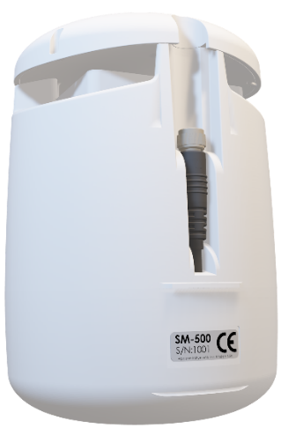
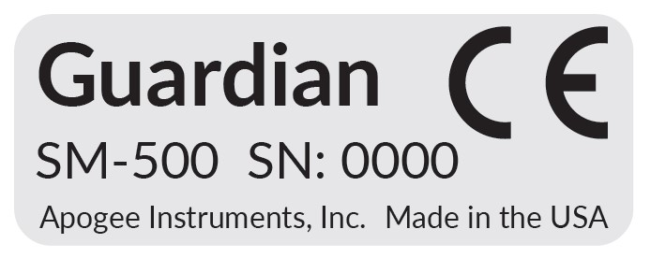
A monitor’s model number and serial number are located on a label on the lower, back side of the Guardian.

The SM-500 and SM-600 models are identical in all ways (size, function, and appearance) except for the embedded light sensor. The SM-600 sensor measures extended photosynthetically active radiation (ePAR), which includes far-red photons, while the SM-500 does not.

SM-500
PAR

SM-600
ePAR

750nm
700nm
400nm

Data from recent studies indicate that far-red photons synergistically interact with photons in the historically defined PAR range of 400-700 nm to increase photochemical efficiency in leaves (Hogewoning et al., 2012; Murakami et al., 2018; Zhen and van Iersel, 2017; Zhen et al., 2019). Measurements from whole plants and plant canopies indicate adding far-red photons to radiation sources outputting photons in the 400-700 nm range increases canopy photosynthesis equal to the addition of the same number of photons in the 400-700 nm range for multiple species, but far-red photons alone are photosynthetically inefficient and result in minimal photosynthesis (Zhen and Bugbee, 2020a; Zhen and Bugbee, 2020b).
Far-red photons (700-750 nm) drive photosynthesis with similar efficiency as photons in the PAR range (400-700 nm) when acting synergistically with photons in the PAR range. Fraction of far-red photons relative to photons in the PAR range influences plant morphology through plant perception of shade.

Specifications
 | PAR (SM-500) | ePAR (SM-600) | Temperature | Relative Humidity | CO₂ | Barometric Pressure
Calibration Uncertainty | ± 5 % |  | ± 0.2 C | ± 3 %  from 20 to 80 % | ± 50 ppm + 2 % of the measured value | ----
Long-term Drift (Non-stability) | less than 2 % per year |  | less than 0.02 C | ---- | ---- | ----
Measurement Repeatability | less than 0.5 % |  | less than 0.01 C
Measurement Range | 0 to 4000 µmol m-2 s-1 |  | -60 to 80 C | 0 to 95 % | 0 to 2000 ppm | 70 to 110 kPa
Spectral Range | 389 to 692 nm | 383 to 757 nm | ---- | ---- | ---- | ----
Field of View | 180 ° |  | ---- | ---- | ---- | ----
Directional Response | ± 5 % at 75 ° zenith angle (see Directional Response graph) |  | ---- | ---- | ---- | ----
Azimuth Error | less than 0.5 % |  | ---- | ---- | ---- | ----
Tilt Error | less than 0.5 % |  | ---- | ---- | ---- | ----
Non-linearity | less than 1 % (up to 4000 mmol m-2 s-1) |  | ---- | ---- | ---- | ----
Response Time | less than 1 ms |  | 7 s |  | 105 s
Temperature Response | -0.11 % ± 0.04 % per C |  | ---- | ---- |  | ----
Uncertainty in Daily Total | less than 5 % |  | ---- | ---- | ---- | ----
Operating Environment | -40 to 60 C, and 0 to 95 % Relative Humidity
Aspiration Rate | ---- | ---- | 7 m s-1 | < 1 m s-1
Housing | White ASA
IP Rating | IP53
Mass | 392 grams
Dimensions | 105mm diameter, 157mm height (4.2in x 6.2in)
Cable | 6 conductor, shielded wire, with TPR jacket and M8 connector (available in 5, 10, and 20 m lengths);  5V 1A USB power adapter and 5 m USB to M8 connector cable
Input Voltage | 5V to 32V
Power Usage | 1.1W to 1.5W
Current Draw | at 12V: 92mA typical, 500mA peak
Connectivity | Modbus RS485, RS232 and/or Bluetooth
Data Storage | 9 months of 1 min data
Warranty | 4 years against defects in original materials and workmanship.
Calibration Traceability
Apogee SM series embedded quantum sensors are calibrated through side-by-side comparison to the mean of four transfer standard quantum sensors under a reference lamp. The reference quantum sensors are recalibrated with a 200 W quartz halogen lamp traceable to the National Institute of Standards and Technology (NIST).
Spectral Response
Mean spectral response measurements of six replicate Apogee MQ-500 (full-spectrum) and MQ-610 (ePAR) series quantum sensors. Spectral response measurements were made at 10 nm increments across a wavelength range of 300 to 800 nm with a monochromator and an attached electric light source. Measured spectral data from each quantum sensor were normalized by the measured spectral response of the monochromator/electric light combination, which was measured with a spectroradiometer.

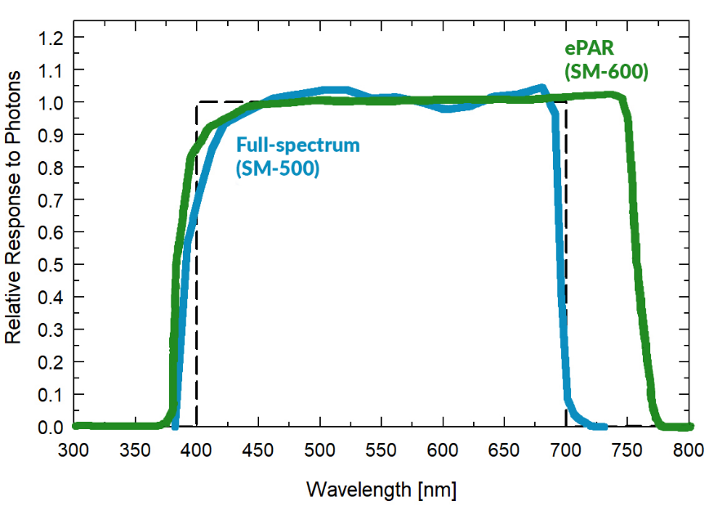

Temperature Response
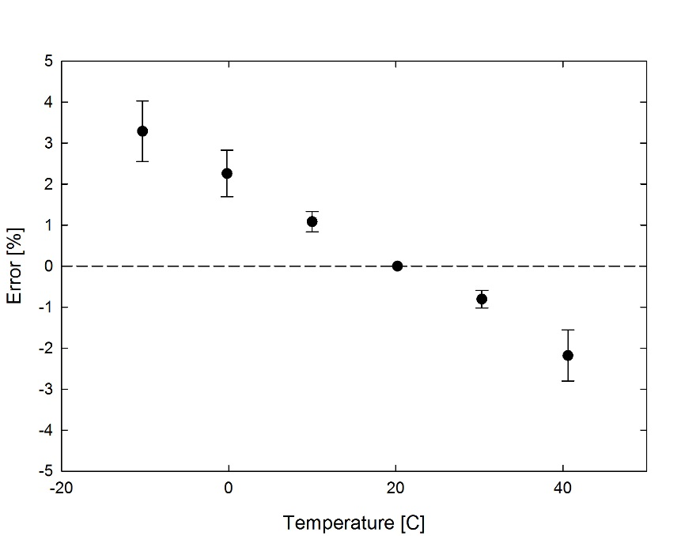
Mean temperature response of ten MQ-500 series quantum sensors (errors bars represent two standard deviations above and below mean). Temperature response measurements were made at 10 C intervals across a temperature range of approximately -10 to 40 C in a temperature-controlled chamber under a fixed, broad spectrum, electric lamp. At each temperature set point, a spectroradiometer was used to measure light intensity from the lamp and all quantum sensors were compared to the spectroradiometer. The spectroradiometer was mounted external to the temperature control chamber and remained at room temperature during the experiment.

Cosine Response
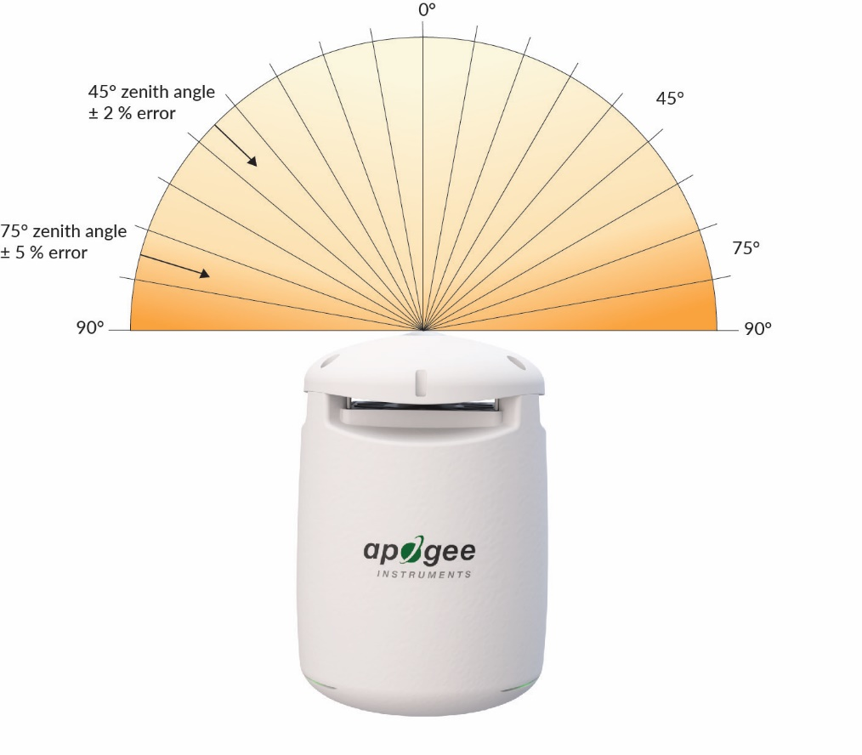
Directional (cosine) response is defined as the measurement error at a specific angle of radiation incidence. Error for Apogee MQ-500 series quantum sensors is approximately ± 2 % and ± 5 % at solar zenith angles of 45° and 75°, respectively.

Mean directional (cosine) response of seven apogee MQ-500 series quantum sensors. Directional response measurements were made on the rooftop of the Apogee building in Logan, Utah. Directional response was calculated as the relative difference of MQ-500 quantum sensors from the mean of replicate reference quantum sensors (LI-COR models LI-190 and LI-190R, Kipp & Zonen model PQS 1). Data were also collected in the laboratory using a reference lamp and positioning the sensor at varying angles.

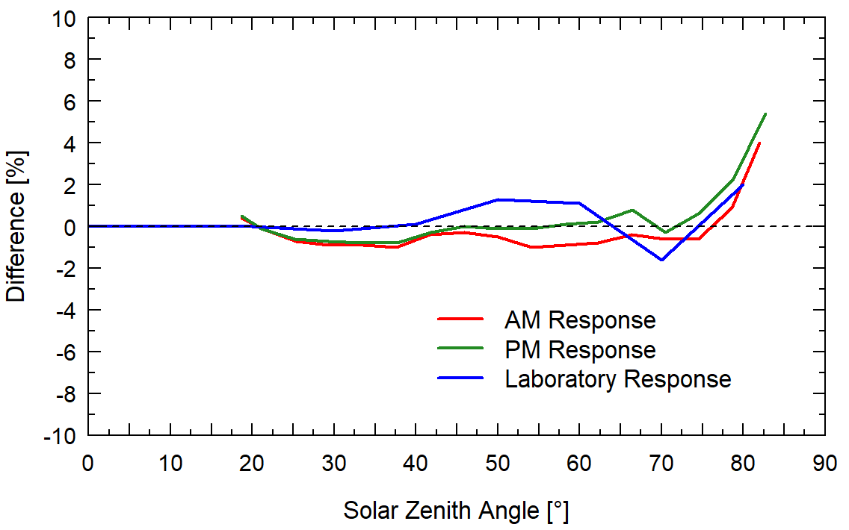

Deployment and Installation
The Guardian works as a stand-alone device, or it can also integrate into systems for greenhouses, grow rooms, vertical farms, and other controlled environments. It can connect to your phone via Bluetooth using the Apogee Connect app (iOS/Android) or dataloggers via Modbus. Bluetooth and Modbus connectivity can be simultaneous, allowing for in-person spot checks and supplementary logging even while connected to a larger controller system.
There are two primary ways the Guardian can be deployed; hanging from thin wires or being mounted to a mast. Each package comes complete with wires for suspending the Guardian. Apogee also sells a mounting apparatus for attaching to poles or masts (see the Apogee AM-270 Guardian mounting bracket, coming soon).
The Guardian needs continual power, either through a Modbus connection or power cord. Depending on the selected package, there are different cable types and lengths available:
- L-5: Includes a 5-meter cable
- L-10: Includes a 10-meter cable
- L-20: Includes a 20-meter cable
- AC: Includes a 5-meter USB power cable and AC adapter.
When connected to power, the Guardian’s fan will automatically start, and the unit is now ready for operation.

Other Notes and Tips:
- When mounting the Guardian, be sure to allow for adequate space underneath the instrument to ensure air flow through the sensor.
- USB connection is for power only. Data transmission will not occur.
- USB extension cables are not recommended, as they may result in inadequate supply voltage.
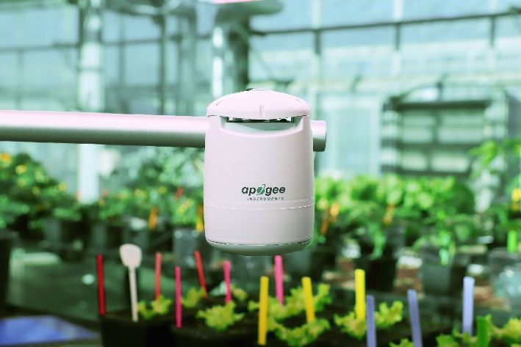
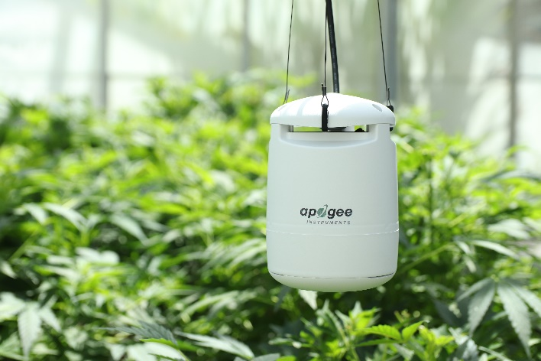

Mounting via Wires Mounting via AM-270

CABLE CONNECTORS
Guardians include the same M8 connector found on many Apogee Instruments products.  The ruggedized connectors are IP68 rated, made of corrosion-resistant marine-grade stainless-steel, and designed for extended use in harsh environmental conditions.  The cable connector is located on the back of the unit and is partially flexible. It can be manipulated to fit your setup. | 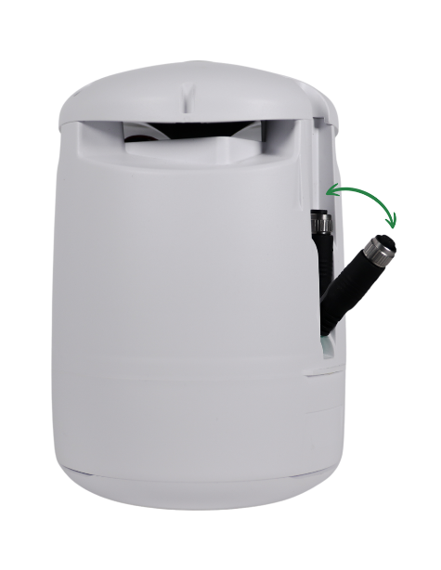
Instructions
Alignment: When reconnecting a sensor, arrows on the connector jacket and an aligning notch ensure proper orientation.  Disconnection for extended periods: When disconnecting the sensor for an extended period of time from a station, protect the remaining half of the connector still on the station from water and dirt with electrical tape or other method. | 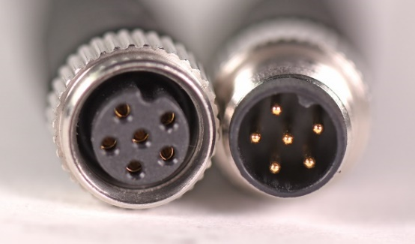  A reference notch inside the connector ensures  proper alignment before tightening.
Tightening: Connectors are designed to be firmly finger-tightened only. There is an o-ring inside the connector that can be overly compressed if a wrench is used. Pay attention to thread alignment to avoid cross-threading. When fully tightened, 1-2 threads may still be visible.  WARNING: Do not tighten the connector by twisting the black cable, only twist the metal connector. | 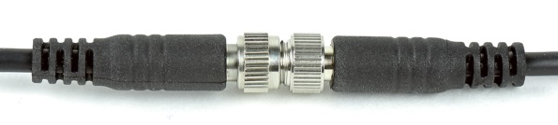  Finger-tighten firmly

MODBUS WIRING
The Guardian has a Modbus output, where measurement values are returned in digital format. Measurement of the Guardian requires a measurement device with a Modbus interface that supports the Read Holding Registers (0x03) function.

Wiring
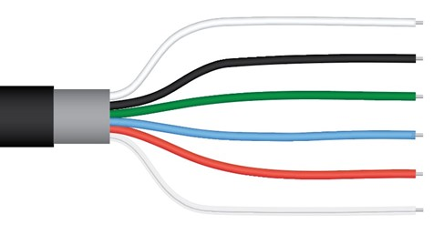
White: RS-232 RX / RS-485 Positive
Black: Ground
Green: Select (Switch between RS-232 and RS-485)
Blue: RS-232 TX / RS-485 Negative
Red: Power 5.5V-32V DC
Clear: Shield/Ground

The Green wire should be connected to Ground to enable RS-485 communication, or should be connected to 12 V power for RS-232 communication. Note that text labels shown in the graphic above for the White and Blue wires refer to the port that the wires should be connected to.

General Operation
As soon as it’s powered, the Guardian is operational, but does not operate until configured to collect data (via Bluetooth communication) or connected to a Modbus system.
Guardian supports simultaneous Bluetooth, internal logging, and Modbus operation.
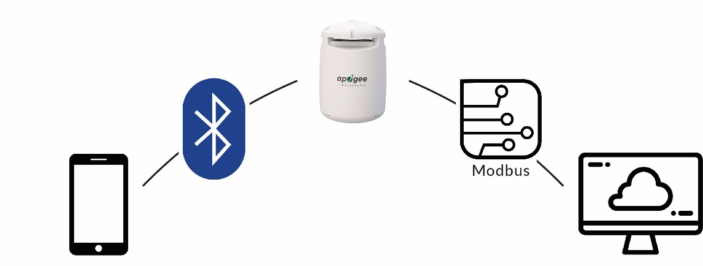
LED Status Indication
••• | (blue) | Successfully Connected to Device
• | (blue) | Currently Connected to Device
• | (purple) | Modbus Communication
• | (green) | Data Collected
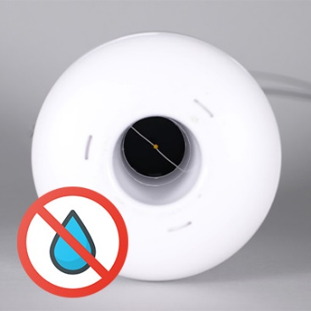
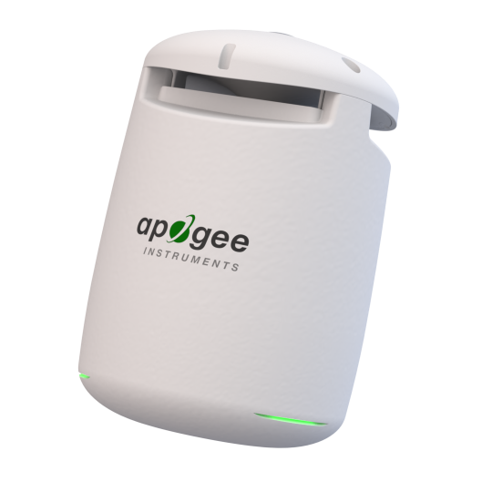
At three locations near the bottom are LED lights to indicate operational status. Light indication may be disabled if desired (see sections for Bluetooth or Modbus connections).

While the Guardian includes components that are rated higher, the entire product is deemed IP53. This rating indicates the product is splashproof, but directed water streams from below may damage the product. Take care not to direct water into the auxiliary inlet located at the bottom of the product.

Apogee Connect Software
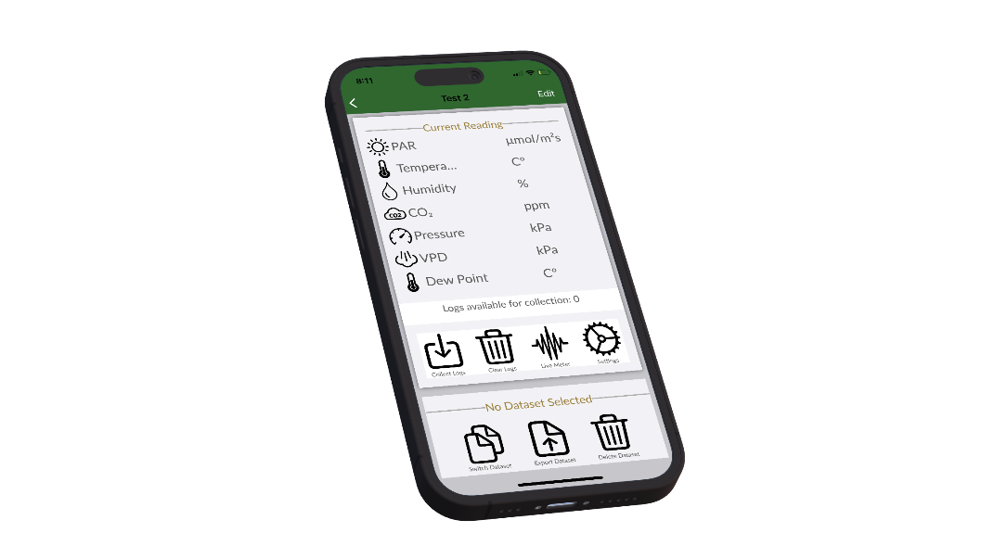


Downloading data to a computer requires the free Apogee Connect software. The Guardian can also communicate with the Apogee Connect apps for iOS and Android via Bluetooth.
The most recent version of the Apogee Connect software and apps can be downloaded by visiting: http://www.apogeeinstruments.com/downloads/.
Or by scanning the QR codes below:

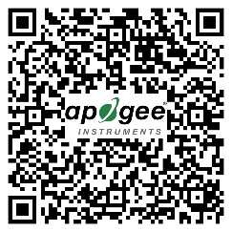

Apple App Store Google Play

Bluetooth® Connection Quick Start Guide
- Ensure the Guardian is powered. Open the Apogee Connect mobile app. To add a µCache to the app for the first time, tap on the + icon in the upper corner.
- Once discovered, the Guardian will flash blue 3 times, and the device name (e.g., “Guardian PAR 1087”) will appear. Tap on the device name to pair.
- If desired, rename the Guardian. Hit ADD.
- Your device is now shown on the app’s main display with live readings. Select your device to view more data and settings.

Note: Subsequent connections are automatic as long as you are within range. Manual reconnection is also possible if need. View in-app instructions for more details.

App Features
Live Data Readings  Once connected, the Guardian will stream live readings to the app. This is viewable from the home screen, the main view, and in live meter mode.  Note: It can take up to 30 seconds for accurate measurements to become available when the Guardian is powered on due to the CO₂/humidity module booting up. | Data Logging  The Guardian can collect measurement data. When logging is enabled, you can set the logging and sampling intervals. The logging interval determines how often a data point is recorded and the sampling interval determines how many readings are averaged to create the log data point.
View and Export Data  When ready and within range, recorded data may be transferred to the app where it may be viewed and/or export as CSV files. You can add the logs to an existing data set or create a new data set. | Live Meter Mode  Similar to viewing live data, but with graphs and the ability to save samples at the touch of an on-screen button.
Live Data Averaging  For use in live meter mode. Live data averaging smooths out fluctuations in the sensor signal. This is useful for sensors that detect subtle trends. | Dark Threshold  Dark threshold is the amount of light accepted before the dark section of a photoperiod is considered disrupted. This is useful for measuring photoperiods, especially with light sensitive plants.
Fan Control  The app allows you to control the speed of the internal fan. You can set the duty cycle, disable the fan, or use the “Fan Pause” option for automatic restart after a set period of time. | LED Toggle  Turn off the Guardian’s LED indicators if you think it might interfere with your research or your plants’ growth.
Custom Calibration and Offsets  If needed, a custom light calibration factor and various offsets may be specified for the following parameters:  PAR/ePAR, temperature, humidity, CO₂, and pressure. | Firmware Updates  The Guardian can receive firmware updates over Bluetooth. The app will automatically check and notify of available updates.

Modbus connectivity
The following features and functionality found through the Apogee Connect mobile app are also available via Modbus commands:

Live Data Averaging  Live data averaging smooths out fluctuations in the sensor signal. This is useful for sensors that detect subtle trends. | Custom Calibration and Offsets  If needed, a custom light calibration factor and various offsets may be specified for the following parameters:  PAR/ePAR, temperature, humidity, CO₂, and pressure
Fan Control  You can enable or disable the fan. This could be used to control the fan and pause its operation for fogging or other needs. Note, this setting does not persist through a power cycle. | Fan Tachometer  You can read the speed of the fan in RPM. This could be used to diagnose issues.
Bluetooth Toggle  Turn off the Guardian’s Bluetooth radio if you think it is unnecessary or may interfere with other equipment. | LED Toggle  Turn off the Guardian’s LED indicators if you think it might interfere with your research or your plants’ growth.
Note: It can take up to 30 seconds for accurate measurements to become available when the Guardian is powered on due to the CO₂/humidity module booting up.
Note: The Modbus communication settings, including address, baudrate, parity, and number of stop bits, can be viewed or modified via Bluetooth using the Apogee Connect app. Changes to the baudrate, parity, and number of stop bits require a power cycle before they will be set. Changes to the address take place immediately.
Enabling Modbus Measurements
To lower energy consumption, the Guardian does not continuously take measurements until prompted. The first Modbus read command of any measurement register will enable continuous measurements but return a “0” result. All subsequent communication will operate normally. Please note that this will happen after every power cycle.

Start Modbus Measurements at Power-on

To avoid the initial “0” read command, users can turn on a feature that allows Modbus measurements to start when the Guardian is powered on. This feature avoids running Modbus measurements twice after things like power outages or power cycling. You can turn on this feature via register 139 on page 20.

Note: The AC-422 (Modbus USB stick) does not work with the Guardian.

Sensor Calibration
All Apogee Modbus sensors have sensor-specific calibration coefficients determined during the custom calibration process. Coefficients are programmed into the sensors at the factory.
The PAR multiplier factory calibration is stored in float registers 56 and 57 or integer register 108. The PAR multiplier coefficient in float registers 58 and 59 or integer register 109 is used to calculate the PAR value. These should generally match, however, to allow the user to use a different multiplier than the factory calibration, this register is user configurable. To revert the PAR multiplier back to the factory calibration, 0 can be written to the PAR multiplier register (float registers 58 and 59 or integer register 109).
Modbus Interface
The following is a brief explanation of the Modbus protocol instructions used in Apogee Guardian SM-500 and SM-600. For questions on the implementation of this protocol, please refer to the official serial line implementation of the Modbus protocol: http://www.modbus.org/docs/Modbus_over_serial_line_V1_02.pdf (2006) and the general Modbus protocol specification: http://www.modbus.org/docs/Modbus_Application_Protocol_V1_1b3.pdf (2012). Further information can be found at: http://www.modbus.org/specs.php

Overview

The primary idea of the Modbus interface is that each sensor exists at an address and appears as a table of values. These values are called Registers. Each value in the table has an associated index, and that index is used to identify which value in the table is being accessed.
Sensor Addresses

Each sensor is given an address from 1 to 247. Apogee sensors are shipped with a default address of 1. If using multiple sensors on the same Modbus line, the sensor’s address will have to be changed by writing the Slave Address register.

Register Index

Each register in a sensor represents a value in the sensor, such as a measurement or a configuration parameter. Some registers can only be read, some registers can only be written, and some can be both read and written. Each register exists at a specified index in the table for the sensor. Often this index is called an address, which is a separate address than the sensor address, but can be easily confused with the sensor address.

However, there are two different indexing schemes used for Modbus sensors, though translating between them is simple. One indexing scheme is called one-based numbering, where the first register is given the index of 1 and is thereby accessed by requesting access to register 1. The other indexing scheme is called zero-based numbering, where the first register is given the index 0, and is thereby accessed by requesting access to register 0. Apogee sensors use zero-based numbering. However, if using the sensor in a system that uses one-based numbering, such as using a CR1000X logger, adding 1 to the zero-based address will produce the one-based address for the register.

Register Format:

According to the Modbus protocol specification, Holding Registers (the type registers Apogee sensors contain) are defined to be 16 bits wide. However, when making scientific measurements, it is desirable to obtain a more precise value than 16 bits allows. Thus, several Modbus implementations will use two 16-bit registers to act as one 32-bit register. Apogee Modbus sensors use this 32-bit implementation to provide measurement values as 32-bit IEEE 754 floating point numbers.

Apogee Modbus sensors also contain a redundant, duplicate set of registers that use 16-bit signed integers to represent values as decimal-shifted numbers. It is recommended to use the 32-bit values, if possible, as they contain more precise values.

Communication Parameters:

Apogee sensors communicate using the Modbus RTU variant of the Modbus protocol. The default communication parameters are as follows:

Slave address: 1
Baudrate: 19200
Data bits: 8
Stop bits: 1
Parity: Even
Byte Order: Big-Endian (most significant byte sent first)

The baudrate and slave address are user configurable. Valid slave addresses are 1 to 247. Since the address 0 is reserve as the broadcast address, setting the slave address to 0 will actually set the slave address to 1. (This will also reset factory-calibrated values and should NOT be done by the user unless otherwise instructed.)

The following Modbus Function Codes are supported:
- 0x03 Read Holding Registers
- 0x06 Write Single Register
- 0x10 Write Multiple registers
- 0x11 Report Server ID (Serial Line only)

SM-500/SM-600 Modbus Registers

Read Only  Function Code 0x03 | Read/Write  Function Codes 0x03, 0x06 and 0x10

Modbus Address | FLOAT REGISTERS | Modbus Address | INTEGER REGISTERS
0  1 | PAR [µmol m⁻² s⁻¹] | 100 | PAR [µmol m⁻² s⁻¹]  (multiplied by 10)
2  3 | Temperature [°C] | 101 | Temperature [°C]  (multiplied by 100)
4  5 | Relative humidity [%] | 102 | Relative humidity [%]  (multiplied by 10)
6  7 | CO₂ [ppm] | 103 | CO₂ [ppm]
8  9 | Pressure [kPa] | 104 | Pressure [kPa]  (multiplied by 100)
10  11 | VPD [kPa] | 105 | VPD [kPa]  (multiplied by 100)
12  13 | Dew point [°C] | 106 | Dew point [°C]  (multiplied by 100)
14  15 | Fan RPM measured | 107 | Fan RPM measured
40  41 | Slave address | 120 | Slave address
42  43 | Model number | 121 | Model number
44  45 | Serial number | 122 | Serial number
46  47 | Baudrate  (0 = 115200, 1 = 57600, 2 = 38400, 3 = 19200, 4 = 9600)  (Power Cycle Required after write) | 123 | Baudrate  (0 = 115200, 1 = 57600, 2 = 38400, 3 = 19200, 4 = 9600)  (Power Cycle Required after write)
48  49 | Parity  (0 = none, 2 = even) odd not supported  (Power Cycle Required after write) | 124 | Parity  (0 = none, 2 = even) odd not supported  (Power Cycle Required after write)
50  51 | Number of stopbits  (1 or 2)  (Power Cycle Required after write) | 125 | Number of stopbits  (1 or 2)  (Power Cycle Required after write)
52  53 | Device status  (1 means device is busy, 0 otherwise) | 126 | Device status  (1 means device is busy, 0 otherwise)
54  55 | Firmware version | 127 | Firmware version
56  57 | PAR multiplier [µmol m⁻² s⁻¹ per mV]  factory calibration | 128 | PAR multiplier [µmol m⁻² s⁻¹ per mV]  factory calibration  (multiplied by 100)
58  59 | PAR multiplier [µmol m⁻² s⁻¹ per mV]  (to revert to factory calibration, write 0) | 129 | PAR multiplier [µmol m⁻² s⁻¹ per mV]  (multiplied by 100)  (to revert to factory calibration, write 0)
60  61 | PAR offset [µmol m⁻² s⁻¹] | 130 | PAR offset [µmol m⁻² s⁻¹]  (multiplied by 100)
62  63 | Temperature offset | 131 | Temperature offset [°C]  (multiplied by 100)
64  65 | Humidity offset | 132 | Humidity offset [%]  (multiplied by 10)
66  67 | CO₂ offset | 133 | CO₂ offset
68  69 | Running average time  0-127 in units of 0.25 seconds.  A value of 0 is interpreted as no averaging and data calculated from a single measurement. | 134 | Running average time  0-127 in units of 0.25 seconds.  A value of 0 is interpreted as no averaging and data calculated from a single measurement.
70  71 | Bluetooth control  (0 = off, 1 = on)  (not persistent through power cycle) | 135 | Bluetooth control  (0 = off, 1 = on)  (not persistent through power cycle)
72  73 | LED indication control  (0 = off, 1 = on) | 136 | LED indication control  (0 = off, 1 = on)
74  75 | Fan duty cycle [%]  (0 = off, 40% minimum fan speed) | 137 | Fan duty cycle [%]  (0 = off, 40% minimum fan speed)
76  77 | Fan Power Savings Darkness Threshold [µmol m⁻² s⁻¹]  (The fan runs at the minimum speed of 40% below this light level) | 138 | Fan Power Savings Darkness Threshold [µmol m⁻² s⁻¹]  (shifted one decimal point to the left)  (The fan runs at the minimum speed of 40% below this light level)
78  79 | Start Modbus Measurements at Power-on  0 = Modbus measurements start after the first read of a measurement register  1 = Modbus measurements start at  power-on | 139 | Start Modbus Measurements at Power-on  0 = Modbus measurements start after the first read of a measurement register  1 = Modbus measurements start at  power-on

Maintenance and Recalibration

PAR or EPAR sensor:
Moisture or debris on the diffuser is a common cause of low readings. The sensor has a domed diffuser and housing for improved self-cleaning from rainfall, but materials can accumulate on the diffuser (e.g., dust during periods of low rainfall, salt deposits from evaporation of sea spray or sprinkler irrigation water) and partially block the optical path. Dust or organic deposits are best removed using water or window cleaner and a soft cloth or cotton swab. Salt deposits should be dissolved with vinegar and removed with a soft cloth or cotton swab. Never use an abrasive material or cleaner on the diffuser.
Although Apogee sensors are very stable, nominal accuracy drift is normal for all research-grade sensors. To ensure maximum accuracy, we generally recommend sensors are sent in for recalibration every two years, although you can often wait longer according to your particular tolerances. You can always verify sensor accuracy by using the Clear Sky Calculator (clearskycalculator.com, or mobile apps).
Email calibration@apogeeinstruments.com to discuss recalibration and return of sensor(s).

CO₂, Humidity, and Pressure sensor:
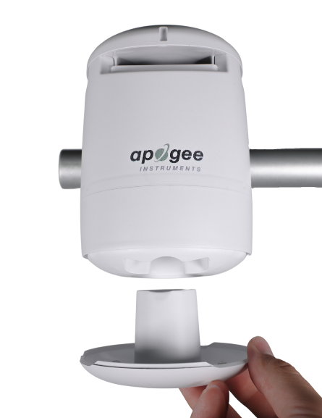
The Guardian comes with a separate module used to measure CO₂, humidity, and pressure. This module is aspirated by a passive, low velocity airstream using a “fluid entrainment” principle. The low airflow will keep the module relatively free of debris or contamination. It is recommended to utilize the fan control functionality when fogging with aerosols or chemicals to temporarily stop airflow and further minimize negative impacts to the module.
As shown to the right, the bottom cover of the Guardian is removable to allow access to the module. If necessary, it can be easily removed and replaced with a new, pre-calibrated module.

FAN
The internal fan is rugged with an IP rating of IP55 and should remain operational for many years. Ensure there is adequate space underneath the Guardian. Covering the bottom of the Guardian will stress the fan and reduce the accuracy of the measurements.

Troubleshooting and Customer Support
Power Interruptions during Bluetooth Data Logging
If a power outage occurs or the Guardian is unplugged, connect via the mobile app as soon as possible to ensure that the internal time is accurate for Bluetooth data logging. The internal clock can track time for a few days when the Guardian is not powered, but it runs fast by about three minutes per hour. If the Guardian goes too long without power, the time will be lost requiring a Bluetooth connection to set the time and restart data logging.
Cable Length
When the sensor is connected to a measurement device with high input impedance, sensor output signals are not changed by shortening the cable or splicing on additional cable in the field. Tests have shown that if the input impedance of the measurement device is greater than 1 mega-ohm there is negligible effect on the calibration, even after adding up to 100 m of cable. All Apogee sensors use shielded, twisted-pair cable to minimize electromagnetic interference. For best measurements, the shield wire must be connected to an earth ground. This is particularly important when using the sensor with long lead lengths in electromagnetically noisy environments.
Modifying Cable Length
See Apogee webpage for details on how to extend sensor cable length:
(http://www.apogeeinstruments.com/how-to-make-a-weatherproof-cable-splice/).
Using Separate Power and Communication Devices
In differential signaling, a sufficiently high or low voltage must be reached in order to be detected as a valid signal. If there is not a common ground between the power and communication source when using RS-485, those thresholds may not be met. If you experience communication issues while using this set up, bridge a ground wire between the Modbus device and the communication system.
Similarly, if there is no ground connection between devices when using RS-232, there may still be communication failures. If this occurs, establish a ground connection between the sensor and the host device.
FAQs
See Apogee FAQ webpage for more troubleshooting support:
https://www.apogeeinstruments.com/guardian-faqs/

Return and Warranty Policy

RETURN POLICY
Apogee Instruments will accept returns within 30 days of purchase as long as the product is in new condition (to be determined by Apogee). Returns are subject to a 10 % restocking fee.

WARRANTY POLICY
What is Covered
All products manufactured by Apogee Instruments are warranted to be free from defects in materials and craftsmanship for a period of four (4) years from the date of shipment from our factory. To be considered for warranty coverage an item must be evaluated by Apogee.
Products not manufactured by Apogee (spectroradiometers, chlorophyll content meters, EE08-SS probes) are covered for a period of one (1) year.
What is Not Covered
The customer is responsible for all costs associated with the removal, reinstallation, and shipping of suspected warranty items to our factory.
The warranty does not cover equipment that has been damaged due to the following conditions:
1. Improper installation, use, or abuse.
2. Operation of the instrument outside of its specified operating range.
3. Natural occurrences such as lightning, fire, etc.
4. Unauthorized modification.
5. Improper or unauthorized repair.
Please note that nominal accuracy drift is normal over time. Routine recalibration of sensors/meters is considered part of proper maintenance and is not covered under warranty.
Who is Covered
This warranty covers the original purchaser of the product or other party who may own it during the warranty period.
What Apogee Will Do
At no charge Apogee will:
1. Either repair or replace (at our discretion) the item under warranty.
2. Ship the item back to the customer by the carrier of our choice.
Different or expedited shipping methods will be at the customer’s expense.

How To Return an Item
1. Please do not send any products back to Apogee Instruments until you have received a Return Merchandise Authorization (RMA) number from our technical support department by submitting an online RMA form at www.apogeeinstruments.com/tech-support-recalibration-repairs/. We will use your RMA number for tracking the service item. Call (435) 245-8012 or email techsupport@apogeeinstruments.com with questions.
2. For warranty evaluations, send all RMA sensors and meters back in the following condition: Clean the sensor’s exterior and cord. Do not modify the sensors or wires, including splicing, cutting wire leads, etc. If a connector has been attached to the cable end, please include the mating connector – otherwise the sensor connector will be removed in order to complete the repair/recalibration. Note: When sending back sensors for routine calibration that have Apogee’s standard stainless-steel connectors, you only need to send the sensor with the 30 cm section of cable and one-half of the connector. We have mating connectors at our factory that can be used for calibrating the sensor.
3. Please write the RMA number on the outside of the shipping container.
4. Return the item with freight pre-paid and fully insured to our factory address shown below. We are not responsible for any costs associated with the transportation of products across international borders.
Apogee Instruments, Inc.
721 West 1800 North Logan, UT
84321, USA
5. Upon receipt, Apogee Instruments will determine the cause of failure. If the product is found to be defective in terms of operation to the published specifications due to a failure of product materials or craftsmanship, Apogee Instruments will repair or replace the items free of charge. If it is determined that your product is not covered under warranty, you will be informed and given an estimated repair/replacement cost.

Products Beyond the Warranty Period
For issues with sensors beyond the warranty period, please contact Apogee at techsupport@apogeeinstruments.com to discuss repair or replacement options.

Other Terms
The available remedy of defects under this warranty is for the repair or replacement of the original product, and Apogee Instruments is not responsible for any direct, indirect, incidental, or consequential damages, including but not limited to loss of income, loss of revenue, loss of profit, loss of data, loss of wages, loss of time, loss of sales, accruement of debts or expenses, injury to personal property, or injury to any person or any other type of damage or loss.
This limited warranty and any disputes arising out of or in connection with this limited warranty ("Disputes") shall be governed by the laws of the State of Utah, USA, excluding conflicts of law principles and excluding the Convention for the International Sale of Goods. The courts located in the State of Utah, USA, shall have exclusive jurisdiction over any Disputes.
This limited warranty gives you specific legal rights, and you may also have other rights, which vary from state to state and jurisdiction to jurisdiction, and which shall not be affected by this limited warranty. This warranty extends only to you and cannot be transferred or assigned. If any provision of this limited warranty is unlawful, void, or unenforceable, that provision shall be deemed severable and shall not affect any remaining provisions. In case of any inconsistency between the English and other versions of this limited warranty, the English version shall prevail.
This warranty cannot be changed, assumed, or amended by any other person or agreement
APOGEE INSTRUMENTS, INC. | 721 WEST 1800 NORTH, LOGAN, UTAH 84321, USA
TEL: (435) 792-4700 | FAX: (435) 787-8268 | WEB: APOGEEINSTRUMENTS.COM
Copyright © 2024 Apogee Instruments, Inc.

