

# Owner’s Manual

Net radiometer

Model SN-522-SS

Rev: 17-Oct-2023

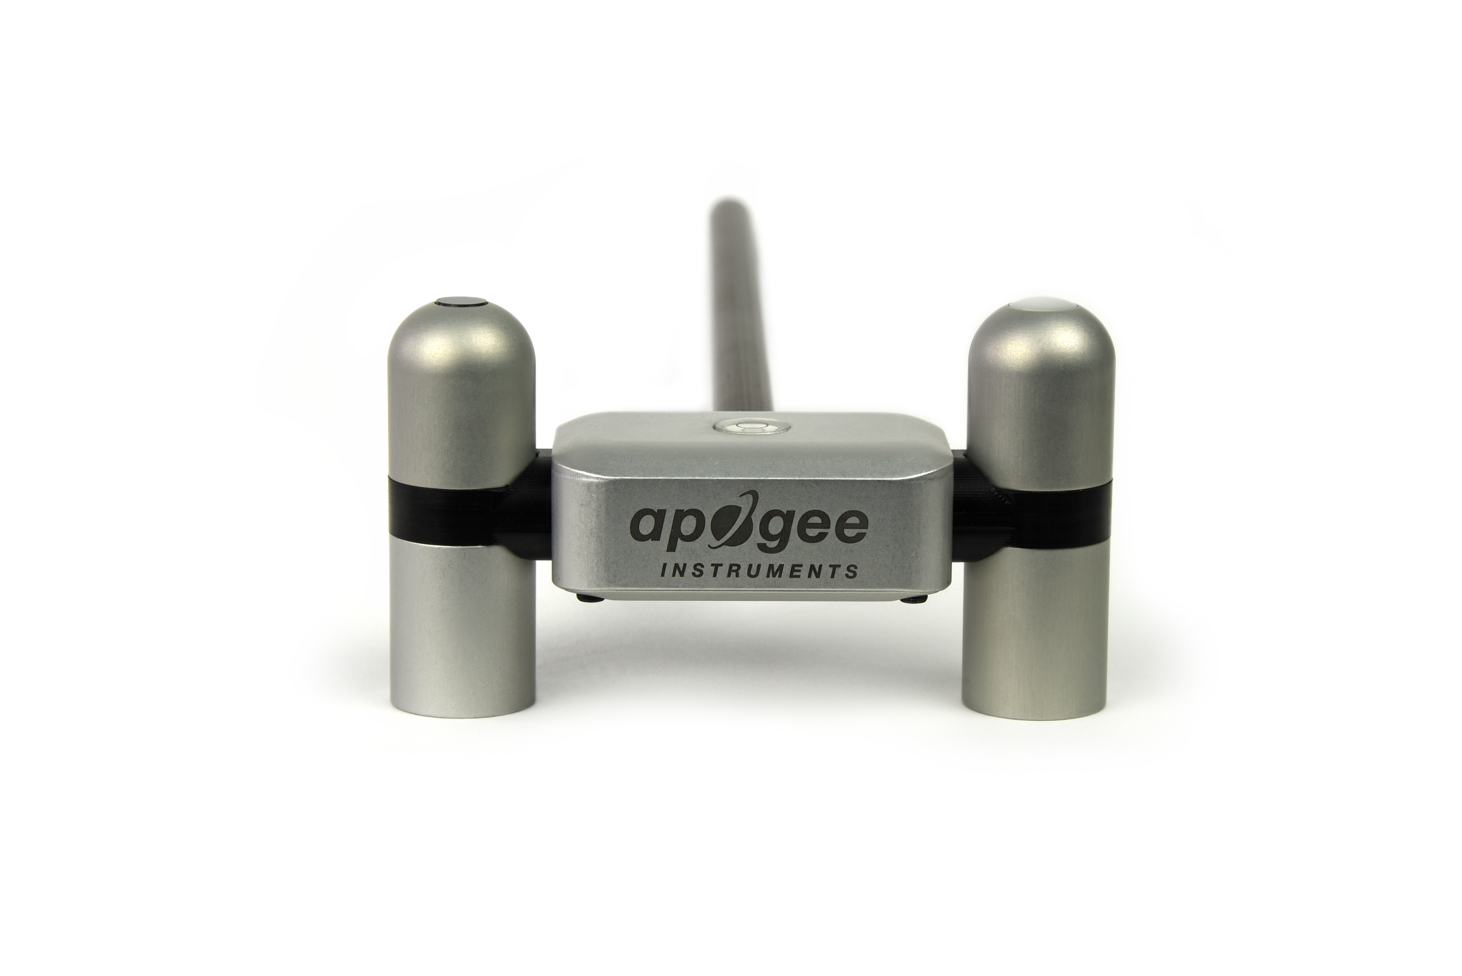

Table of contents

Owner’s Manual 1

Certificates of Compliance 3

Introduction 5

Sensor Models 5

Specifications 7

Deployment and Installation 9

Cable Connectors 10

Operation and Measurement 10

Maintenance and Recalibration 16

Troubleshooting and Customer Support 18

Return and Warranty Policy 19

### Certificate of Compliance

**EU Declaration of Conformity**

This declaration of conformity is issued under the sole responsibility of the manufacturer:

Apogee Instruments, Inc.  
721 W 1800 N  
Logan, Utah 84321  
USA

for the following product(s):

Models: SN-522

Type: Net Radiometer

The object of the declaration described above is in conformity with the relevant Union harmonization legislation:

2014/30/EU Electromagnetic Compatibility (EMC) Directive

2011/65/EU Restriction of Hazardous Substances (RoHS 2) Directive

2015/863/EU Amending Annex II to Directive 2011/65/EU (RoHS 3)

Standards referenced during compliance assessment:

EN 61326-1:2013 Electrical equipment for measurement, control, and laboratory use – EMC requirements

EN 63000:2018 Technical documentation for the assessment of electrical and electronic products with respect to the restriction of hazardous substances

Please be advised that based on the information available to us from our raw material suppliers, the products manufactured by us do not contain, as intentional additives, any of the restricted materials including lead (see note below), mercury, cadmium, hexavalent chromium, polybrominated biphenyls (PBB), polybrominated diphenyls (PBDE), bis (2-ethylhexyl) phthalate (DEHP), butyl benzyl phthalate (BBP), dibutyl phthalate (DBP), and diisobutyl phthalate (DIBP). However, please note that articles containing greater than 0.1 % lead concentration are RoHS 3 compliant using exemption 6c.

Further note that Apogee Instruments does not specifically run any analysis on our raw materials or end products for the presence of these substances, but we rely on the information provided to us by our material suppliers.

Signed for and on behalf of:

Apogee Instruments, October 2023



Bruce Bugbee  
President  
Apogee Instruments, Inc.

### Certificate of Compliance

**UK Declaration of Conformity**

This declaration of conformity is issued under the sole responsibility of the manufacturer:

Apogee Instruments, Inc.  
721 W 1800 N  
Logan, Utah 84321  
USA

for the following product(s):

Models: SN-522

Type: Net Radiometer

The object of the declaration described above is in conformity with the relevant UK Statutory Instruments and their amendments:

2016 No. 1091 The Electromagnetic Compatibility Regulations 2016

2012 No. 3032 The Restriction of the Use of Certain Hazardous Substances in Electrical and Electronic Equipment Regulations 2012

Standards referenced during compliance assessment:

BS EN 61326-1:2013 Electrical equipment for measurement, control, and laboratory use – EMC requirements

BS EN 63000:2018 Technical documentation for the assessment of electrical and electronic products with respect to the restriction of hazardous substances

Please be advised that based on the information available to us from our raw material suppliers, the products manufactured by us do not contain, as intentional additives, any of the restricted materials including lead (see note below), mercury, cadmium, hexavalent chromium, polybrominated biphenyls (PBB), polybrominated diphenyls (PBDE), bis (2-ethylhexyl) phthalate (DEHP), butyl benzyl phthalate (BBP), dibutyl phthalate (DBP), and diisobutyl phthalate (DIBP). However, please note that articles containing greater than 0.1 % lead concentration are RoHS 3 compliant using exemption 6c.

Further note that Apogee Instruments does not specifically run any analysis on our raw materials or end products for the presence of these substances, but we rely on the information provided to us by our material suppliers.

Signed for and on behalf of:

Apogee Instruments, October 2023



Bruce Bugbee  
President  
Apogee Instruments, Inc.

### Introduction

Net radiation at Earth’s surface is the source of available energy that drives key processes, including surface and atmospheric heating, evaporation, sublimation, and transpiration. Shortwave radiation (approximately 280 to 4000 nm) is emitted by the sun, and a fraction incident at Earth’s surface is reflected. Longwave radiation (approximately 4000 to 100 000 nm) is emitted by molecules in the atmosphere and land surfaces. Net radiation is the difference between incoming (downwelling) and outgoing (upwelling) shortwave and longwave radiation. Net radiation at Earth’s surface is spatially and temporally variable due to changes in position of the sun with respect to Earth’s surface, changes in atmospheric conditions, and differences in land surface conditions. Shortwave radiation accounts for a larger proportion of net radiation during the day when the sun is shining. Longwave radiation contributes to net radiation during the day and at night.

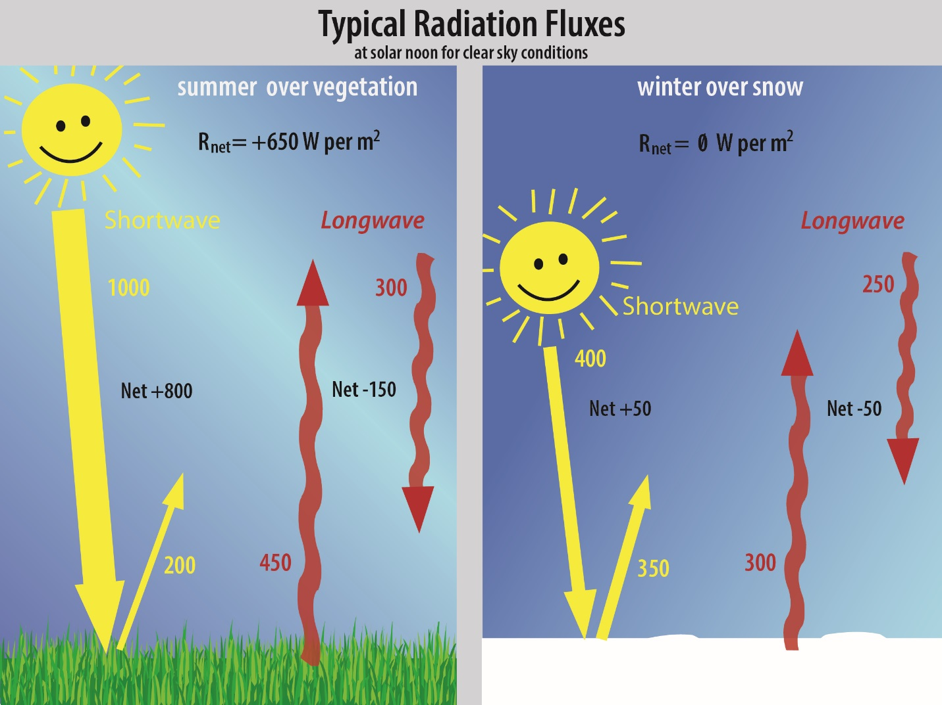Typical values of the four components of net radiation (Rnet) for a clear summer day near solar noon over vegetation and a clear winter day near solar noon over snow are shown in the figure below (all units are W m-2). Net shortwave radiation is the difference between incoming shortwave (from sun, SWi) and outgoing shortwave (reflected by surface, SWo). Net longwave radiation is the difference between incoming longwave (emitted by molecules in the atmosphere, LWi) and outgoing longwave (emitted by elements at the surface, LWo). Net radiation is the sum of net shortwave and net longwave radiation. Net radiation changes with solar zenith angle, atmospheric conditions (e.g., degree of cloudiness), and surface conditions (e.g., bare soil, plant cover, snow).

Net radiometers are instruments designed to measure net radiation. Typical applications of net radiometers include measurement of net radiation on surface flux towers and weather stations. Net radiation is a key variable in the surface energy balance and influences turbulent fluxes, including evapotranspiration.

Apogee Instruments model SN-522 net radiometers are four-component instruments, with individual upward- and downward-looking pyranometers and pyrgeometers. Each radiometer consists of a thermopile detector and filter mounted in an anodized aluminum housing. Each radiometer is heated to minimize the effects of dew, frost, snow, and ice on the filter and sensor head. Analog signals from each radiometer are measured with an onboard voltmeter and converted to a digital value. That value can then be accessed via a Modbus RTU interface over an RS-232 or RS-485 serial connection. This eliminates the need for multiple analog datalogger channels to make the four-component measurement of net radiation. SN-522 net radiometers are small and lightweight to facilitate rapid and simple mounting.

### Sensor Models

This manual covers the Modbus RTU communication protocol, net radiometer model SN-522 (in bold below). Additional models are covered in their respective manuals.

|  |  |
| --- | --- |
| Model | Signal |
| SN-522 | **Modbus** |
| SN-500 | SDI-12 |

Apogee Instruments’ four-component net radiometer consists of an upward-looking (model SP-510) and downward-looking (model SP-610) pyranometer (to measure shortwave radiation), and an upward-looking (model SL-510) and downward-looking (model SL-610) pyrgeometer to measure longwave radiation). Each of the individual sensors are available as stand-alone sensors.

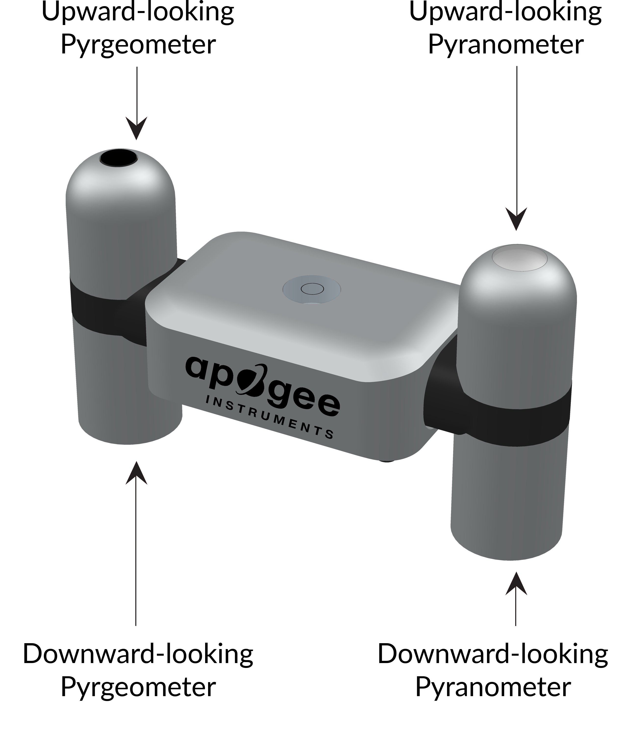

A sensor’s name and model number are located near the pigtail leads on the sensor cable.

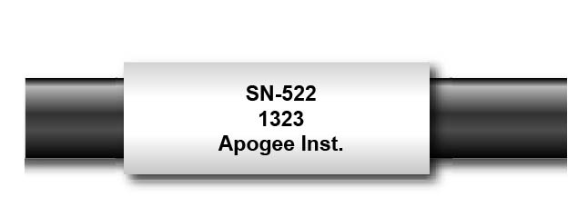

### Specifications

**Pyranometer (Shortwave Radiation) SP-510 and SP-610**

|  |  |  |  |
| --- | --- | --- | --- |
|  | **SP-510-SS (Upward-looking)** | **SP-610-SS (Downward-looking)** | |
| Sensitivity (variable from sensor to sensor, typical values listed) | 0.045 mV per W m-2 | 0.035 mV per W m-2 | |
| Calibration Factor (Reciprocal of Sensitivity) | 22 W m-2 per mV | 28.5 W m-2 per mV | |
| Calibration Uncertainty | Less than 3 % at 1000 W m-2 (see Calibration Traceability below) | | |
| Output Range (Variable from sensor to sensor) | 0 to 90 mV | | 0 to 70 mV |
| Measurement Range | 0 to 2000 W m-2 (shortwave irradiance) | | |
| Measurement Repeatability | Less than 1 % | | |
| Long-term Drift (Non-stability) | Less than 2 % per year | | |
| Non-linearity | Less than 1 % | | |
| Detector Response Time | 0.5 seconds | | |
| Field of View | 180° | 150° | |
| Spectral Range (wavelengths where response is 50% of maximum) | 385 to 2105 nm | 295 to 2685 nm | |
| Directional (Cosine) Response | Less than 30 W m-2 at 80° solar zenith | | Less than 20% for angles between 0 and 60° |
| Temperature Response | Less than 5 % from -15 to 45 C | | |
| Zero Offset A | Less than 5 W m-2; Less than 10 W m-2 (heated) | | |
| Zero Offset B | Less than 5 W m-2 | | |
| Uncertainty in Daily Total | Less than 5 % | | |

**Calibration Traceability**

Apogee Instruments SP-510 and SP-610 pyranometers are calibrated through side-by-side comparison to the mean of four Apogee model SP-510 transfer standard pyranometers (shortwave radiation reference for upward-looking pyranometer on net radiometer) or to the mean of four Apogee model SP-610 transfer standard pyranometers (shortwave radiation reference for downward-looking pyranometer on net radiometer) under high intensity discharge metal halide lamps. The transfer standard pyranometers are calibrated through side-by-side comparison to the mean of at least two ISO-classified reference pyranometers under sunlight (clear sky conditions) in Logan, Utah. Each of four ISO-classified reference pyranometers are recalibrated on an alternating year schedule (two instruments each year) at the National Renewable Energy Laboratory (NREL) in Golden, Colorado. NREL reference standards are calibrated to the World Radiometric Reference (WRR).

**Pyrgeometers (Longwave Radiation) SL-510 and SL-610**

|  |  |  |
| --- | --- | --- |
|  | **SL-510-SS (upward-looking)** | **SL-610-SS (downward-looking)** |
| Sensitivity | 0.12 mV per W m-2 (variable from sensor to sensor, typical value listed) | |
| Calibration Factor  (Reciprocal of Sensitivity) | 8.5 W m-2 per mV (variable from sensor to sensor, typical value listed) | |
| Calibration Uncertainty | ± 5 % | |
| Measurement Range | -200 to 200 W m-2 (net longwave irradiance) | |
| Measurement Repeatability | Less than 1 % | |
| Long-term Drift (Non-stability) | Less than 2 % change in sensitivity per year | |
| Non-linearity | Less than 1 % | |
| Detector Response Time | Less than 0.5 seconds | |
| Field of View | 150° | |
| Spectral Range | 5 to 30 µm | |
| Temperature Response | Less than 5% from -15 to 45 C | |
| Window Heating Offset | Less than 10 W m-2 | |
| Zero Offset B | Less than 5 W m-2 | |
| Tilt Error | Less than 0.5 % | |
| Uncertainty in Daily Total | ± 5 % | |
| Temperature Sensor | 30 kΩ thermistor, ± 1 C tolerance at 25 C | |
| Output from Thermistor | 0 to 2500 mV (typical, other voltages can be used) | |
| Input Voltage Requirement for Thermistor | 2500 mV excitation (typical, other voltages can be used) | |

**Calibration Traceability**

Apogee SL-510 and SL-610 pyrgeometers are calibrated against the mean of at least two Apogee model SL-510 transfer standard pyrgeometers inside a custom blackbody cone held at multiple fixed temperatures over a range of radiometer (detector and sensor body) temperatures. The temperature of the blackbody cone is measured with replicate precision thermistors thermally bonded to the cone surface. The transfer standard pyrgeometers are calibrated against the mean of least two reference upward-looking pyrgeometers under all sky conditions in Logan, Utah. Each of the two reference pyrgeometers are recalibrated on an alternating year schedule (one instrument per year) at the National Renewable Energy Laboratory (NREL) in Golden, Colorado. NREL reference standards are calibrated to the World Infrared Standard Group (WISG) in Davos, Switzerland.

**Net Radiometer**

|  |  |
| --- | --- |
|  | **SN-500-SS** |
| Input voltage Range | 5.5 to 24 V DC (heaters are optimized to run at 12 V DC) |
| Average Max Current Draw (12 V DC power) | Heaters on: 72 mA;  Heaters off: 13.5 mA |
| Response Time | It takes 750 ms to digitize all detector signals |
| Heaters (4 sensors individually heated) | 62 mA current draw and 740 mW power requirement at 12 V DC |
| Operating Environment | -50 to 80 C; 0 to 100 % relative humidity |
| Dimensions | 116 mm length, 45 mm width, 66 mm height |
| Mass | 320 g ( with mounting rod and 5 m of lead wire) |
| Cable | M8 connector (IP68 rating) to interface to sensor housing, 5 m of four conductor, shielded, twisted-pair wire, TPR jacket (high water resistance, high UV stability, flexibility in cold conditions), pigtail lead wires |

### Deployment and Installation

An Apogee Instruments model AM-500 mounting bracket can be used to mount the net radiometer to a cross arm.

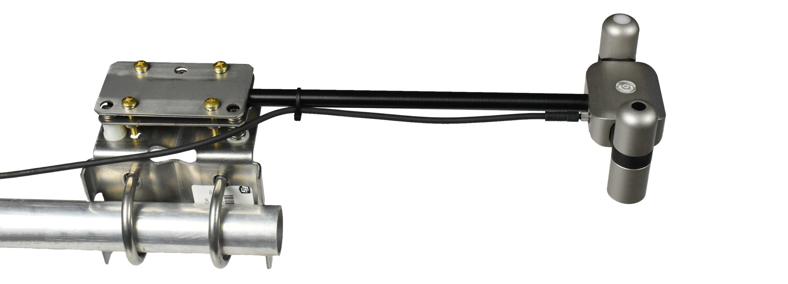

To minimize azimuth error, the sensor should be mounted with the cable pointing toward true north in the northern hemisphere or true south in the southern hemisphere. Azimuth error is typically less than 0.5 %, but it is easy to minimize by proper cable orientation.

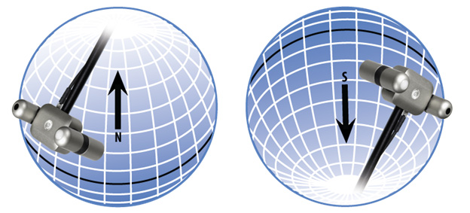

In addition to orienting the cable to point toward the nearest pole, the sensor should also be mounted such that obstructions (e.g., weather station tripod/tower or other instrumentation) do not shade the sensor. **Once mounted, the green caps should be removed from the sensor.** The green caps can be used as a protective covering for the sensor when it is not in use.

### Cable Connectors

|  |  |
| --- | --- |
| Apogee sensors offer cable connectors to simplify the process of removing sensors from weather stations for calibration (the entire cable does **not** have to be removed from the station and shipped with the sensor).  The ruggedized M8 connectors are rated IP68, made of corrosion-resistant marine-grade stainless-steel, and designed for extended use in harsh environmental conditions. | Cable connectors are attached directly to the head. |

**Instructions**

|  |  |
| --- | --- |
| **Pins and Wiring Colors:** All Apogee connectors have six pins, but not all pins are used for every sensor. There may also be unused wire colors inside the cable. To simplify datalogger connection, we remove the unused pigtail lead colors at the datalogger end of the cable.  If a replacement cable is required, please contact Apogee directly to ensure ordering the proper pigtail configuration.  **Alignment:** When reconnecting a sensor, arrows on the connector jacket and an aligning notch ensure proper orientation.  **Disconnection for extended periods:**  When disconnecting the sensor for an extended period of time from a station, protect the remaining half of the connector still on the station from water and dirt with electrical tape or other method. | A reference notch inside the connector ensures  proper alignment before tightening.      Finger-tighten firmly |
| **Tightening:** Connectors are designed to be firmly finger-tightened only. There is an o-ring inside the connector that can be overly compressed if a wrench is used. Pay attention to thread alignment to avoid cross-threading. When fully tightened, 1-2 threads may still be visible.  **\*NOTE:** To avoid damaging the pins inside the connector, finger-tighten the connector by only turning the **metal** nut (see blue arrows). Do not tighten by turning the black cable. |  |

### Operation and Measurement

The SN-522 has a Modbus output, where the four components of net radiation, along with net values (net shortwave, net longwave, and net radiation), are returned in digital format. Measurement of SN-522 net radiometers requires a measurement device with a Modbus interface that supports the Read Holding Registers (0x03) function.­­­

**Wiring**

**White**: RS-232 RX / RS-485 Positive

**Blue**: RS-232 TX / RS-485 Negative

**Green**: Select (Switch between RS-232 and RS-485)

**Black**: Ground

**Red**: Power +12 V

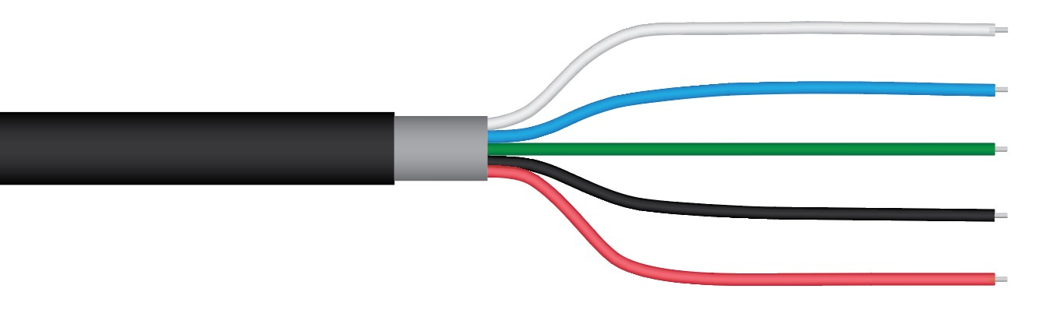  
The Green wire should be connected to Ground to enable RS-485 communication, or it should be connected to 12 V power for RS-232 communication. Text for the White and Blue wires above refers to the port that the wires should be connected to.

**Sensor Calibration**

All Apogee Modbus net radiometers (model SN-522) have sensor-specific calibration coefficients determined during the custom calibration process. Coefficients are programmed into the sensors at the factory.

**Modbus Interface**

The following is a brief explanation of the Modbus protocol instructions used in Apogee SN-522 net radiometers. For questions on the implementation of this protocol, please refer to the official serial line implementation of the Modbus protocol: <http://www.modbus.org/docs/Modbus_over_serial_line_V1_02.pdf> (2006) and the general Modbus protocol specification: <http://www.modbus.org/docs/Modbus_Application_Protocol_V1_1b3.pdf> (2012). Further information can be found at: <http://www.modbus.org/specs.php>

**Overview**

The primary idea of the Modbus interface is that each sensor exists at an address and appears as a table of values. These values are called Registers. Each value in the table has an associated index, and that index is used to identify which value in the table is being accessed.   
  
**Sensor addresses**

Each sensor is given an address from 1 to 247. Apogee sensors are shipped with a default address of 1. If using multiple sensors on the same Modbus line, the sensor’s address will have to be changed by writing the Slave Address register.

**Register Index**

Each register in a sensor represents a value in the sensor, such as a measurement or a configuration parameter. Some registers can only be read, some registers can only be written, and some can be both read and written. Each register exists at a specified index in the table for the sensor. Often this index is called an address, which is a separate address than the sensor address, but can be easily confused with the sensor address.

However, there are two different indexing schemes used for Modbus sensors, though translating between them is simple. One indexing scheme is called one-based numbering, where the first register is given the index of 1, and is thereby accessed by requesting access to register 1. The other indexing scheme is called zero-based numbering, where the first register is given the index 0, and is thereby accessed by requesting access to register 0. Apogee Sensors use zero-based numbering. However, if using the sensor in a system that uses one-based numbering, such as using a CR1000X logger, adding 1 to the zero-based address will produce the one-based address for the register.

**Register Format:**

According to the Modbus protocol specification, Holding Registers (the type registers Apogee sensors contain) are defined to be 16 bits wide. However, when making scientific measurements, it is desirable to obtain a more precise value than 16 bits allows. Thus, several Modbus implementations will use two 16-bit registers to act as one 32-bit register. Apogee Modbus sensors use this 32-bit implementation to provide measurement values as 32-bit IEEE 754 floating point numbers.

Apogee Modbus sensors also contain a redundant, duplicate set of registers that use 16-bit signed integers to represent values as decimal-shifted numbers. It is recommended to use the 32-bit values, if possible, as they contain more precise values.

**Communication Parameters:**

Apogee Sensors communicate using the Modbus RTU variant of the Modbus protocol. The default communication parameters are as follows:

Slave address: 1

Baudrate: 19200

Data bits: 8

Stop bits: 1

Parity: Even

Byte Order: Big-Endian (most significant byte sent first)

The baudrate and slave address are user configurable. **Valid slave addresses are 1 to 247. Since the address 0 is reserve as the broadcast address, setting the slave address to 0 will actually set the slave address to 1.** (This will also reset factory-calibrated values and should **NOT** be done by the user unless otherwise instructed.)

**Read only registers (function code 0x3).**

|  |  |
| --- | --- |
| **Float Registers** | |
| 0  1 | calibrated shortwave up output Watts |
| 2  3 | calibrated shortwave down output Watts |
| 4  5 | calibrated longwave up output Watts |
| 6  7 | calibrated longwave down output Watts |
| 8  9 | shortwave net Watts |
| 10  11 | longwave net Watts |
| 12  13 | total net radiation |
| 14  15 | albedo |
| 16  17 | shortwave up millivolts |
| 18  19 | shortwave down millivolts |
| 20  21 | longwave up millivolts |
| 22  23 | longwave down millivolts |
| 24  25 | longwave up temperature |
| 26  27 | longwave down temperature |
| 28  29 | Reserved for Future Use |
| 30  31 | device status  (1 means device is busy, 0 otherwise) |
| 32  33 | firmware version |
| **Integer Registers** | |
| 70 | calibrated shortwave up Watts (shifted one decimal point to the left) |
| 71 | calibrated shortwave down Watts (shifted one decimal point to the left) |
| 72 | calibrated longwave up Watts (shifted one decimal point to the left) |
| 73 | calibrated longwave down Watts (shifted one decimal point to the left) |
| 74 | shortwave net Watts |
| 75 | longwave net Watts |
| 76 | total net radiation |
| 77 | albedo |
| 78 | shortwave up millivolts |
| 79 | shortwave down millivolts |
| 80 | longwave up millivolts |
| 81 | longwave down millivolts |
| 82 | longwave up temperature |
| 83 | longwave down temperature |
| 81 | Reserved for Future Use |
| 85 | device status (1 means device is busy, 0 otherwise) |
| 86 | firmware version (shifted one decimal point to the left) |

**Read/Write registers (function codes 0x3 and 0x10).**

|  |  |
| --- | --- |
| **Float Registers** | |
| 40  41 | slave address |
| 42  43 | model number* |
| 44  45 | serial number* |
| 46  47 | Baudrate (0 = 115200, 1 = 57600, 2 = 38400, 3 = 19200, 4 = 9600, writes of any number other than 0, 1, 2, 3, or 4 are ignored |
| 48  49 | parity (0 = none, 1 = odd, 2 = even) |
| 50  51 | number of stopbits |
| 52  53 | longwave up multiplier* |
| 54  55 | longwave up offset* |
| 56  57 | longwave down multiplier* |
| 58  59 | longwave down offset* |
| 60  61 | shortwave up multiplier* |
| 62  63 | shortwave down multiplier* |
| 64  65 | running average |
| 66  67 | heater on/off |
| **Integer Registers** | |
| 90 | slave address |
| 91 | model number* |
| 92 | serial number* |
| 93 | baudrate (0 = 115200, 1 = 57600, 2 = 38400, 3 = 19200, 4 = 9600, writes of any number other than 0, 1, 2, 3, or 4 are ignored |
| 94 | parity (0 = none, 1 = odd, 2 = even) |
| 95 | number of stopbits |
| 96 | longwave up multiplier (shifted two decimal points to the left)* |
| 97 | longwave up offset (shifted two decimal points to the left)* |
| 98 | longwave down multiplier (shifted two decimal points to the left)* |
| 99 | longwave down offset (shifted two decimal points to the left)* |
| 100 | shortwave up multiplier (shifted two decimal points to the left)* |
| 101 | shortwave down multiplier (shifted two decimal points to the left)* |
| 102 | running average |
| 103 | heater on/off |

**\*Registers marked with an asterisk (*) cannot be written to unless a specific procedure is followed. Contact Apogee Instruments to receive the procedure for writing these registers.**

**Write only registers (function code 0x10).**

|  |  |
| --- | --- |
| **Integer Registers** | |
| 190 | Writing to this register resets Coefficients to firmware defaults. (NOT factory calibrated values!) Slave Address = 1, Model = 522, Serial = 1000, Baud = 3, Parity = 2, Stopbits = 1, running average = 1 |

**Packet Framing:**

Apogee Sensors use Modbus RTU packets and tend to adhere to the following pattern:

Slave Address (1 byte), Function Code (1 byte), Starting Address (2 bytes), Number of Registers (2 bytes), Data Length (1 byte, optional) Data (n bytes, optional)

Modbus RTU packets use the zero-based address when addressing registers.

For information on Modbus RTU framing, see the official documentation at <http://www.modbus.org/docs/Modbus_Application_Protocol_V1_1b3.pdf>

**Example Packets:**

An example of a data packet sent from the controller to the sensor using function code 0x3 reading register address 0.Each pair of square brackets indicates one byte.

[Slave Address][Function][Starting Address High Byte][Starting Address Low Byte][No of Registers High Byte][No of Registers Low Byte][CRC High Byte][CRC Low Byte]

0x01 0x03 0x00 0x00 0x00 0x02 0xC4 0x0B

An example of a data packet sent from the controller to the sensor using function code 0x10 writing a 1 to register 26. Each pair of square brackets indicates one byte.

[Slave Address][Function][Starting Address High Byte][Starting Address Low Byte][No of Registers High Byte][No of Registers Low Byte][Byte Count][Data High Byte][Data Low Byte][Data High Byte][Data Low Byte][CRC High Byte][CRC Low Byte]

0x01 0x10 0x00 0x1A 0x00 0x02 0x04 0x3f 0x80 0x00 0x00 0x7f 0x20.

### Maintenance and Recalibration

Moisture or debris on the filters (diffuser for upward-looking pyranometer, glass window for downward-looking pyranometer, silicon windows for pyrgeometers) is a common cause of errors. The upward-looking sensors have a domed housing for improved self-cleaning from rainfall, but materials can accumulate on the diffuser or window (e.g., dust during periods of low rainfall, salt deposits from evaporation of sea spray or sprinkler irrigation water) and partially block the optical path. Materials can also accumulate on the downward-looking detectors. Dust or organic deposits are best removed using water or window cleaner and a soft cloth or cotton swab. Salt deposits should be dissolved with vinegar and removed with a soft cloth or cotton swab. **Never use an abrasive material or cleaner on the diffuser.**

Although Apogee sensors are very stable, nominal accuracy drift is normal for all research-grade sensors. To ensure maximum accuracy, we generally recommend sensors are sent in for recalibration every two years, although you can often wait longer according to your particular tolerances.

**Upward-Looking Pyranometer (Shortwave Radiation)**

The Clear Sky Calculator ([www.clearskycalculator.com](http://www.clearskycalculator.com)) can be used to determine the need for pyranometer recalibration. It determines total shortwave radiation incident on a horizontal surface at any time of day at any location in the world. It is most accurate when used near solar noon in spring and summer months, where accuracy over multiple clear and unpolluted days is estimated to be ± 4 % in all climates and locations around the world. For best accuracy, the sky must be completely clear, as reflected radiation from clouds causes incoming radiation to increase above the value predicted by the clear sky calculator. Measured values of total shortwave radiation can exceed values predicted by the Clear Sky Calculator due to reflection from thin, high clouds and edges of clouds, which enhances incoming shortwave radiation. The influence of high clouds typically shows up as spikes above clear sky values, not a constant offset greater than clear sky values.

To determine recalibration need, input site conditions into the calculator and compare total shortwave radiation measurements to calculated values for a clear sky. If sensor shortwave radiation measurements over multiple days near solar noon are consistently different than calculated values (by more than 6 %), the sensor should be cleaned and re-leveled. If measurements are still different after a second test, email [calibration@apogeeinstruments.com](mailto:calibration@apogeeinstruments.com) to discuss test results and possible return of sensor(s).

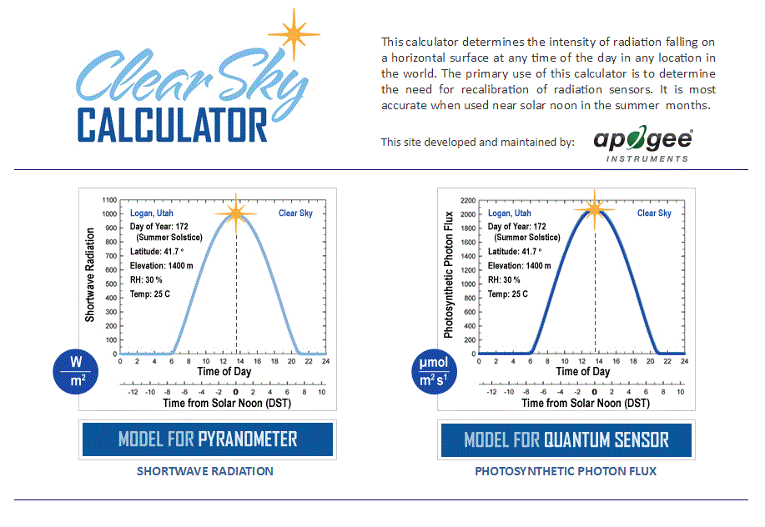

Homepage of the Clear Sky Calculator. Two calculators are available: One for pyranometers (total shortwave radiation) and one for quantum sensors (photosynthetic photon flux density).

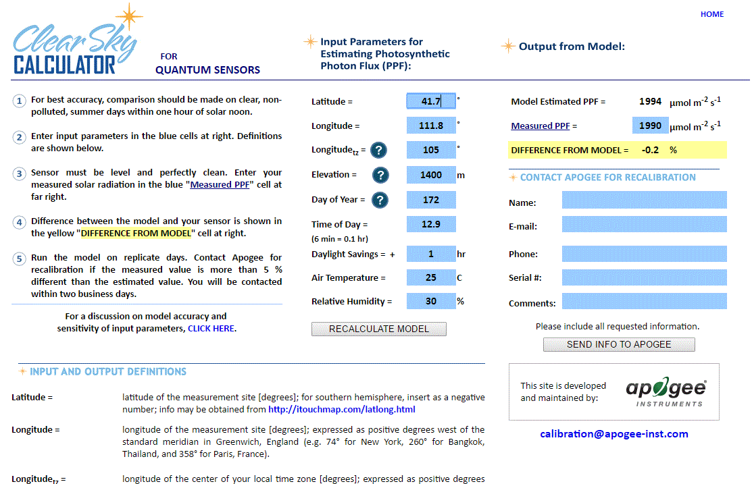

Clear Sky Calculator for pyranometers. Site data are input in blue cells in middle of page and an estimate of total shortwave radiation is returned on right-hand side of page.

### Troubleshooting and Customer Support

**Independent Verification of Functionality**

If the sensor does not communicate with the datalogger, use an ammeter to check the current drain. It should be near 37 mA when the sensor is powered. Any current drain significantly greater than approximately 37 mA indicates a problem with power supply to the sensors, wiring of the sensor, or sensor electronics.

**Compatible Measurement Devices (Dataloggers/Controllers/Meters)**

Any datalogger or meter with RS-232/RS-485 that can read/write float or integer values.

An example datalogger program for Campbell Scientific dataloggers can be found on the Apogee webpage at <http://www.apogeeinstruments.com/downloads/#datalogger>.

**Cable Length**

All Apogee sensors use shielded cable to minimize electromagnetic interference. For best communication, the shield wire must be connected to an earth ground. This is particularly important when using the sensor with long lead lengths in electromagnetically noisy environments.

**RS-232 Cable Length**

If using an RS-232 serial interface, the cable length from the sensor to the controller should be kept short, no longer than 20 meters. For more information, see section 3.3.5 in this document: <http://www.modbus.org/docs/Modbus_over_serial_line_V1_02.pdf>  
  
**RS-485 Cable Length**

If using an RS-485 serial interface, longer cable lengths may be used. The trunk cable can be up to 1000 meters long. The length of cable from the sensor to a tap on the trunk should be short, no more than 20 meters. For more information, see section 3.4 in this document: <http://www.modbus.org/docs/Modbus_over_serial_line_V1_02.pdf>

**Troubleshooting Tips**

* Make sure to use the green wire to select between RS-232 and RS-485.
* Make sure that the sensor is wired correctly (refer to wiring diagram).
* Make sure the sensor is powered by a power supply with a sufficient output (e.g., 12 V).
* Make sure to use the appropriate kind of variable when reading Modbus registers. Use a float variable for float registers and an integer variable for integer registers.
* Make sure the baudrate, stop bits, parity, byte order, and protocols match between the control program and the sensor. Default values are:
  + Baudrate: 19200
  + Stop bits: 1
  + Parity: Even
  + Byte order: ABCD (Big-Endian/Most Significant Byte First)
  + Protocol: RS-232 or RS-485

### Return and Warranty Policy

RETURN POLICY

Apogee Instruments will accept returns within 30 days of purchase as long as the product is in new condition (to be determined by Apogee). Returns are subject to a 10 % restocking fee.

WARRANTY POLICY

**What is Covered**All products manufactured by Apogee Instruments are warranted to be free from defects in materials and craftsmanship for a period of four (4) years from the date of shipment from our factory. To be considered for warranty coverage an item must be evaluated by Apogee.

Products not manufactured by Apogee (spectroradiometers, chlorophyll content meters, EE08-SS probes) are covered for a period of one (1) year.

**What is Not Covered**The customer is responsible for all costs associated with the removal, reinstallation, and shipping of suspected warranty items to our factory.

The warranty does not cover equipment that has been damaged due to the following conditions:

1. Improper installation, use, or abuse.

2. Operation of the instrument outside of its specified operating range.

3. Natural occurrences such as lightning, fire, etc.

4. Unauthorized modification.

5. Improper or unauthorized repair.

Please note that nominal accuracy drift is normal over time. Routine recalibration of sensors/meters is considered part of proper maintenance and is not covered under warranty.

**Who is Covered**This warranty covers the original purchaser of the product or other party who may own it during the warranty period.

**What Apogee Will Do**At no charge Apogee will:

1. Either repair or replace (at our discretion) the item under warranty.

2. Ship the item back to the customer by the carrier of our choice.

Different or expedited shipping methods will be at the customer’s expense.

**How To Return An Item**1. Please do not send any products back to Apogee Instruments until you have received a Return Merchandise Authorization (RMA) number from our technical support department by submitting an online RMA form at [www.apogeeinstruments.com/tech-support-recalibration-repairs/](http://www.apogeeinstruments.com/tech-support-recalibration-repairs/). We will use your RMA number for tracking of the service item. Call (435) 245-8012 or email techsupport@apogeeinstruments.com with questions.

2. For warranty evaluations, send all RMA sensors and meters back in the following condition: Clean the sensor’s exterior and cord. Do not modify the sensors or wires, including splicing, cutting wire leads, etc. If a connector has been attached to the cable end, please include the mating connector – otherwise the sensor connector will be removed in order to complete the repair/recalibration. ***Note:*** *When sending back sensors for routine calibration that have Apogee’s standard stainless-steel connectors, you only need to send the sensor with the 30 cm section of cable and one-half of the connector. We have mating connectors at our factory that can be used for calibrating the sensor.*

3. Please write the RMA number on the outside of the shipping container.

4. Return the item with freight pre-paid and fully insured to our factory address shown below. We are not responsible for any costs associated with the transportation of products across international borders.

**Apogee Instruments, Inc.   
721 West 1800 North Logan, UT  
84321, USA**

5. Upon receipt, Apogee Instruments will determine the cause of failure. If the product is found to be defective in terms of operation to the published specifications due to a failure of product materials or craftsmanship, Apogee Instruments will repair or replace the items free of charge. If it is determined that your product is not covered under warranty, you will be informed and given an estimated repair/replacement cost.

Products Beyond the Warranty Period

For issues with sensors beyond the warranty period, please contact Apogee at [techsupport@apogeeinstruments.com](mailto:techsupport@apogeeinstruments.com) to discuss repair or replacement options.

Other Terms

The available remedy of defects under this warranty is for the repair or replacement of the original product, and Apogee Instruments is not responsible for any direct, indirect, incidental, or consequential damages, including but not limited to loss of income, loss of revenue, loss of profit, loss of data, loss of wages, loss of time, loss of sales, accruement of debts or expenses, injury to personal property, or injury to any person or any other type of damage or loss.

This limited warranty and any disputes arising out of or in connection with this limited warranty ("Disputes") shall be governed by the laws of the State of Utah, USA, excluding conflicts of law principles and excluding the Convention for the International Sale of Goods. The courts located in the State of Utah, USA, shall have exclusive jurisdiction over any Disputes.

This limited warranty gives you specific legal rights, and you may also have other rights, which vary from state to state and jurisdiction to jurisdiction, and which shall not be affected by this limited warranty. This warranty extends only to you and cannot by transferred or assigned. If any provision of this limited warranty is unlawful, void, or unenforceable, that provision shall be deemed severable and shall not affect any remaining provisions. In case of any inconsistency between the English and other versions of this limited warranty, the English version shall prevail.

This warranty cannot be changed, assumed, or amended by any other person or agreement

**APOGEE INSTRUMENTS, INC. |** 721 WEST 1800 NORTH, LOGAN, UTAH 84321, USA

TEL: (435) 792-4700 | FAX: (435) 787-8268 | WEB: APOGEEINSTRUMENTS.COM

*Copyright © 2023 Apogee Instruments, Inc.*