

# Owner’s Manual

USB Pyranometer

Models SP-420

Rev: 26-Sept-2022

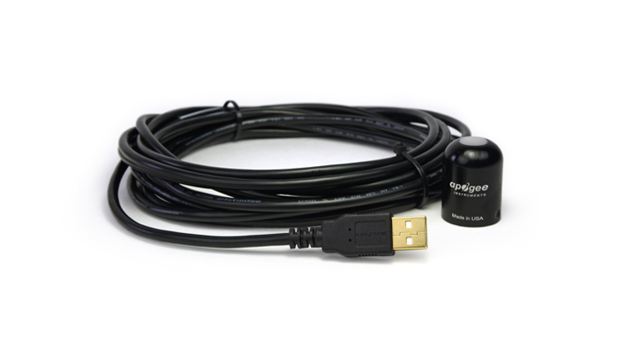

Table of Contents

Owner’s Manual 1

Certificates of Compliance 3

Introduction 5

Sensor Models 6

Specifications 7

Deployment and Installation 10

Software Installation 11

Operation and Measurement 12

Windows Software 14

MAC software 19

Maintenance and Recalibration 25

Troubleshooting and Customer Support 27

Return and Warranty Policy 28

### Certificate of Compliance

**EU Declaration of Conformity**

This declaration of conformity is issued under the sole responsibility of the manufacturer:

Apogee Instruments, Inc.  
721 W 1800 N  
Logan, Utah 84321  
USA

for the following product(s):

Models: SP-420  
Type: Pyranometer

The object of the declaration described above is in conformity with the relevant Union harmonization legislation:

2014/30/EU Electromagnetic Compatibility (EMC) Directive

2011/65/EU Restriction of Hazardous Substances (RoHS 2) Directive

2015/863/EU Amending Annex II to Directive 2011/65/EU (RoHS 3)

Standards referenced during compliance assessment:

EN 61326-1:2013 Electrical equipment for measurement, control, and laboratory use – EMC requirements

EN 63000:2018 Technical documentation for the assessment of electrical and electronic products with respect to the restriction of hazardous substances

Please be advised that based on the information available to us from our raw material suppliers, the products manufactured by us do not contain, as intentional additives, any of the restricted materials including lead (see note below), mercury, cadmium, hexavalent chromium, polybrominated biphenyls (PBB), polybrominated diphenyls (PBDE), bis (2-ethylhexyl) phthalate (DEHP), butyl benzyl phthalate (BBP), dibutyl phthalate (DBP), and diisobutyl phthalate (DIBP). However, please note that articles containing greater than 0.1 % lead concentration are RoHS 3 compliant using exemption 6c.

Further note that Apogee Instruments does not specifically run any analysis on our raw materials or end products for the presence of these substances, but we rely on the information provided to us by our material suppliers.

Signed for and on behalf of:

Apogee Instruments, September 2022



Bruce Bugbee  
President  
Apogee Instruments, Inc.

### Certificate of Compliance

**UK Declaration of Conformity**

This declaration of conformity is issued under the sole responsibility of the manufacturer:

Apogee Instruments, Inc.  
721 W 1800 N  
Logan, Utah 84321  
USA

for the following product(s):

Models: SP-420  
Type: Pyranometer

The object of the declaration described above is in conformity with the relevant UK Statutory Instruments and their amendments:

2016 No. 1091 The Electromagnetic Compatibility Regulations 2016

2012 No. 3032 The Restriction of the Use of Certain Hazardous Substances in Electrical and Electronic Equipment Regulations 2012

Standards referenced during compliance assessment:

BS EN 61326-1:2013 Electrical equipment for measurement, control, and laboratory use – EMC requirements

BS EN 63000:2018 Technical documentation for the assessment of electrical and electronic products with respect to the restriction of hazardous substances

Please be advised that based on the information available to us from our raw material suppliers, the products manufactured by us do not contain, as intentional additives, any of the restricted materials including lead (see note below), mercury, cadmium, hexavalent chromium, polybrominated biphenyls (PBB), polybrominated diphenyls (PBDE), bis (2-ethylhexyl) phthalate (DEHP), butyl benzyl phthalate (BBP), dibutyl phthalate (DBP), and diisobutyl phthalate (DIBP). However, please note that articles containing greater than 0.1 % lead concentration are RoHS 3 compliant using exemption 6c.

Further note that Apogee Instruments does not specifically run any analysis on our raw materials or end products for the presence of these substances, but we rely on the information provided to us by our material suppliers.

Signed for and on behalf of:

Apogee Instruments, September 2022



Bruce Bugbee  
President  
Apogee Instruments, Inc.

### Introduction

Solar radiation at Earth’s surface is typically defined as total radiation across a wavelength range of 280 to 4000 nm (shortwave radiation). Total solar radiation, direct beam and diffuse, incident on a horizontal surface is defined as global shortwave radiation, or shortwave irradiance (incident radiant flux), and is expressed in Watts per square meter (W m-2, equal to Joules per second per square meter).

Pyranometers are sensors that measure global shortwave radiation. Apogee SP series pyranometers are silicon-cell pyranometers and are only sensitive to a portion of the solar spectrum, approximately 350-1100 nm (approximately 80 % of total shortwave radiation is within this range). However, silicon-cell pyranometers are calibrated to estimate total shortwave radiation across the entire solar spectrum. Silicon-cell pyranometer specifications compare favorably to specifications for World Meteorological Organization (WMO) moderate and good quality classifications and specifications for International Organization of Standardization (ISO) Class C classification, but because of limited spectral sensitivity, they do not meet the spectral specification necessary for WMO certification.

Typical applications of silicon-cell pyranometers include incoming shortwave radiation measurement in agricultural, ecological, and hydrological weather networks, and solar panel arrays.

Apogee Instruments SP series pyranometers consist of a cast acrylic diffuser (filter), photodiode, and signal processing circuitry mounted in an anodized aluminum housing, and a cable to connect the sensor to a measurement device. Sensors are potted solid with no internal air space and are designed for continuous total shortwave radiation measurement on a planar surface in outdoor environments. The SP-420 outputs a signal that is directly proportional to total shortwave radiation from the sun. The voltage signal from the sensor is directly proportional to radiation incident on a planar surface (does not have to be horizontal), where the radiation emanates from all angles of a hemisphere.

### Sensor Models

|  |  |  |
| --- | --- | --- |
| Model | Signal | |
| SP-420 | **USB** |
| SP-110 | Self-powered |
| SP-230* | Self-powered |
| SP-212 | 0-2.5 V |
| SP-214 | 4-20 mA |
| SP-215 | 0-5 V |
| SP-421 | SDI-12 |
| SP-422 | Modbus |

This manual covers the USB smart sensor model SP-420. Additional models are covered in their respective manuals.

A sensor’s model number and serial number are located near the pigtail leads on the sensor cable. If you need the manufacturing date of your sensor, please contact Apogee Instruments with the serial number of your sensor.

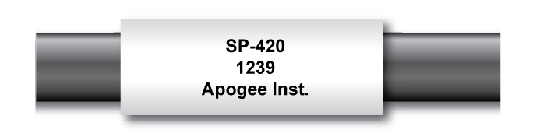

### Specifications

|  |  |  |
| --- | --- | --- |
|  | | SP-420 |
| ISO 9060:2018 | Class C (fast response) | |
| Resolution | 0.1 W m-2 | |
| Calibration Factor | Custom for each sensor and stored in firmware | |
| Calibration Uncertainty at  1000 W m-2 | Less than 3 % (see Calibration Traceability below) | |
| Measurement Repeatability | Less than 1 % | |
| Long-term Drift  (Non-stability) | Less than 2 % per year | |
| Non-linearity | Less than 1 % (up to 1750 W m-2) | |
| Response Time | Software updates every second | |
| Field of View | 180° | |
| Spectral Range | 360 to 1120 nm (wavelengths where response is 10 % of maximum;  see Spectral Response below) | |
| Directional (Cosine) Response | ± 5 % at 75° zenith angle (see Cosine Response below) | |
| Temperature Response | 0.04 ± 0.04 % per C (see Temperature Response below) | |
| Operating Environment | -40 to 70 C; 0 to 100 % relative humidity; can be submerged in water up to depths of 30 m | |
| Dimensions | 24 mm diameter, 33 mm height | |
| Mass | Sensor head weighs 90 g | |
| USB Cable | 4.5 m (15 ft) | |
| Current Draw (when Logging) | 61 mA | |

**Calibration Traceability**

Apogee Instruments SP series pyranometers are calibrated through side-by-side comparison to the mean of four Apogee model SP-110 transfer standard pyranometers (shortwave radiation reference) under high intensity discharge metal halide lamps. The transfer standard pyranometers are calibrated through side-by-side comparison to the mean of at least two ISO-classified reference pyranometers under sunlight (clear sky conditions) in Logan, Utah. Each of four ISO-classified reference pyranometers are recalibrated on an alternating year schedule (two instruments each year) at the National Renewable Energy Laboratory (NREL) in Golden, Colorado. NREL reference standards are calibrated to the World Radiometric Reference (WRR) in Davos, Switzerland.

**Spectral Response**



Spectral response estimate of Apogee silicon-cell pyranometers. Spectral response was estimated by multiplying the spectral response of the photodiode, diffuser, and adhesive. Spectral response measurements of diffuser and adhesive were made with a spectrometer, and spectral response data for the photodiode were obtained from the manufacturer.

**Temperature Response**

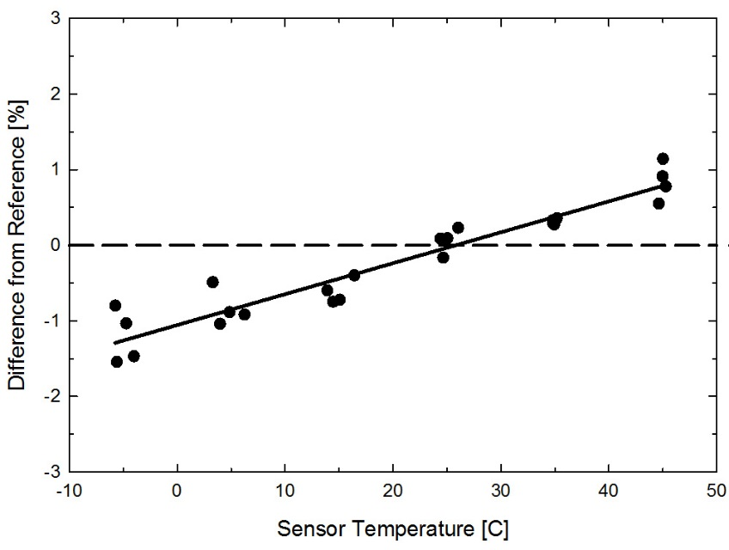

Mean temperature response of four Apogee silicon-cell pyranometers. Temperature response measurements were made at approximately 10 C intervals across a temperature range of approximately -10 to 50 C under sunlight. Each pyranometer had an internal thermistor to measure temperature. At each temperature set point, a reference blackbody pyranometer was used to measure solar intensity.

**Cosine Response**

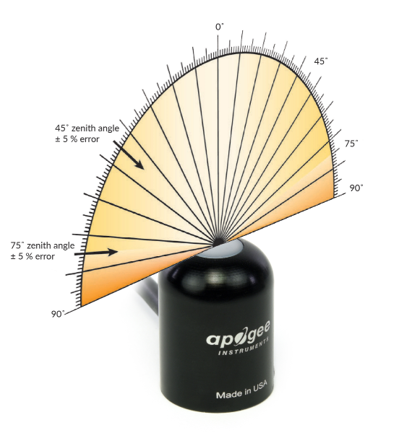

Directional, or cosine, response is defined as the measurement error at a specific angle of radiation incidence. Error for Apogee silicon-cell pyranometers is approximately ± 2 % and ± 5 % at solar zenith angles of 45° and 75°, respectively.

Mean cosine response of eleven Apogee silicon-cell pyranometers (***error bars represent two standard deviations above and below mean***). Cosine response measurements were made during broadband outdoor radiometer calibrations (BORCAL) performed during two different years at the National Renewable Energy Laboratory (NREL) in Golden, Colorado. Cosine response was calculated as the relative difference of pyranometer sensitivity at each solar zenith angle to sensitivity at 45° solar zenith angle. The blue symbols are AM measurements, the red symbols are PM measurements.



### Deployment and Installation

Mount the sensor to a solid surface with the nylon mounting screw provided. To accurately measure PPFD incident on a horizontal surface, the sensor must be level. An Apogee Instruments model AL-100 Leveling Plate is recommended to level the sensor when used on a flat surface or being mounted to surfaces such as wood. To facilitate mounting on a mast or pipe, the Apogee Instruments model AL-120 Solar Mounting Bracket with Leveling Plate is recommended.

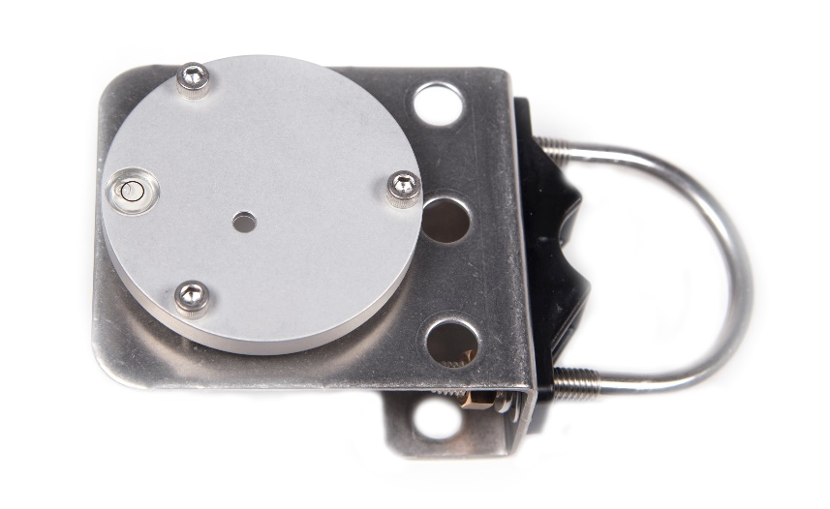C:\Users\emyers\AppData\Local\Microsoft\Windows\INetCache\Content.Word\screw.png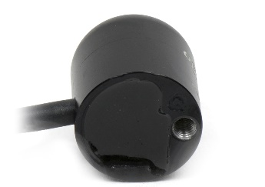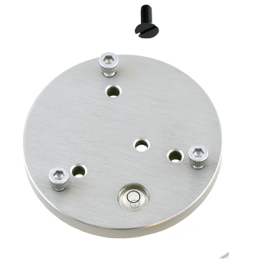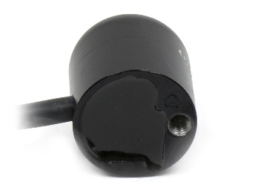

Nylon Screw: 10-32x3/8

Model AL-120

Nylon Screw: 10-32x3/8

Model AL-100

To minimize azimuth error, the sensor should be mounted with the cable pointing toward true north in the northern hemisphere or true south in the southern hemisphere. Azimuth error is typically less than 1 %, but it is easy to minimize by proper cable orientation.

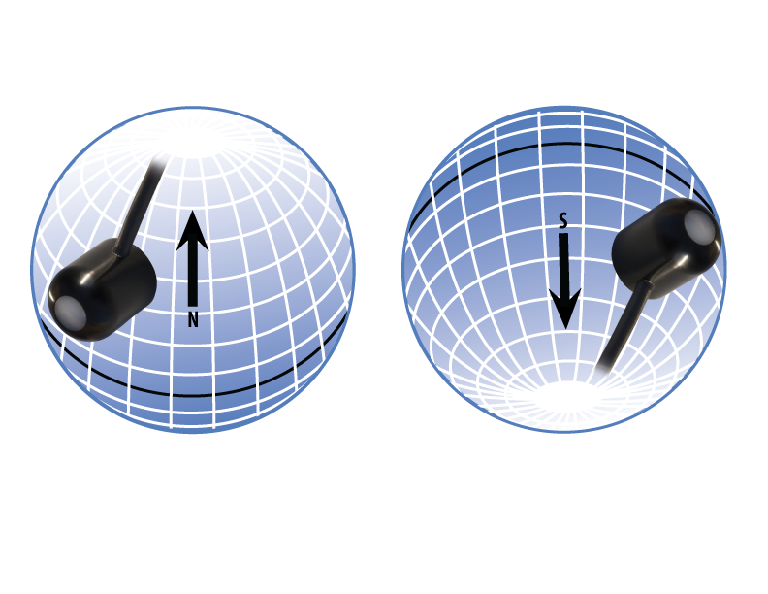

In addition to orienting the cable to point toward the nearest pole, the sensor should also be mounted such that obstructions (e.g., weather station tripod/tower or other instrumentation) do not shade the sensor. **Once mounted, the green cap should be removed from the sensor.** The green cap can be used as a protective covering for the sensor when it is not in use.

### Software Installation

**The most recent version of ApogeeConnect software can be downloaded at** [**http://www.apogeeinstruments.com/downloads/**](http://www.apogeeinstruments.com/downloads/)**.**

C:\Users\emyers\Desktop\apogee-connect.jpg**Installing the software on a PC (Windows compatible, XP and later)**

1. Double click on the installer package:
2. On the ‘Welcome’ screen, please click ‘Next’ to continue.
3. Select the radio button next to “I Agree” to the UELA… and click ‘Next’ to continue.
4. On the ‘Ready to Install the Program’ screen, click ‘Install’ to continue.
5. Click ‘Finish’ to complete the installation. There are shortcuts on your desktop and in your start bar.

**Installing the software on a Mac (Mac compatible, 10.10 and later)**

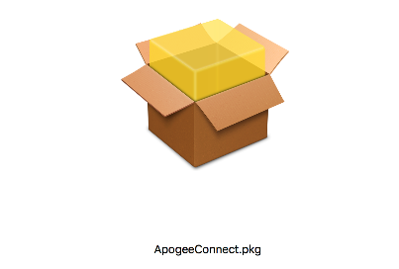

1. Double click on the installer package
2. On the ‘Introduction’ screen, please click ‘Continue’ to proceed.
3. Select ‘Continue’ on the ‘Read Me’ screen to continue, this screen contains a history of updates made to the ApogeeConnect software versions.
4. Select ‘Continue’ on the ‘License’ screen to receive a prompt to agree to the terms of the software license agreement. Click ‘Agree’ to continue once you receive the prompt.
5. On the ‘Installation Type’ screen, click ‘Install’ to install the software. You can change the location the software installs to by clicking ‘Change Install Location…’. *Note: You may be prompted for an administrator password at this time. If you are, proceed by entering your respective password and clicking ‘Install Software’.
6. Once you receive the message “The installation was successful.” on the ‘Summary’ screen click ‘Close’. Your software is now ready to be used.

### Operation and Measurement

**Spectral Errors for Measurements with Silicon-cell Pyranometers**

Apogee SP series pyranometers are calibrated under electric lamps in a calibration laboratory. The calibration procedure simulates calibration under clear sky conditions at a solar zenith angle of approximately 45°. However, due to the limited spectral sensitivity of silicon-cell pyranometers compared to the solar radiation spectrum (see graph below), spectral errors occur when measurements are made in conditions that differ from conditions the sensor was calibrated under (e.g., the solar spectrum differs in clear sky and cloudy conditions, thus measurements in cloudy conditions result in spectral error because sensors are calibrated in clear sky conditions).

Spectral response of Apogee SP series pyranometers compared to solar radiation spectrum at Earth’s surface. Silicon-cell pyranometers, such as Apogee SP series, are only sensitive to the wavelength range of approximately 350-1100 nm and are not equally sensitive to all wavelengths within this range. As a result, when the spectral content of solar radiation is significantly different than the spectrum that silicon-cell pyranometers were calibrated to, spectral errors result.



Silicon-cell pyranometers can still be used to measure shortwave radiation in conditions other than clear sky or from radiation sources other than incoming sunlight, but spectral errors occur when measuring radiation with silicon-cell pyranometers in these conditions. The graphs below show spectral error estimates for Apogee silicon-cell pyranometers at varying solar zenith angles and varying atmospheric air mass. The diffuser is optimized to minimize directional errors, thus the cosine response graph in the Specifications section shows the actual directional errors in practice (which includes contributions from the spectral shift that occurs as solar zenith angle and atmospheric air mass change with time of day and time of year). The table below provides spectral error estimates for shortwave radiation measurements from shortwave radiation sources other than clear sky solar radiation.



Spectral error for Apogee SP series pyranometers as a function of solar zenith angle, assuming calibration at a zenith angle of 45°.



Spectral error for Apogee SP series pyranometers as a function of atmospheric air mass, assuming calibration at an air mass of 1.5.

### Windows Software

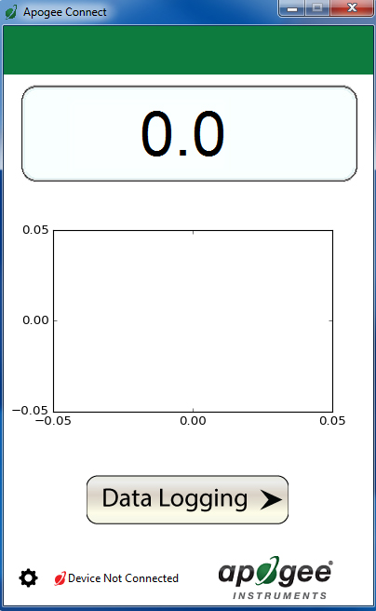

When the SP-420 sensor is not plugged into the USB port, the software will display a message in the lower left corner, “Device Not Connected,” indicating it cannot establish communication with the sensor.

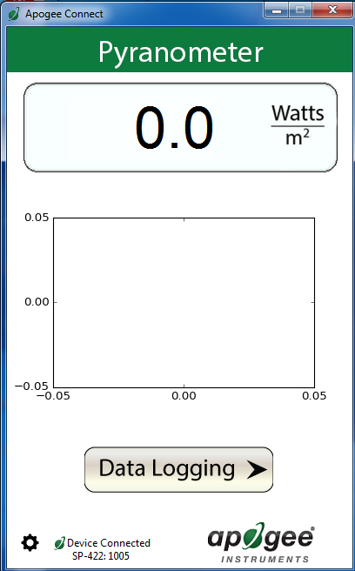

Plug the sensor into a USB port and allow some time for the sensor to automatically establish communication with the software. Once established, the message in the lower left corner will display “Device Connected SN: ####” and real-time shortwave radiation readings will update on the screen. Moving the sensor closer to a light source should increase the readings, while blocking all light from the sensor should drop the reading to zero.

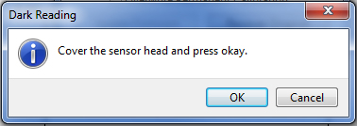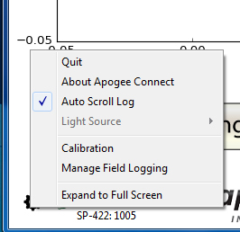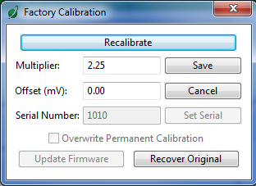

After clicking the ‘Recalibate’ button the user will be prompted to cover the sensor. Place a dark cap over the sensor and wait for the real-time shortwave readiation reading to settle at zero. Click OK.

Clicking **‘Calibration’** will display the factory calibrated multiplier and offset values. These values are saved in firmware and can be recovered by clicking the ‘Recover Original’ button. Deriving a new calibration multiplier and offset is accomplished by clicking the ‘Recalibrate’ button. This is applicable if users want to calibrate the sensor to their own specific light source. Note that a reference value of the light source is required to complete a recalibration.

Click the ‘**Settings**’ icon to display the software options. Note **‘Light Source’** is not a setting for the SP-420.

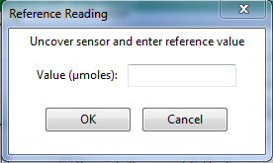

Uncover the sensor and wait for the shortwave radiation reading to settle ***before*** entering the reference value. Click OK.

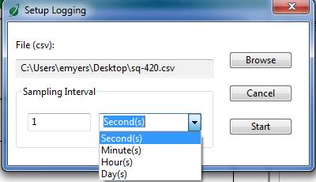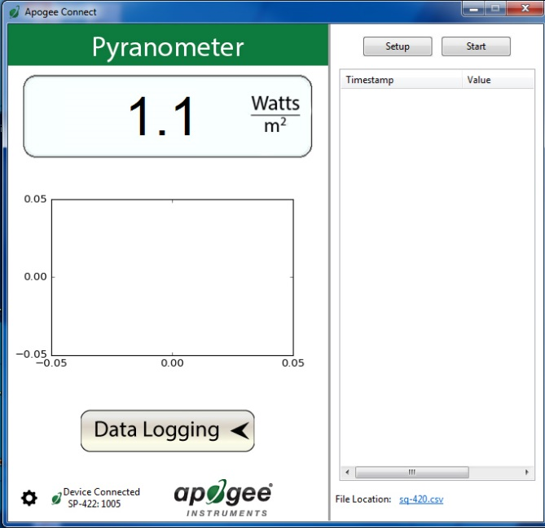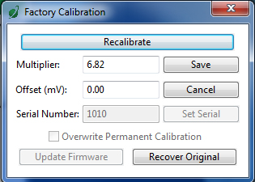

Click ‘Setup’ and the Setup Logging window appears. Click the ‘Browse’ button to create or select a csv file.

Select the desired sampling interval. Note that 1 second is the minimum interval allowed. Click ‘Start’.

The multiplier and offset values will automatically calculate and update in the appropriate field. Be sure to click ‘Save’ to retain the new multiplier and offset.

Clicking **‘Data Logging’** will allow the user to log interval measurements in a csv file while the software is open and communicating with the sensor.

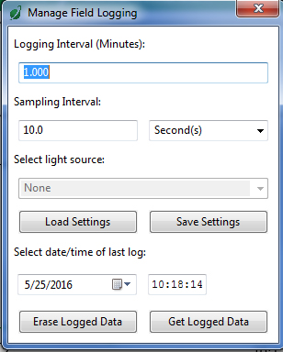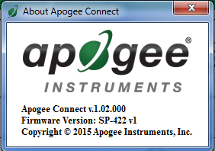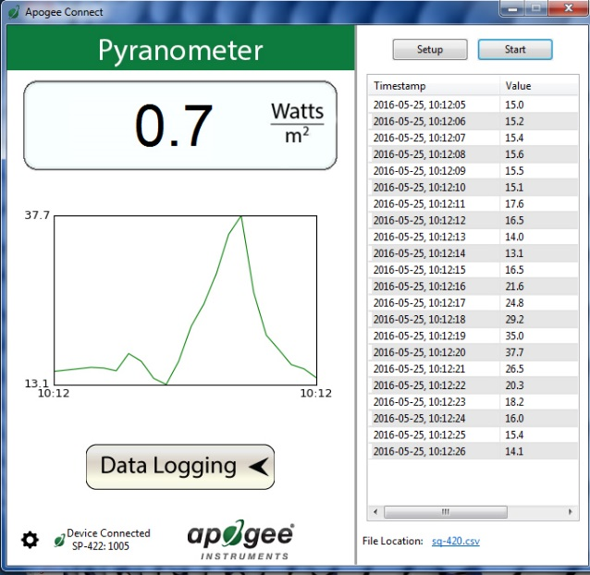

The data logging window will start to update at the specified sampling interval and display the Timestamp and Data Value. At the same time, data will be written to the csv file. Note that if the csv file is open in another program new data will not be saved to it.

The data logging window can be closed without affec­ting logged data by clicking the ‘Exit’ button. The ‘Stop’ button must be clicked to end data logging.

**‘Manage Field Logging’** is used to setup the SP-420 for use in the field. When the SP-420 is supplied power from a USB power source it will log data which you can retrieve. Choose the interval that data is saved, as well as the interval that data is sampled, and the light source used. The shortest sampling interval is 1 second. The longest sampling or logging interval is 1440 minutes (1 day). Click ‘Load Settings’ to see current settings and ‘Save Settings’ to save the settings you want to the sensor. Note: If you don’t click save the sensor won’t change the settings.

The about screen tells you the software and firmware versions. These can be used to help troubleshoot if problems arise.

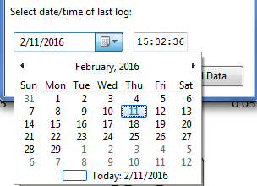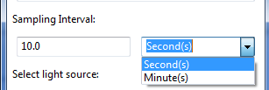C:\Users\emyers\Desktop\logged-data.PNG

Click **‘Get Logged Data’** to save the data to your computer. You will be asked where you want to save the data.

Click **‘Erase Data’** to erase all the saved data. This can’t be undone.

Before clicking ‘Get Logged Data’ it is important to set the time of the last logged data point. This is used to back calculate the timestamps for the remaining data points. If you just unplugged the sensor and plugged it into the computer, the preloaded day and time should be sufficient.

To use additional SP-420 devices, open additional ApogeeConnect software windows. The device serial number will display in the lower left-hand corner of the corresponding software window. Devices may be selected by serial number in the tool bar.

Set the sampling interval in minutes or seconds. The sampling interval is how often a measurement is taken and logging interval is how often the data is saved. The logged data is the average of the samples. The logging interval must be evenly divided by the sampling interval. For example, if the logging interval is 5 minutes and the sampling interval is 2 minutes it causes an error. But a sampling interval of 1 minute is acceptable.

### C:\Users\emyers\Pictures\main-m.pngC:\Users\emyers\Desktop\start-m.pngMAC software

Plug the sensor into a USB port and allow some time for the sensor to automatically establish communication with the software. Once established, the message in the lower left corner will display “Device Connected Model: SN ####” and real-time shortwave radiation readings will update on the screen. Moving the sensor closer to a light source should increase the readings, while blocking all light from the sensor should drop the reading to zero.

When the SP-420 sensor is not plugged into the USB port, the software will display a message in the lower left corner, “Device Not Connected,” indicating it cannot establish communication with the sensor.

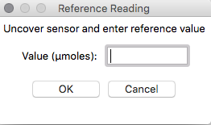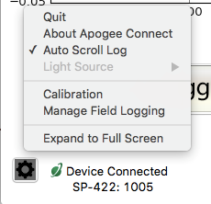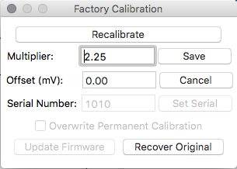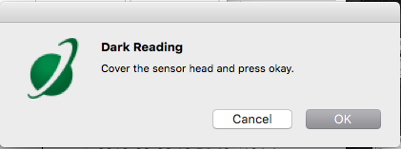

Uncover the sensor and wait for the shortwave radiation reading to settle ***before*** entering the reference value. Click OK.

Clicking **‘Calibration’** will display the factory calibrated multiplier and offset values. These values are saved in firmware and can be recovered by clicking the ‘Recover Original’ button. Deriving a new calibration multiplier and offset is accomplished by clicking the ‘Recalibrate’ button. This is applicable if users want to calibrate the sensor to their own specific light source. Note that a reference value of the light source is required to complete a recalibration.

After clicking the ‘Recalibrate’ button the user will be prompted to cover the sensor. Place a dark cap over the sensor and wait for the real-time shortwave radiation reading to settle at zero. Click OK.

Click the **‘Settings’** icon to display the software options. Note **‘Light Source’** is not a setting option for the SP-420.

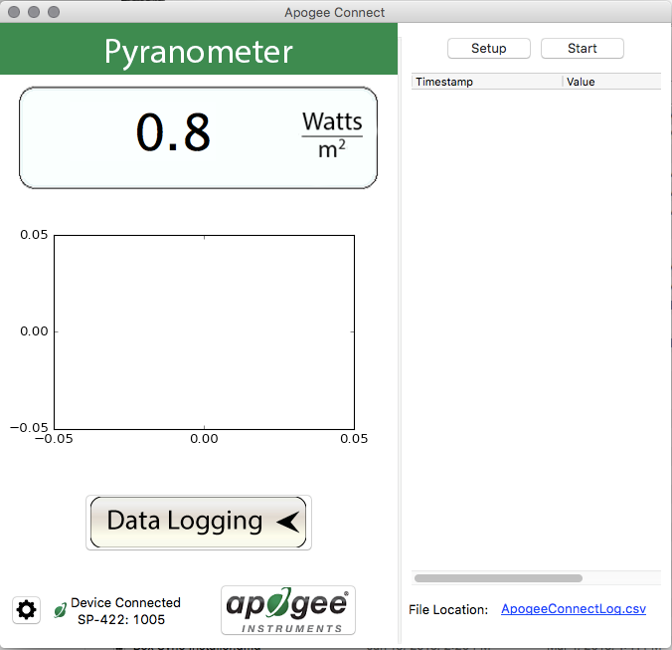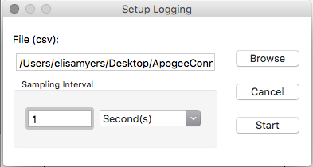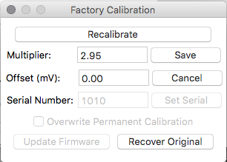

Clicking **‘Data Logging’** will allow the user to log interval measurements in a csv file while the software is open and communicating with the sensor.

The multiplier and offset values will automatically calculate and update in the appropriate field. Be sure to click ‘Save’ to retain the new multiplier and offset.

Click ‘Setup’ and the Setup Logging window appears. Click the ‘Browse button to create or select a csv file.

Select the desired sampling interval. Note that 1 second is the minimum interval allowed. Click ‘Start’.

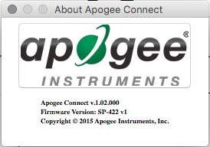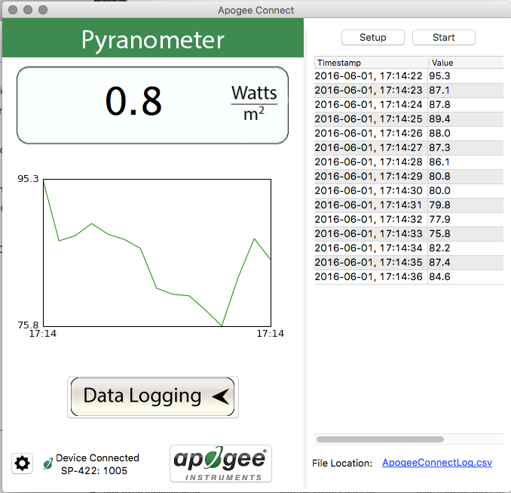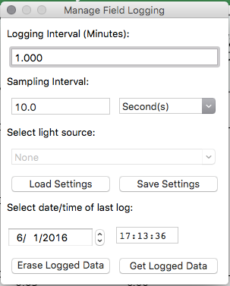

‘**Manage Field Logging**’ is used to setup the SP-420 for the use in the field. When the SP-420 is supplied power from a USB power source it will log data which you can retrieve. Choose the interval the data is saved as well as the interval that data is sampled and the light source used. The shortest sampling interval is 1 second. The longest sampling or logging interval is 1440 minutes (1 day). Click ‘Load Settings’ to see current settings and ‘Save Setting’ to save the settings you want to the sensor. Note: If you don’t click save the sensor won’t change the settings.

The about screen tells you the software and firmware versions. These can be used to help troubleshoot if problems arise.

The data logging window will start to update at the specified sampling interval and display the Timestamp and Data Value. At the same time, data will be written to the csv file. Note that if the csv file is open in another program new data will not be saved to it.

The data logging window can be closed without affecting logged data by clicking the ‘Exit’ button. The ‘Stop’ button must be clicked to end data logging.

Screen Shot 2016-02-26 at 10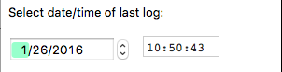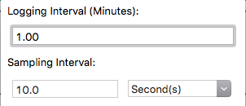

Before clicking ‘Get Logged Data’ it is important to set the time of the last logged data point. This is used to back calculate the timestamps for the remaining data points. If you just unplugged the sensor and plugged it into the computer, the preloaded day and time should be sufficient.

Set the sampling interval in minutes or seconds. The sampling interval is how often a measurement is taken and logging interval is how often the data is saved. The logged data is the average of the samples. The logging interval must be evenly divided by the sampling interval. For example, if the logging interval is 5 minutes and the sampling interval is 2 minutes it causes an error. But a sampling interval of 1 minute is acceptable.

To use additional SP-422 devices, open additional ApogeeConnect software windows. The device serial number will display in the lower left-hand corner of the corresponding software window. Devices may be selected by serial number in the tool bar.

Click ‘**Get Logged Data**’ to save the data to your computer. You will be asked where you want to save the data.

Click ‘**Erase Data**’ to erase all the save data. This can’t be undone.

**Spectral Errors for Shortwave Radiation Measurements with Apogee SP Series Pyranometers**

|  |  |
| --- | --- |
| **Radiation Source (Error Calculated Relative to Sun, Clear Sky)** | **Error [%]** |
| Sun (Clear Sky) | 0.0 |
| Sun (Cloudy Sky) | 9.6 |
| Reflected from Grass Canopy | 14.6 |
| Reflected from Deciduous Canopy | 16.0 |
| Reflected from Conifer Canopy | 19.2 |
| Reflected from Agricultural Soil | -12.1 |
| Reflected from Forest Soil | -4.1 |
| Reflected from Desert Soil | 3.0 |
| Reflected from Water | 6.6 |
| Reflected from Ice | 0.3 |
| Reflected from Snow | 13.7 |

### Maintenance and Recalibration

Moisture or debris on the diffuser is a common cause of low readings. The sensor has a domed diffuser and housing for improved self-cleaning from rainfall, but materials can accumulate on the diffuser (e.g., dust during periods of low rainfall, salt deposits from evaporation of sea spray or sprinkler irrigation water) and partially block the optical path. Dust or organic deposits are best removed using water or window cleaner and a soft cloth or cotton swab. Salt deposits should be dissolved with vinegar and removed with a soft cloth or cotton swab. **Never use an abrasive material or cleaner on the diffuser.**

Although Apogee sensors are very stable, nominal accuracy drift is normal for all research-grade sensors. To ensure maximum accuracy, we generally recommend sensors are sent in for recalibration every two years, although you can often wait longer according to your particular tolerances.

To determine if your sensor needs recalibration, the Clear Sky Calculator ([www.clearskycalculator.com](http://www.clearskycalculator.com)) website and/or smartphone app can be used to indicate the total shortwave radiation incident on a horizontal surface at any time of day at any location in the world. It is most accurate when used near solar noon in spring and summer months, where accuracy over multiple clear and unpolluted days is estimated to be ± 4 % in all climates and locations around the world. For best accuracy, the sky must be completely clear, as reflected radiation from clouds causes incoming radiation to increase above the value predicted by the clear sky calculator. Measured values of total shortwave radiation can exceed values predicted by the Clear Sky Calculator due to reflection from thin, high clouds and edges of clouds, which enhances incoming shortwave radiation. The influence of high clouds typically shows up as spikes above clear sky values, not a constant offset greater than clear sky values.

To determine recalibration need, input site conditions into the calculator and compare total shortwave radiation measurements to calculated values for a clear sky. If sensor shortwave radiation measurements over multiple days near solar noon are consistently different than calculated values (by more than 6 %), the sensor should be cleaned and re-leveled. If measurements are still different after a second test, email [calibration@apogeeinstruments.com](mailto:calibration@apogeeinstruments.com) to discuss test results and possible return of sensor(s).

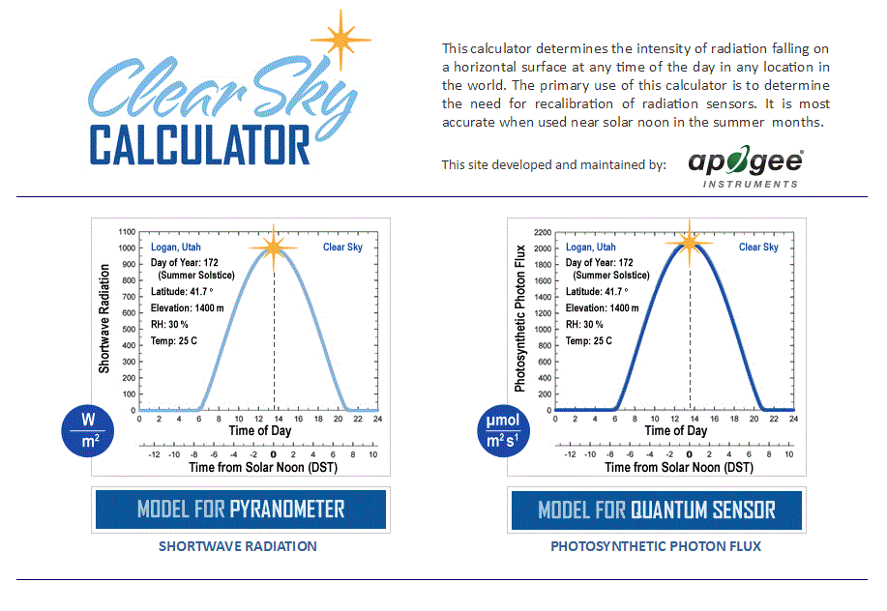

Homepage of the Clear Sky Calculator. Two calculators are available: One for pyranometers (total shortwave radiation) and one for quantum sensors (photosynthetic photon flux density).

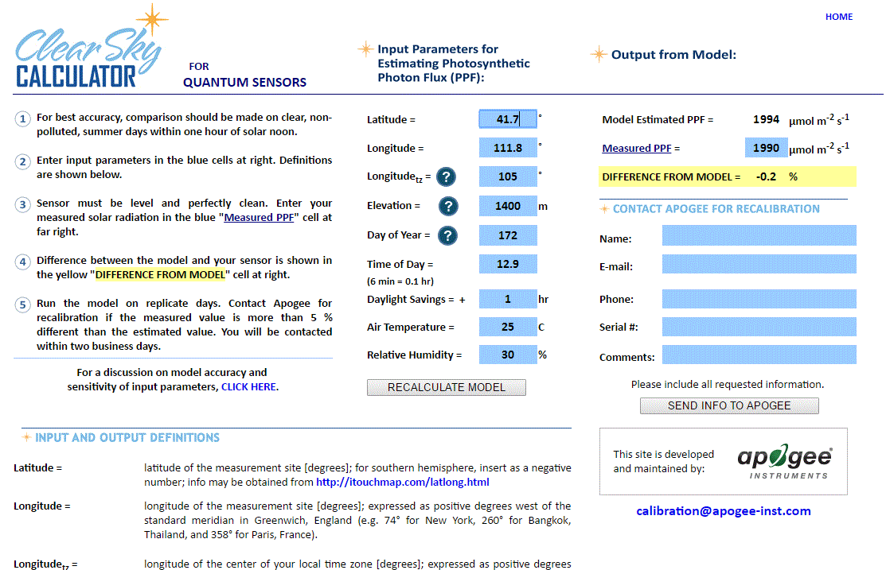

Clear Sky Calculator for pyranometers. Site data are input in blue cells in middle of page and an estimate of total shortwave radiation is returned on right-hand side of page.

### Troubleshooting and Customer Support

**Cable Length**

Fifteen feet is the maximum cable length that can be built into the sensor.

**Modifying Cable Length**

If you required a longer cable length an “active” USB extension cable is required. Please note, the connection between the cables must be made watertight prior to submersion.

### Return and Warranty Policy

RETURN POLICY

Apogee Instruments will accept returns within 30 days of purchase as long as the product is in new condition (to be determined by Apogee). Returns are subject to a 10 % restocking fee.

WARRANTY POLICY

**What is Covered**All products manufactured by Apogee Instruments are warranted to be free from defects in materials and craftsmanship for a period of four (4) years from the date of shipment from our factory. To be considered for warranty coverage an item must be evaluated by Apogee.

Products not manufactured by Apogee (spectroradiometers, chlorophyll content meters, EE08-SS probes) are covered for a period of one (1) year.

**What is Not Covered**The customer is responsible for all costs associated with the removal, reinstallation, and shipping of suspected warranty items to our factory.

The warranty does not cover equipment that has been damaged due to the following conditions:

1. Improper installation, use, or abuse.

2. Operation of the instrument outside of its specified operating range.

3. Natural occurrences such as lightning, fire, etc.

4. Unauthorized modification.

5. Improper or unauthorized repair.

Please note that nominal accuracy drift is normal over time. Routine recalibration of sensors/meters is considered part of proper maintenance and is not covered under warranty.

**Who is Covered**This warranty covers the original purchaser of the product or other party who may own it during the warranty period.

**What Apogee Will Do**At no charge Apogee will:

1. Either repair or replace (at our discretion) the item under warranty.

2. Ship the item back to the customer by the carrier of our choice.

Different or expedited shipping methods will be at the customer’s expense.

**How To Return An Item**1. Please do not send any products back to Apogee Instruments until you have received a Return Merchandise Authorization (RMA) number from our technical support department by submitting an online RMA form at [www.apogeeinstruments.com/tech-support-recalibration-repairs/](http://www.apogeeinstruments.com/tech-support-recalibration-repairs/). We will use your RMA number for tracking of the service item. Call (435) 245-8012 or email techsupport@apogeeinstruments.com with questions.

2. For warranty evaluations, send all RMA sensors and meters back in the following condition: Clean the sensor’s exterior and cord. Do not modify the sensors or wires, including splicing, cutting wire leads, etc. If a connector has been attached to the cable end, please include the mating connector – otherwise the sensor connector will be removed in order to complete the repair/recalibration. ***Note:*** *When sending back sensors for routine calibration that have Apogee’s standard stainless-steel connectors, you only need to send the sensor with the 30 cm section of cable and one-half of the connector. We have mating connectors at our factory that can be used for calibrating the sensor.*

3. Please write the RMA number on the outside of the shipping container.

4. Return the item with freight pre-paid and fully insured to our factory address shown below. We are not responsible for any costs associated with the transportation of products across international borders.

**Apogee Instruments, Inc.   
721 West 1800 North Logan, UT  
84321, USA**

5. Upon receipt, Apogee Instruments will determine the cause of failure. If the product is found to be defective in terms of operation to the published specifications due to a failure of product materials or craftsmanship, Apogee Instruments will repair or replace the items free of charge. If it is determined that your product is not covered under warranty, you will be informed and given an estimated repair/replacement cost.

Products Beyond the Warranty Period

For issues with sensors beyond the warranty period, please contact Apogee at [techsupport@apogeeinstruments.com](mailto:techsupport@apogeeinstruments.com) to discuss repair or replacement options.

Other Terms

The available remedy of defects under this warranty is for the repair or replacement of the original product, and Apogee Instruments is not responsible for any direct, indirect, incidental, or consequential damages, including but not limited to loss of income, loss of revenue, loss of profit, loss of data, loss of wages, loss of time, loss of sales, accruement of debts or expenses, injury to personal property, or injury to any person or any other type of damage or loss.

This limited warranty and any disputes arising out of or in connection with this limited warranty ("Disputes") shall be governed by the laws of the State of Utah, USA, excluding conflicts of law principles and excluding the Convention for the International Sale of Goods. The courts located in the State of Utah, USA, shall have exclusive jurisdiction over any Disputes.

This limited warranty gives you specific legal rights, and you may also have other rights, which vary from state to state and jurisdiction to jurisdiction, and which shall not be affected by this limited warranty. This warranty extends only to you and cannot by transferred or assigned. If any provision of this limited warranty is unlawful, void, or unenforceable, that provision shall be deemed severable and shall not affect any remaining provisions. In case of any inconsistency between the English and other versions of this limited warranty, the English version shall prevail.

This warranty cannot be changed, assumed, or amended by any other person or agreement

**APOGEE INSTRUMENTS, INC. |** 721 WEST 1800 NORTH, LOGAN, UTAH 84321, USA

TEL: (435) 792-4700 | FAX: (435) 787-8268 | WEB: APOGEEINSTRUMENTS.COM

*Copyright © 2022 Apogee Instruments, Inc.*