

Owner’s Manual

Quantum Sensor
Model SQ-500
Rev: 11-July-2025
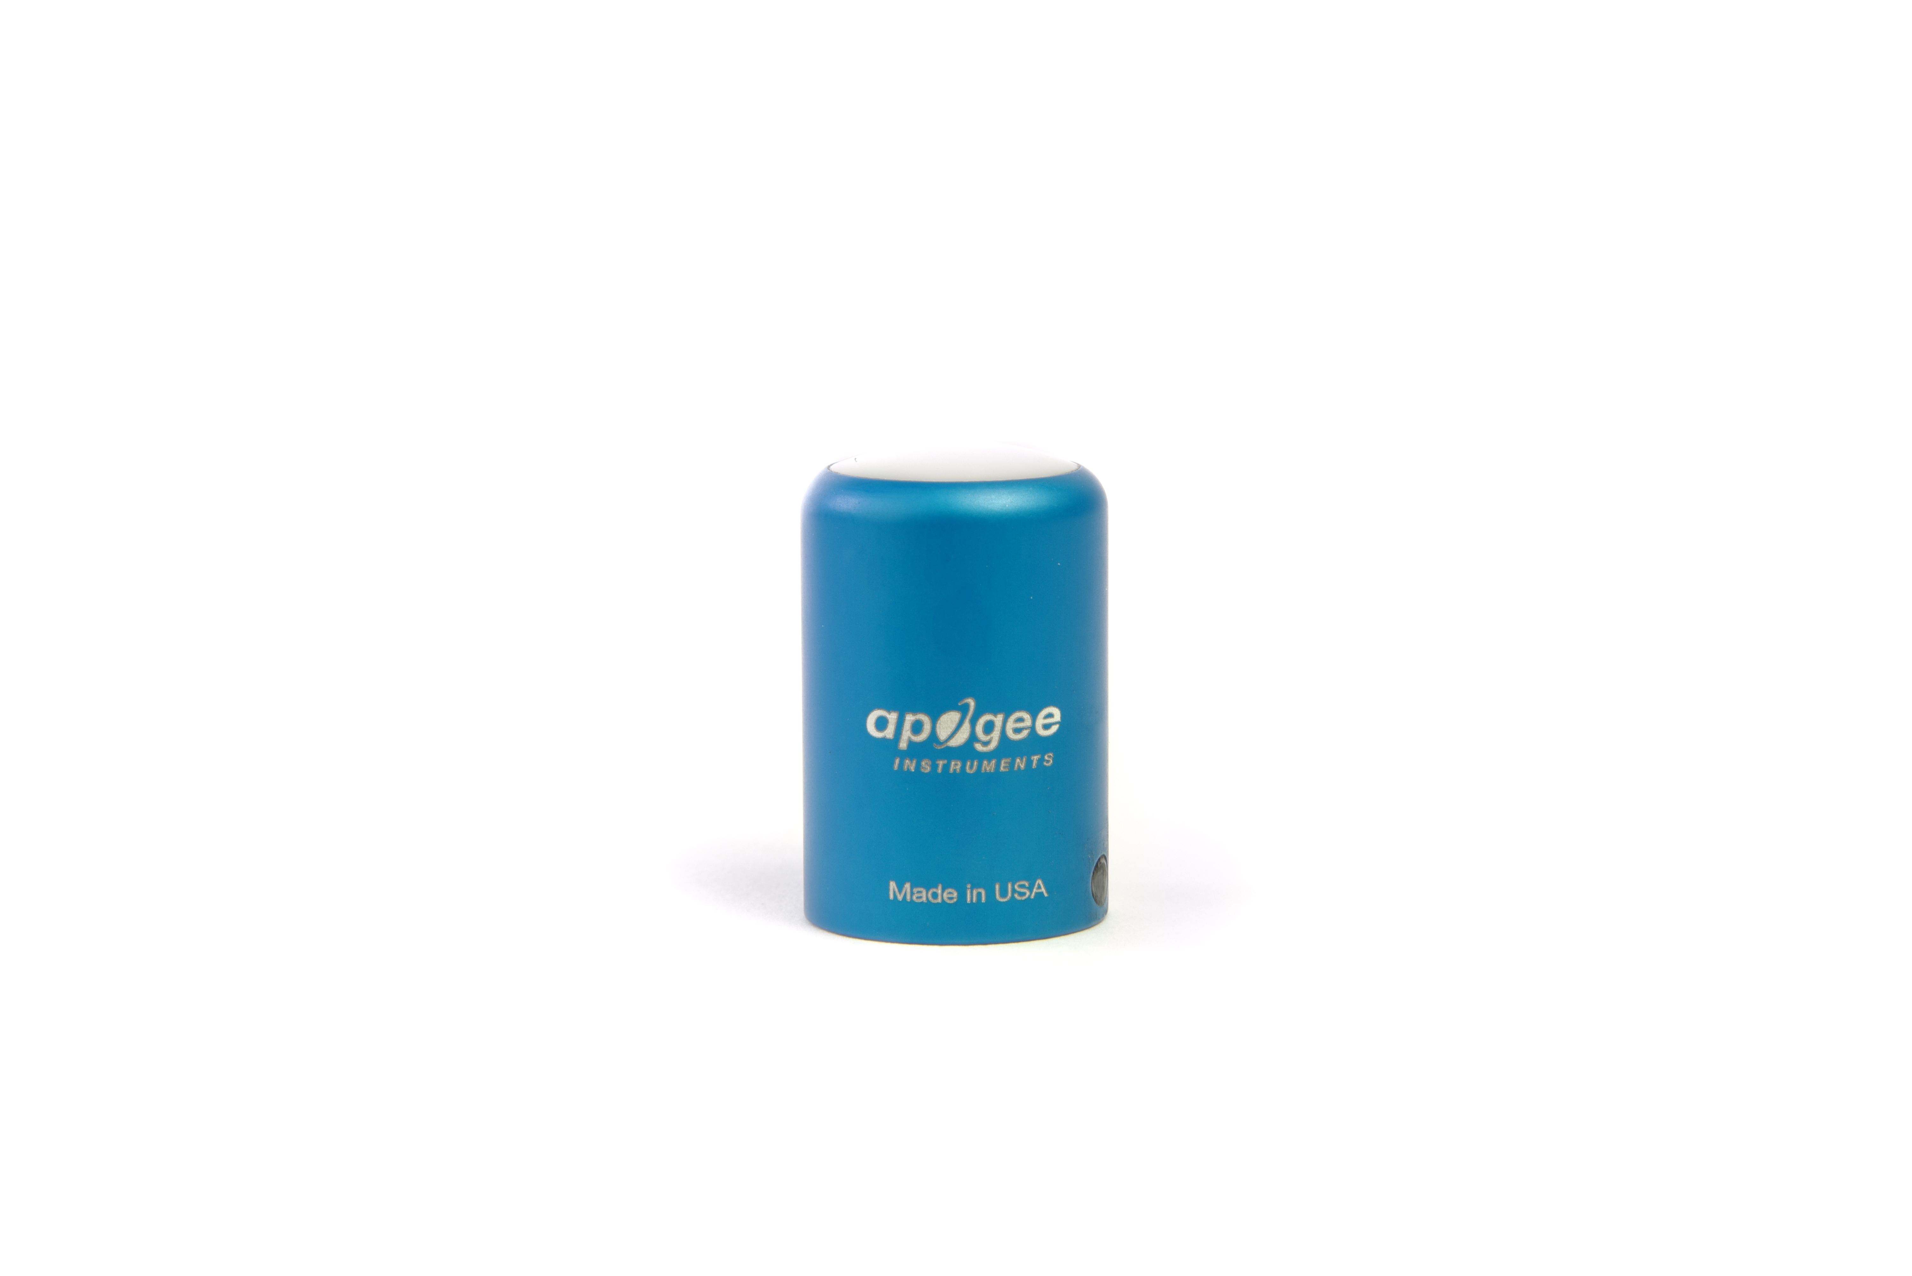
Table of Contents
Owner’s Manual 1
Certificates of Compliance 3
Introduction 5
Sensor Models 6
Specifications 7
Deployment and Installation 10
Cable Connectors 11
Operation and Measurement 12
Maintenance and Recalibration 18
Troubleshooting and Customer Support 20
Return and Warranty Policy 21

Certificate of Compliance

EU Declaration of Conformity
This declaration of conformity is issued under the sole responsibility of the manufacturer:
Apogee Instruments, Inc.
721 W 1800 N
Logan, Utah 84321
USA
for the following product(s):

Models: SQ-500
Type: Quantum Sensor

The object of the declaration described above is in conformity with the relevant Union harmonization legislation:

2014/30/EU Electromagnetic Compatibility (EMC) Directive
2011/65/EU Restriction of Hazardous Substances (RoHS 2) Directive
2015/863/EU Amending Annex II to Directive 2011/65/EU (RoHS 3)

Standards referenced during compliance assessment:

EN 61326-1:2013 Electrical equipment for measurement, control, and laboratory use – EMC requirements
EN 63000:2018 Technical documentation for the assessment of electrical and electronic products with respect to the restriction of hazardous substances

Please be advised that based on the information available to us from our raw material suppliers, the products manufactured by us do not contain, as intentional additives, any of the restricted materials including lead (see note below), mercury, cadmium, hexavalent chromium, polybrominated biphenyls (PBB), polybrominated diphenyls (PBDE), bis (2-ethylhexyl) phthalate (DEHP), butyl benzyl phthalate (BBP), dibutyl phthalate (DBP), and diisobutyl phthalate (DIBP). However, please note that articles containing greater than 0.1 % lead concentration are RoHS 3 compliant using exemption 6c.

Further note that Apogee Instruments does not specifically run any analysis on our raw materials or end products for the presence of these substances, but we rely on the information provided to us by our material suppliers.

Signed for and on behalf of:
Apogee Instruments, October 2022


Bruce Bugbee
President
Apogee Instruments, Inc.

Certificate of Compliance

UK Declaration of Conformity
This declaration of conformity is issued under the sole responsibility of the manufacturer:
Apogee Instruments, Inc.
721 W 1800 N
Logan, Utah 84321
USA
for the following product(s):

Models: SQ-500
Type: Quantum Sensor

The object of the declaration described above is in conformity with the relevant UK Statutory Instruments and their amendments:

2016 No. 1091 The Electromagnetic Compatibility Regulations 2016
2012 No. 3032 The Restriction of the Use of Certain Hazardous Substances in Electrical and Electronic Equipment Regulations 2012

Standards referenced during compliance assessment:

BS EN 61326-1:2013 Electrical equipment for measurement, control, and laboratory use – EMC requirements
BS EN 63000:2018 Technical documentation for the assessment of electrical and electronic products with respect to the restriction of hazardous substances

Please be advised that based on the information available to us from our raw material suppliers, the products manufactured by us do not contain, as intentional additives, any of the restricted materials including lead (see note below), mercury, cadmium, hexavalent chromium, polybrominated biphenyls (PBB), polybrominated diphenyls (PBDE), bis (2-ethylhexyl) phthalate (DEHP), butyl benzyl phthalate (BBP), dibutyl phthalate (DBP), and diisobutyl phthalate (DIBP). However, please note that articles containing greater than 0.1 % lead concentration are RoHS 3 compliant using exemption 6c.

Further note that Apogee Instruments does not specifically run any analysis on our raw materials or end products for the presence of these substances, but we rely on the information provided to us by our material suppliers.

Signed for and on behalf of:
Apogee Instruments, October 2022

Bruce Bugbee
President
Apogee Instruments, Inc.

Introduction
Radiation that drives photosynthesis is called photosynthetically active radiation (PAR) and is typically defined as total radiation across a range of 400 to 700 nm. PAR is almost universally quantified as photosynthetic photon flux density (PPFD), the sum of photons from 400 to 700 nm in units of micromoles per square meter per second (µmol m⁻² s⁻¹, equal to microEinsteins m⁻² s⁻¹). While microEinsteins and micromoles are equal (one Einstein = one mole of photons), the Einstein is not an SI unit, so expressing PPFD as µmol m⁻² s⁻¹ is preferred. Daily total PPFD is typically reported in units of moles of photons per square meter per day (mol m⁻² d⁻¹) and is often called daily light integral (DLI).
The acronym PPF is also used and refers to the photosynthetic photon flux. The acronyms PPF and PPFD refer to the same variable. Both terms are used because there is not a universal definition of the term flux. Flux is sometimes defined as per unit area per unit time and sometimes defined as per unit time only. PPFD is used in this manual.
Sensors that measure PPFD are often called quantum sensors due to the quantized nature of radiation. A quantum refers to the minimum quantity of radiation, one photon, involved in physical interactions (e.g., absorption by photosynthetic pigments). In other words, one photon is a single quantum of radiation.
Typical applications of quantum sensors include measurement of incident PPFD on plant canopies in outdoor environments or in greenhouses and growth chambers and reflected or under-canopy (transmitted) PPFD measurement in the same environments.
Apogee Instruments SQ-500 series quantum sensors consist of a cast acrylic diffuser (filter), interference filter, photodiode, and signal processing circuitry mounted in an anodized aluminum housing, and a cable to connect the sensor to a measurement device. SQ-500 series quantum sensors are designed for continuous PPFD measurement in indoor or outdoor environments. The SQ-500 model quantum sensor outputs a voltage that is directly proportional to PPFD. The voltage output by the sensor is directly proportional to radiation incident on a planar surface (does not have to be horizontal), where the radiation emanates from all angles of a hemisphere.

Sensor Models
This manual covers the unamplified analog output quantum sensor, model SQ-500 (listed in bold below). Additional models are covered in their respective manuals.
Model | Signal
SQ-500 | 0-40 mV
SQ-512 | 0-2.5 V
SQ-515 | 0-5 V
SQ-520 | USB
SQ-521 | SDI-12
SQ-522 | Modbus

A sensor’s model number and serial number are located near the pigtail leads on the sensor cable. If the manufacturing date of a specific sensor is required, please contact Apogee Instruments with the serial number of the sensor.

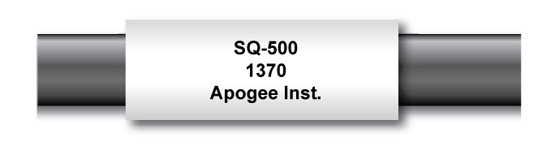

Specifications
 | SQ-500-SS
Power Supply | Self-powered
Sensitivity | 0.01 mV per µmol m⁻² s⁻¹
Calibration Factor | 100 µmol m⁻² s⁻¹ per mV
Calibration Uncertainty | ± 5 % (see Calibration Traceability below)
Measurement Range | 0 to 4000 µmol m⁻² s⁻¹
Measurement Repeatability | Less than 0.5 %
Calibrated Output Range | 0 to 40 mV
Long-term Drift  (Non-stability) | Less than 2 % per year
Non-linearity | Less than 1 % (up to 4000 µmol m⁻² s⁻¹)
Response Time | Less than 1 ms
Field of View | 180°
Spectral Range | 389 to 692 nm ± 5 nm (wavelengths where response is greater than 50 %)
Calibrated Spectral Range | 400 to 700 nm
Spectral Selectivity | Less than 10 % from 412 to 682 ± 5 nm (see Spectral Response below)
Directional (Cosine) Response | ± 2 % at 45° zenith angle, ± 5 % at 75° zenith angle (see Directional Response below)
Azimuth Error | Less than 0.5 %
Tilt Error | Less than 0.5 %
Temperature Response | -0.11 ± 0.04 % per C (see Temperature Response below)
Uncertainty in Daily Total | Less than 5 %
Detector | Blue-enhanced silicon photodiode
Housing | Anodized aluminum body with acrylic diffuser
IP Rating | IP68
Operating Environment | -40 to 70 C; 0 to 100 % relative humidity; can be submerged in water up to depths of 30 m
Dimensions | 24 mm diameter, 37 mm height
Mass (with 5 m of cable) | 100 g
Cable | 5 m of two conductor, shielded, twisted-pair wire; TPR jacket; pigtail lead wires; stainless steel (316), M8 connector located 25 cm from sensor head

Calibration Traceability
Apogee Instruments SQ-500 series quantum sensors are calibrated through side-by-side comparison to the mean of four transfer standard quantum sensors under a reference lamp. The reference quantum sensors are recalibrated with a quartz halogen lamp traceable to the National Institute of Standards and Technology (NIST).

Spectral Response
Mean spectral response measurements of six replicate Apogee SQ-100 (original) and SQ-500 (full-spectrum) series quantum sensors. Spectral response measurements were made at 10 nm increments across a wavelength range of 300 to 800 nm with a monochromator and an attached electric light source. Measured spectral data from each quantum sensor were normalized by the measured spectral response of the monochromator/electric light combination, which was measured with a spectroradiometer.

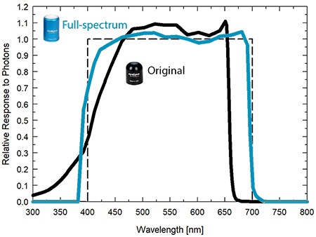

Temperature Response
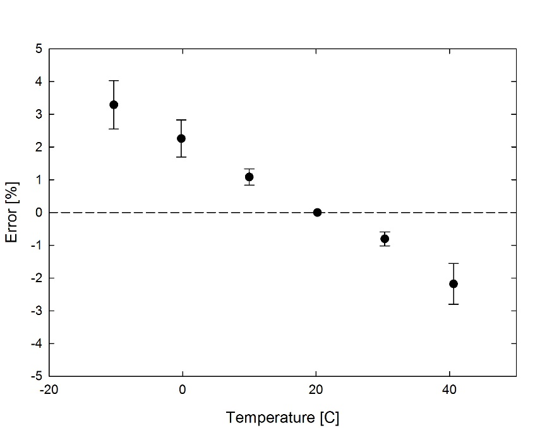
Mean temperature response of ten SQ-500 series quantum sensors (errors bars represent two standard deviations above and below mean). Temperature response measurements were made at 10 C intervals across a temperature range of approximately -10 to 40 C in a temperature-controlled chamber under a fixed, broad spectrum, electric lamp. At each temperature set point, a spectroradiometer was used to measure light intensity from the lamp and all quantum sensors were compared to the spectroradiometer. The spectroradiometer was mounted external to the temperature control chamber and remained at room temperature during the experiment.

Cosine Response
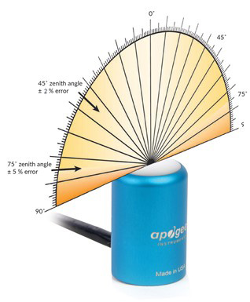
Directional (cosine) response is defined as the measurement error at a specific angle of radiation incidence. Error for Apogee SQ-500 series quantum sensors is approximately ± 2 % and ± 5 % at solar zenith angles of 45° and 75°, respectively.

Mean directional (cosine) response of seven apogee SQ-500 series quantum sensors. Directional response measurements were made on the rooftop of the Apogee building in Logan, Utah. Directional response was calculated as the relative difference of SQ-500 quantum sensors from the mean of replicate reference quantum sensors (LI-COR models LI-190 and LI-190R, Kipp & Zonen model PQS 1). Data were also collected in the laboratory using a reference lamp and positioning the sensor at varying angles.

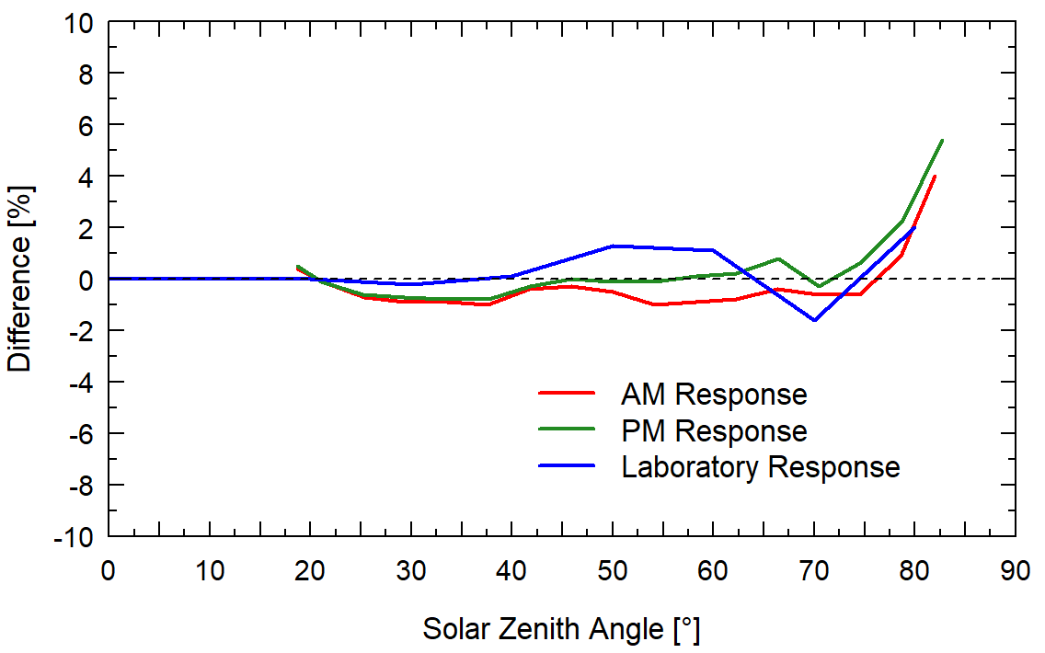

Deployment and Installation

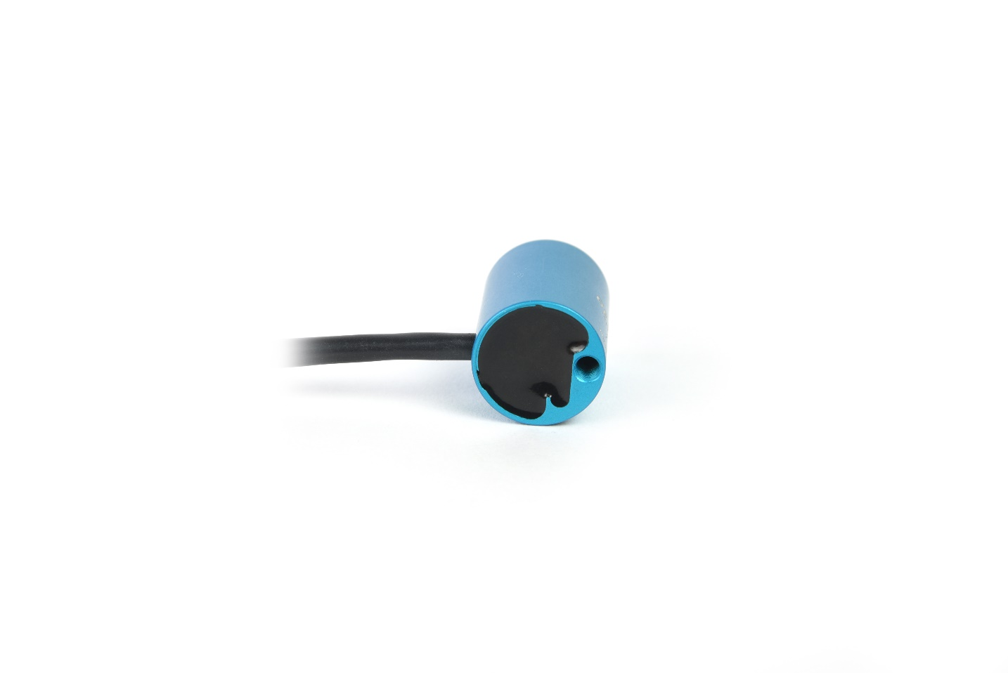
Mount the sensor to a solid surface with the nylon mounting screw provided. To accurately measure PPFD incident on a horizontal surface, the sensor must be level. An Apogee Instruments model AL-100 leveling plate is recommended for this purpose. To facilitate mounting on a cross arm, an Apogee Instruments model AL-120 mounting bracket is recommended.
Important: Only use the nylon screw provided when mounting to insulate the non-anodized threads of the aluminum sensor head from the base to help prevent galvanic corrosion. For extended submersion applications, more insulation may be necessary. Contact Apogee tech support for details.

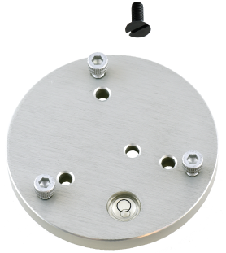
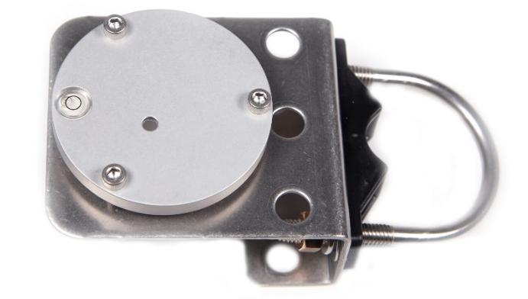
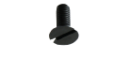
Model: AL-100
Nylon Screw: 10-32 x 5/8
Nylon Screw: 10-32 x 5/8
Model: AL-120

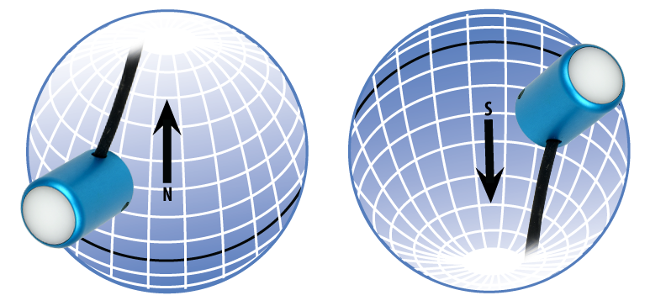
To minimize azimuth error, the sensor should be mounted with the cable pointing toward true north in the northern hemisphere or true south in the southern hemisphere. Azimuth error is typically less than 0.5 %, but it is easy to minimize by proper cable orientation.

In addition to orienting the cable to point toward the nearest pole, the sensor should also be mounted such that obstructions (e.g., weather station tripod/tower or other instrumentation) do not shade the sensor. Once mounted, the blue cap should be removed from the sensor. The blue cap can be used as a protective covering for the sensor when it is not in use.

Cable Connectors
Apogee started offering in-line cable connectors on some bare-lead wire sensors in March 2018 to simplify the process of removing sensors from installations for recalibration (the entire cable does not have to be removed from the station and shipped with the sensor).  The ruggedized M8 connectors are rated IP68, made of corrosion-resistant marine-grade stainless-steel, and designed for extended use in harsh environmental conditions. | 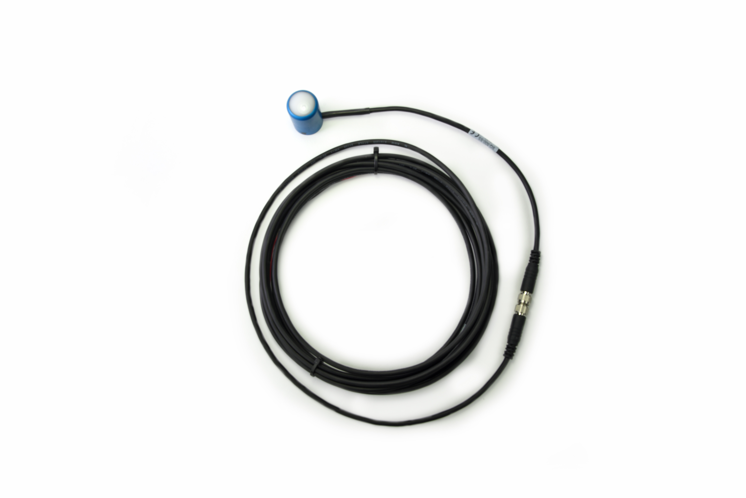  Inline cable connectors are installed 30 cm from the sensor head.
Instructions
Pins and Wiring Colors: All Apogee connectors have six pins, but not all pins are used for every sensor. There may also be unused wire colors inside the cable. To simplify connection to a measurement device, the unused pigtail lead wire colors are removed.  If a replacement cable is required, please contact Apogee directly to ensure ordering the proper pigtail configuration.  Alignment: When reconnecting a sensor, arrows on the connector jacket and an aligning notch ensure proper orientation.  Disconnection for extended periods: When disconnecting the sensor for an extended period of time from an installation, protect the remaining half of the connector still on the station from water and dirt with electrical tape or other method. | 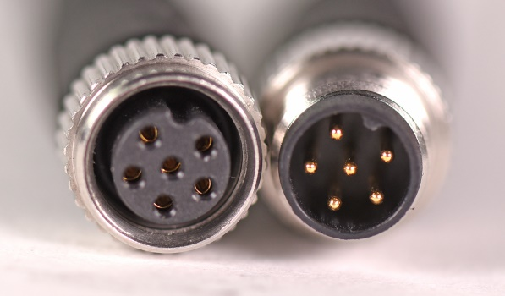  A reference notch inside the connector ensures  proper alignment before tightening.  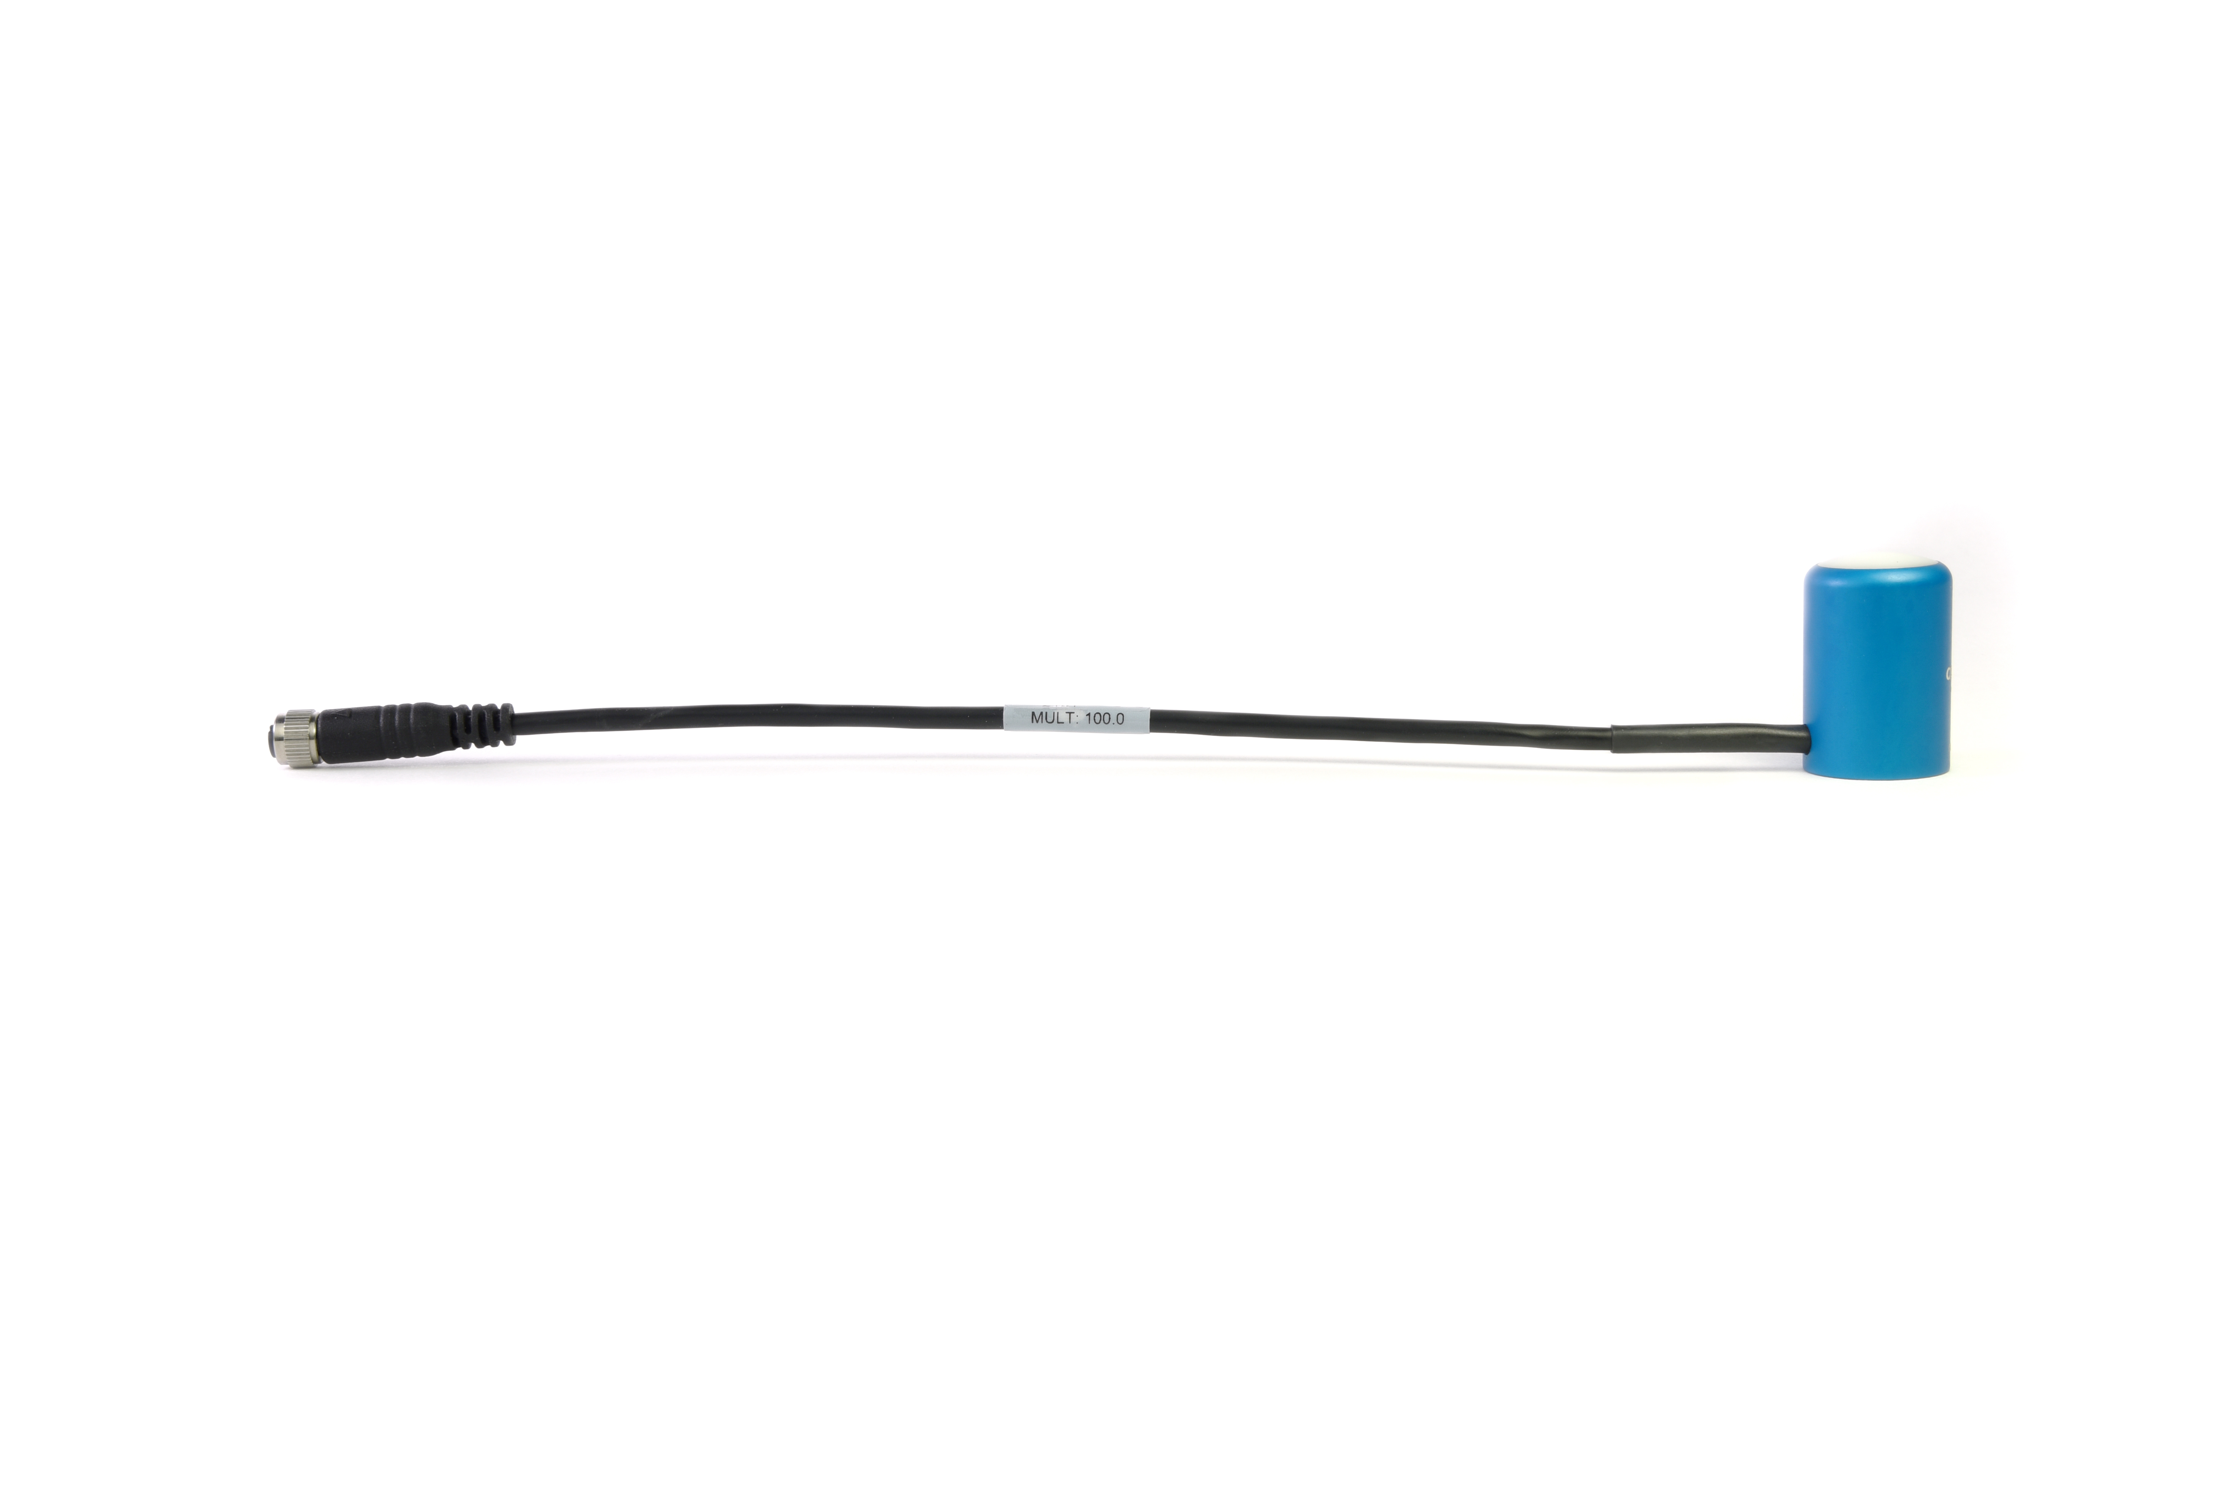  When sending sensors back for recalibration, only send the section of cable that is hard-wired to the sensor. The section of cable with the pigtail is not required.
Tightening: Connectors are designed to be firmly finger-tightened only. There is an O-ring inside the connector that can be overly compressed if a wrench is used. Pay attention to thread alignment to avoid cross-threading. When fully tightened, one to two threads may still be visible.  WARNING: Do not tighten the connector by twisting the black cable, only twist the metal connector. | 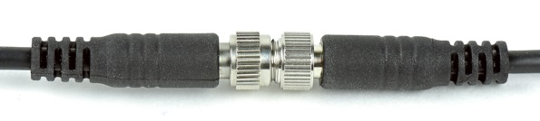  Finger-tighten firmly.

Operation and Measurement

Connect the sensor to a measurement device (meter, datalogger, controller) capable of measuring and displaying or recording a millivolt signal (an input measurement range of approximately 0 to 25 mV is required to cover the entire range of PPFD from the sun). In order to maximize measurement resolution and signal-to-noise ratio, the input range of the measurement device should closely match the output range of the quantum sensor. DO NOT connect the sensor to a power source. The sensor is self-powered and applying voltage will damage the sensor.

VERY IMPORTANT: Apogee changed all wiring colors of our bare-lead sensors in March 2018 in conjunction with the release of inline cable connectors on some sensors. To ensure proper connection to your data device, please note your serial number or if your sensor has a stainless-steel connector 30 cm from the sensor head then use the appropriate wiring configuration below.

Wiring for SQ-500 Serial Numbers 1559 and above or with a cable connector
White: Positive (signal from sensor)

Black: Negative (signal from sensor)

Clear: Shield/Ground
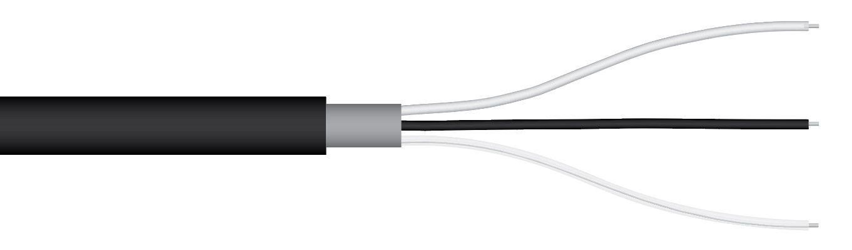

Wiring for SQ-500 Serial Numbers within range 0-1558

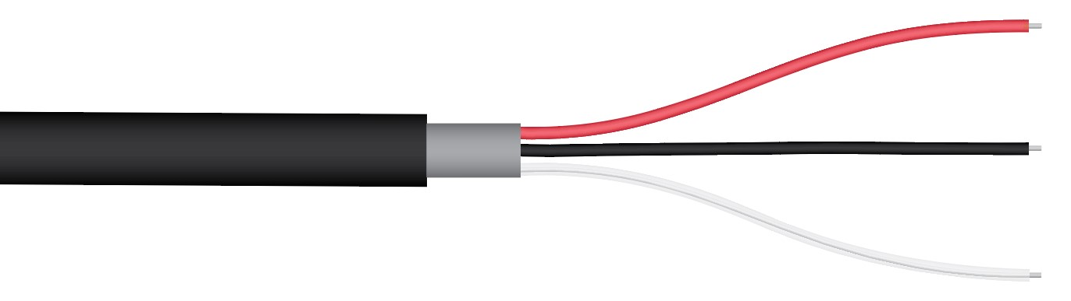
Red: Positive (signal from sensor)
Black: Negative (signal from sensor)
Clear: Shield/Ground

Sensor Calibration
Apogee un-amplified full spectrum quantum sensors, model SQ-500, have a standard PPFD calibration factor of exactly:
100.0 µmol m⁻² s⁻¹ per mV
Multiply this calibration factor by the measured voltage to convert sensor output to PPFD in units of µmol m⁻² s⁻¹:
Calibration Factor (100 µmol m⁻² s⁻¹ per mV) * Sensor Output Signal (mV) = PPFD (µmol m⁻² s⁻¹)
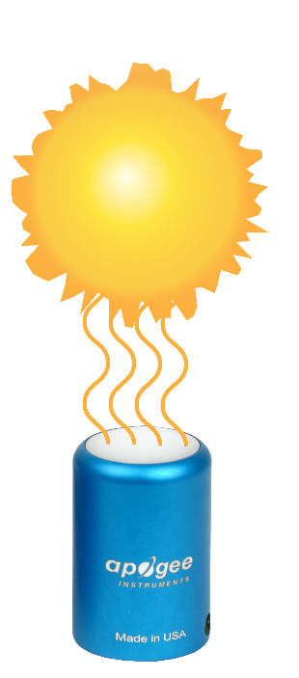
100 * 20 = 2000
Sensor Output
20 mV
Full Sunlight
(2000 µmol m⁻²s⁻¹)
Example of PPFD measurement with an Apogee model SQ-500 quantum sensor. Full sunlight yields a PPFD on a horizontal plane at the Earth’s surface of approximately 2000 µmol m⁻² s⁻¹. This yields an output signal of 20 mV. The signal is converted to PPFD by multiplying by the calibration factor of 100.0 µmol m⁻² s⁻¹ per mV.

Spectral Error
The combination of diffuser transmittance, interference filter transmittance, and photodetector sensitivity yields spectral response of a quantum sensor. A perfect photodetector/filter/diffuser combination would exactly match the defined plant photosynthetic response to photons (equal weighting to all photons between 400 and 700 nm, no weighting of photons outside this range), but this is challenging in practice. Mismatch between the defined plant photosynthetic response and sensor spectral response results in spectral error when the sensor is used to measure radiation from sources with a different spectrum than the radiation source used to calibrate the sensor (Federer and Tanner, 1966; Ross and Sulev, 2000).
Spectral errors for PPFD measurements made under common radiation sources for growing plants were calculated for Apogee SQ-100 and SQ-500 series quantum sensors using the method of Federer and Tanner (1966). This method requires PPFD weighting factors (defined plant photosynthetic response), measured sensor spectral response (shown in Spectral Response section on page 7), and radiation source spectral outputs (measured with a spectroradiometer). Note, this method calculates spectral error only and does not consider calibration, directional (cosine), temperature, and stability/drift errors. Spectral error data (listed in table below) indicate errors less than 5 % for sunlight in different conditions (clear, cloudy, reflected from plant canopies, transmitted below plant canopies) and common broad spectrum electric lamps (cool white fluorescent, metal halide, high pressure sodium), but larger errors for different mixtures of light emitting diodes (LEDs) for the SQ-100 series sensors. Spectral errors for the SQ-500 series sensors are smaller than those for SQ-100 series sensors because the spectral response of SQ-500 series sensors is a closer match to the defined plant photosynthetic response.
Quantum sensors are the most common instrument for measuring PPFD, because they are about an order of magnitude lower cost the spectroradiometers, but spectral errors must be considered. The spectral errors in the table below can be used as correction factors for individual radiation sources.
Spectral Errors for PPFD Measurements with Apogee SQ-100 and SQ-500 Series Quantum Sensors
Radiation Source (Error Calculated Relative to Sun, Clear Sky) | SQ-100 Series  PPFD Error [%] | SQ-500 Series  PPFD Error [%]
Sun (Clear Sky) | 0.0 | 0.0
Sun (Cloudy Sky) | 0.2 | 0.1
Reflected from Grass Canopy | 3.8 | -0.3
Transmitted below Wheat Canopy | 4.5 | 0.1
Cool White Fluorescent (T5) | 0.0 | 0.1
Metal Halide | -2.8 | 0.9
Ceramic Metal Halide | -16.1 | 0.3
High Pressure Sodium | 0.2 | 0.1
Blue LED (448 nm peak, 20 nm full-width half-maximum) | -10.5 | -0.7
Green LED (524 nm peak, 30 nm full-width half-maximum) | 8.8 | 3.2
Red LED (635 nm peak, 20 nm full-width half-maximum) | 2.6 | 0.8
Red LED (667 nm peak, 20 nm full-width half-maximum) | -62.1 | 2.8
Red, Blue LED Mixture (80 % Red, 20 % Blue) | -72.8 | -3.9
Red, Blue, White LED Mixture (60 % Red, 25 % White, 15 % Blue) | -35.5 | -2.0
Cool White LED | -3.3 | 0.5
Warm White LED | -8.9 | 0.2

Federer, C.A., and C.B. Tanner, 1966. Sensors for measuring light available for photosynthesis. Ecology 47:654-657.
Ross, J., and M. Sulev, 2000. Sources of errors in measurements of PAR. Agricultural and Forest Meteorology 100:103-125.

Yield Photon Flux Density (YPFD) Measurements
Photosynthesis in plants does not respond equally to all photons. Relative quantum yield (plant photosynthetic efficiency) is dependent on wavelength (green line in figure below) (McCree, 1972a; Inada, 1976). This is due to the combination of spectral absorptivity of plant leaves (absorptivity is higher for blue and red photons than green photons) and absorption by non-photosynthetic pigments. As a result, photons in the wavelength range of approximately 600-630 nm are the most efficient.
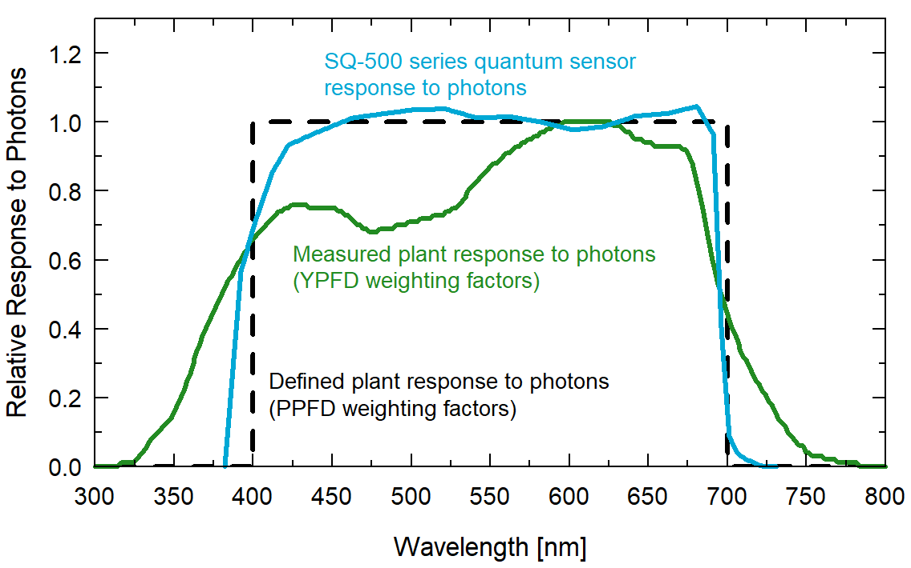
Defined plant response to photons (black line, weighting factors used to calculate PPFD), measured plant response to photons (green line, weighting factors used to calculate YPFD), and SQ-500 series quantum sensor response to photons (sensor spectral response).

One potential definition of PAR is weighting photon flux density in units of μmol m⁻² s⁻¹ at each wavelength between 300 and 800 nm by measured relative quantum yield and summing the result. This is defined as yield photon flux density (YPFD, units of μmol m⁻² s⁻¹) (Sager et al., 1988). There are uncertainties and challenges associated with this definition of PAR. Measurements used to generate the relative quantum yield data were made on single leaves under low radiation levels and at short time scales (McCree, 1972a; Inada, 1976). Whole plants and plant canopies typically have multiple leaf layers and are generally grown in the field or greenhouse over the course of an entire growing season. Thus, actual conditions plants are subject to are likely different than those the single leaves were in when measurements were made by McCree (1972a) and Inada (1976). In addition, relative quantum yield shown in the figure above is the mean from twenty-two species grown in the field (McCree, 1972a). Mean relative quantum yield for the same species grown in growth chambers was similar, but there were differences, particularly at shorter wavelengths (less than 450 nm). There was also some variability between species (McCree, 1972a; Inada, 1976).
McCree (1972b) found that equally weighting all photons between 400 and 700 nm and summing the result, defined as photosynthetic photon flux density (PPFD, in units of μmol m⁻² s⁻¹), was well correlated to photosynthesis, and very similar to correlation between YPFD and photosynthesis. As a matter of practicality, PPFD is a simpler definition of PAR. At the same time as McCree’s work, others had proposed PPFD as an accurate measure of PAR and built sensors that approximated the PPFD weighting factors (Biggs et al., 1971; Federer and Tanner, 1966). Correlation between PPFD and YPFD measurements for several radiation sources is very high (figure below), as an approximation, YPFD = 0.9PPFD. As a result, almost universally PAR is defined as PPFD rather than YPFD, although YPFD has been used in some studies. The only radiation sources shown (figure below) that don’t fall on the regression line are the high-pressure sodium (HPS) lamp, reflection from a plant canopy, and transmission below a plant canopy. A large fraction of radiation from HPS lamps is in the red range of wavelengths where the YPFD weighting factors (measured relative quantum yield) are at or near one. The factor for converting PPFD to YPFD for HPS lamps is 0.95, rather than 0.90. The factor for converting PPFD to YPFD for reflected and transmitted photons is 1.00
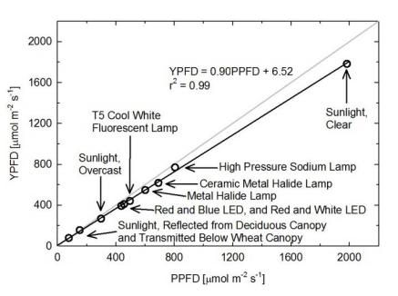
Correlation between photosynthetic photon flux density (PPFD) and yield photon flux density (YPFD) for multiple different radiation sources. YPFD is approximately 90 % of PPFD. Measurements were made with a spectroradiometer (Apogee Instruments model PS-200) and weighting factors shown in the previous figure were used to calculate PPFD and YPFD.
Biggs, W., A.R. Edison, J.D. Eastin, K.W. Brown, J.W. Maranville, and M.D. Clegg, 1971. Photosynthesis light sensor and meter. Ecology 52:125-131.
Federer, C.A., and C.B. Tanner, 1966. Sensors for measuring light available for photosynthesis. Ecology 47:654-657.
Inada, K., 1976. Action spectra for photosynthesis in higher plants. Plant and Cell Physiology 17:355-365.
McCree, K.J., 1972a. The action spectrum, absorptance and quantum yield of photosynthesis in crop plants. Agricultural Meteorology 9:191-216.
McCree, K.J., 1972b. Test of current definitions of photosynthetically active radiation against leaf photosynthesis data. Agricultural Meteorology 10:443-453.
Sager, J.C., W.O. Smith, J.L. Edwards, and K.L. Cyr, 1988. Photosynthetic efficiency and phytochrome photoequilibria determination using spectral data. Transactions of the ASAE 31:1882-1889.

Underwater Measurements and Immersion Effect
When a quantum sensor that was calibrated in air is used to make underwater measurements, the sensor reads

Immersion Effect Correction Factor
When a radiation sensor is submerged in water, more of the incident radiation is backscattered out of the diffuser than when the sensor is in air (Smith, 1969; Tyler and Smith, 1970). This phenomenon is caused by the difference in the refractive index for air (1.00) and water (1.33) and is called the immersion effect. Without correction for the immersion effect, radiation sensors calibrated in air can only provide relative values underwater (Smith, 1969; Tyler and Smith, 1970). Immersion effect correction factors can be derived by making measurements in air and at multiple water depths at a constant distance from a lamp in a controlled laboratory setting.
Apogee SQ-500 series quantum sensors have an immersion effect correction factor of 1.25 (serial numbers 2876 and above) or 1.32 (serial numbers 0-2875). This correction factor should be multiplied by PPFD measurements made underwater to yield accurate PPFD.
Further information on underwater measurements and the immersion effect can be found on the Apogee webpage (http://www.apogeeinstruments.com/underwater-par-measurements/).

Smith, R.C., 1969. An underwater spectral irradiance collector. Journal of Marine Research 27:341-351.
Tyler, J.E., and R.C. Smith, 1970. Measurements of Spectral Irradiance Underwater. Gordon and Breach, New York, New York. 103 pages.

Maintenance and Recalibration
Blocking of the optical path between the target and detector can cause low readings. Occasionally, accumulated materials on the diffuser of the upward-looking sensor can block the optical path in three common ways:
- Moisture or debris on the diffuser.
- Dust during periods of low rainfall.
- Salt deposit accumulation from evaporation of sea spray or sprinkler irrigation water.
Apogee Instruments upward-looking sensors have a domed diffuser and housing for improved self-cleaning from rainfall, but active cleaning may be necessary. Dust or organic deposits are best removed using water, or window cleaner, and a soft cloth or cotton swab. Salt deposits should be dissolved with vinegar and removed with a cloth or cotton swab. Salt deposits cannot be removed with solvents such as alcohol or acetone. Use only gentle pressure when cleaning the diffuser with a cotton swab or soft cloth to avoid scratching the outer surface. The solvent should be allowed to do the cleaning, not mechanical force. Never use abrasive material or cleaner on the diffuser.
Although Apogee sensors are very stable, nominal accuracy drift is normal for all research-grade sensors. To ensure maximum accuracy, we generally recommend sensors are sent in for recalibration every two years, although you can often wait longer according to your particular tolerances.
To determine if a specific sensor needs recalibration, the Clear Sky Calculator (www.clearskycalculator.com) website and/or smartphone app can be used to indicate PPFD incident on a horizontal surface at any time of day at any location in the world. It is most accurate when used near solar noon in spring and summer months, where accuracy over multiple clear and unpolluted days is estimated to be ± 4 % in all climates and locations around the world. For best accuracy, the sky must be completely clear, as reflected radiation from clouds causes incoming radiation to increase above the value predicted by the clear sky calculator. Measured PPFD can exceed PPFD predicted by the Clear Sky Calculator due to reflection from thin, high clouds and edges of clouds, which enhances incident PPFD. The influence of high clouds typically shows up as spikes above clear sky values, not a constant offset greater than clear sky values.
To determine recalibration need, input site conditions into the calculator and compare PPFD measurements to calculated PPFD for a clear sky. If sensor PPFD measurements over multiple days near solar noon are consistently different than calculated PPFD (by more than 6 %), the sensor should be cleaned and re-leveled. If measurements are still different after a second test, email calibration@apogeeinstruments.com to discuss test results and possible return of sensor(s).
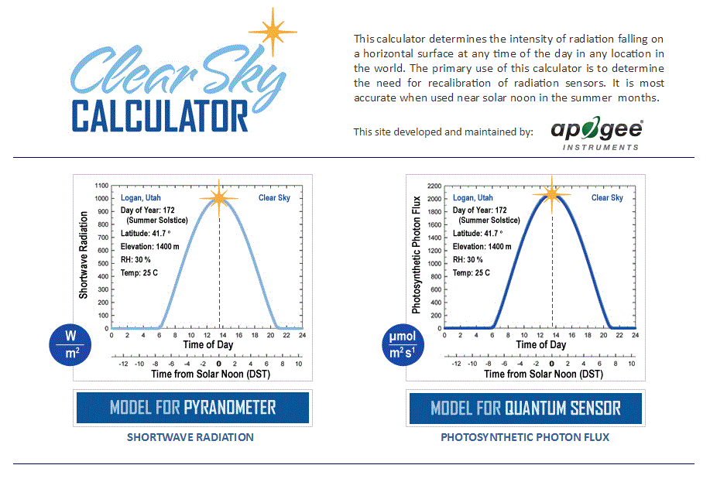
Homepage of the Clear Sky Calculator. Two calculators are available: one for quantum sensors (PPFD) and one for pyranometers (total shortwave radiation).

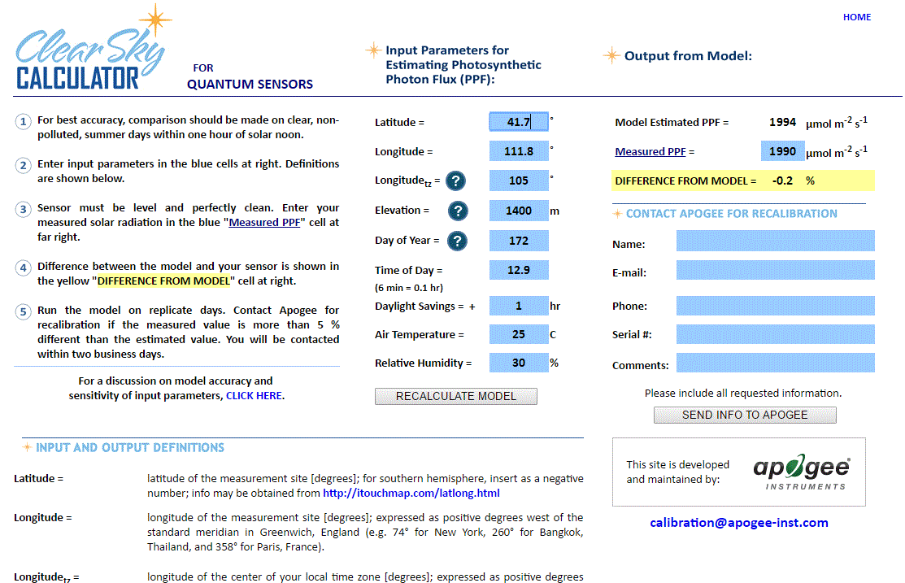
Clear Sky Calculator for quantum sensors. Site data are input in blue cells in middle of page and an estimate of PPFD is returned on right-hand side of page.

Troubleshooting and Customer Support
Independent Verification of Functionality
Apogee SQ-500 series quantum sensors are self-powered devices and output an analog signal proportional to incident PPFD. A quick and easy check of sensor functionality can be determined using a voltmeter with millivolt resolution. Connect the positive lead wire from the voltmeter to the white wire from the sensor and the negative (or common) lead wire from the voltmeter to the black wire from the sensor. Direct the sensor head toward a light source and verify the sensor provides a signal. Increase and decrease the distance from the sensor head to the light source to verify that the signal changes proportionally (decreasing signal with increasing distance and increasing signal with decreasing distance). Blocking all radiation from the sensor should force the sensor signal to zero.
Compatible Measurement Devices (Dataloggers/Controllers/Meters)
Model SQ-500 quantum sensors are calibrated with a standard calibration factor of 100.0 µmol m⁻² s⁻¹ per mV, yielding a sensitivity of 0.01 mV per µmol m⁻² s⁻¹. Thus, a compatible measurement device (e.g., datalogger or controller) should have resolution of at least 0.01 mV in order to provide PPFD resolution of 1 µmol m⁻² s⁻¹ and at least 0.001 mV in order to provide PPFD resolution of 0.1 µmol m⁻² s⁻¹.
An example datalogger program for Campbell Scientific dataloggers can be found on the Apogee webpage at http://www.apogeeinstruments.com/content/Full-Spectrum-Quantum-Sensor-Unamplified.CR1.
Cable Length
When the sensor is connected to a measurement device with high input impedance, sensor output signals are not changed by shortening the cable or splicing on additional cable in the field. Tests have shown that if the input impedance of the measurements device is greater than 1 mega-ohm there is negligible effect on the calibration, even after adding up to 100 m of cable. All Apogee sensors use shielded, twisted pair cable to minimize electromagnetic interference. For best measurements, the shield wire must be connected to an earth ground. This is particularly important when using the sensor with long lead lengths in electromagnetically noisy environments.
Modifying Cable Length
See Apogee webpage for details on how to extend sensor cable length: (http://www.apogeeinstruments.com/how-to-make-a-weatherproof-cable-splice/).
Unit Conversion Charts
Apogee SQ-500 series quantum sensors are calibrated to measure PPFD in units of µmol m⁻² s⁻¹. Units other than photon flux density (e.g., energy flux density, illuminance) may be required for certain applications. It is possible to convert PPFD from a quantum sensor to other units, but it requires spectral output of the radiation source of interest. Conversion factors for common radiation sources can be found in the Knowledge Base on the Apogee website (http://www.apogeeinstruments.com/knowledge-base/; scroll down to Quantum Sensors section). A spreadsheet to convert PPFD to energy flux density or illuminance is also provided in the Knowledge Base on the Apogee website (http://www.apogeeinstruments.com/content/PPFD-to-Illuminance-Calculator.xls).

Return and Warranty Policy

RETURN POLICY
Apogee Instruments will accept returns within 30 days of purchase as long as the product is in new condition (to be determined by Apogee). Returns are subject to a 10 % restocking fee.

WARRANTY POLICY
What is Covered
All products manufactured by Apogee Instruments are warranted to be free from defects in materials and craftsmanship for a period of four (4) years from the date of shipment from our factory. To be considered for warranty coverage an item must be evaluated by Apogee.
Products not manufactured by Apogee (spectroradiometers, chlorophyll content meters, EE08-SS probes) are covered for a period of one (1) year.
What is Not Covered
The customer is responsible for all costs associated with the removal, reinstallation, and shipping of suspected warranty items to our factory.
The warranty does not cover equipment that has been damaged due to the following conditions:
1. Improper installation, use, or abuse.
2. Operation of the instrument outside of its specified operating range.
3. Natural occurrences such as lightning, fire, etc.
4. Unauthorized modification.
5. Improper or unauthorized repair.
Please note that nominal accuracy drift is normal over time. Routine recalibration of sensors/meters is considered part of proper maintenance and is not covered under warranty.
Who is Covered
This warranty covers the original purchaser of the product or other party who may own it during the warranty period.
What Apogee Will Do
At no charge Apogee will:
1. Either repair or replace (at our discretion) the item under warranty.
2. Ship the item back to the customer by the carrier of our choice.
Different or expedited shipping methods will be at the customer’s expense.

How To Return An Item
1. Please do not send any products back to Apogee Instruments until you have received a Return Merchandise Authorization (RMA) number from our technical support department by submitting an online RMA form at www.apogeeinstruments.com/tech-support-recalibration-repairs/. We will use your RMA number for tracking of the service item. Call (435) 245-8012 or email techsupport@apogeeinstruments.com with questions.
2. For warranty evaluations, send all RMA sensors and meters back in the following condition: Clean the sensor’s exterior and cord. Do not modify the sensors or wires, including splicing, cutting wire leads, etc. If a connector has been attached to the cable end, please include the mating connector – otherwise the sensor connector will be removed in order to complete the repair/recalibration. Note: When sending back sensors for routine calibration that have Apogee’s standard stainless-steel connectors, you only need to send the sensor with the 30 cm section of cable and one-half of the connector. We have mating connectors at our factory that can be used for calibrating the sensor.
3. Please write the RMA number on the outside of the shipping container.
4. Return the item with freight pre-paid and fully insured to our factory address shown below. We are not responsible for any costs associated with the transportation of products across international borders.
Apogee Instruments, Inc.
721 West 1800 North Logan, UT
84321, USA
5. Upon receipt, Apogee Instruments will determine the cause of failure. If the product is found to be defective in terms of operation to the published specifications due to a failure of product materials or craftsmanship, Apogee Instruments will repair or replace the items free of charge. If it is determined that your product is not covered under warranty, you will be informed and given an estimated repair/replacement cost.

Products Beyond the Warranty Period
For issues with sensors beyond the warranty period, please contact Apogee at techsupport@apogeeinstruments.com to discuss repair or replacement options.

Other Terms
The available remedy of defects under this warranty is for the repair or replacement of the original product, and Apogee Instruments is not responsible for any direct, indirect, incidental, or consequential damages, including but not limited to loss of income, loss of revenue, loss of profit, loss of data, loss of wages, loss of time, loss of sales, accruement of debts or expenses, injury to personal property, or injury to any person or any other type of damage or loss.
This limited warranty and any disputes arising out of or in connection with this limited warranty ("Disputes") shall be governed by the laws of the State of Utah, USA, excluding conflicts of law principles and excluding the Convention for the International Sale of Goods. The courts located in the State of Utah, USA, shall have exclusive jurisdiction over any Disputes.
This limited warranty gives you specific legal rights, and you may also have other rights, which vary from state to state and jurisdiction to jurisdiction, and which shall not be affected by this limited warranty. This warranty extends only to you and cannot by transferred or assigned. If any provision of this limited warranty is unlawful, void, or unenforceable, that provision shall be deemed severable and shall not affect any remaining provisions. In case of any inconsistency between the English and other versions of this limited warranty, the English version shall prevail.
This warranty cannot be changed, assumed, or amended by any other person or agreement
APOGEE INSTRUMENTS, INC. | 721 WEST 1800 NORTH, LOGAN, UTAH 84321, USA
TEL: (435) 792-4700 | FAX: (435) 787-8268 | WEB: APOGEEINSTRUMENTS.COM
Copyright © 2022 Apogee Instruments, Inc.

