

Owner’s Manual

ePAR Sensor
Model SQ-616
Rev: 11-July-2025
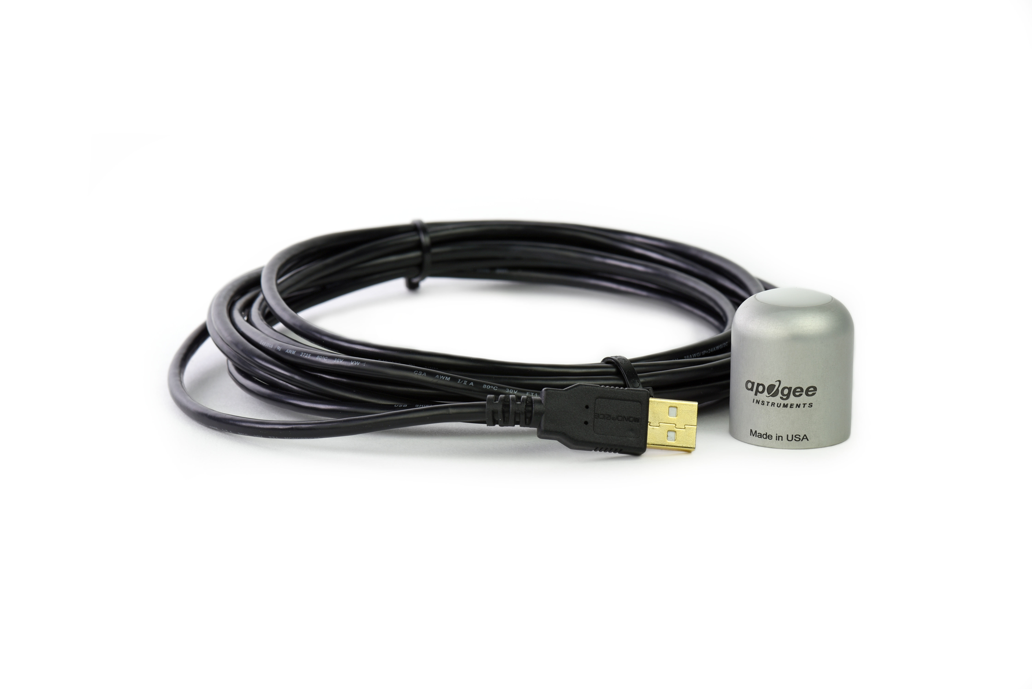

Table of Contents
Owner’s Manual 1
Certificates of Compliance 3
Introduction 5
Sensor Models 7
Specifications 8
Deployment and Installation 11
Software Installation 12
Operation and Measurement 13
Windows Software 15
Mac Software 20
Maintenance and Recalibration 25
Troubleshooting and Customer Support 26
Return and Warranty Policy 27

Certificate of Compliance

EU Declaration of Conformity
This declaration of conformity is issued under the sole responsibility of the manufacturer:
Apogee Instruments, Inc.
721 W 1800 N
Logan, Utah 84321
USA
for the following product(s):

Models: SQ-616
Type: ePAR Sensor

The object of the declaration described above is in conformity with the relevant Union harmonization legislation:

2014/30/EU Electromagnetic Compatibility (EMC) Directive
2011/65/EU Restriction of Hazardous Substances (RoHS 2) Directive
2015/863/EU Amending Annex II to Directive 2011/65/EU (RoHS 3)

Standards referenced during compliance assessment:

EN 61326-1:2013 Electrical equipment for measurement, control, and laboratory use – EMC requirements
EN 63000:2018 Technical documentation for the assessment of electrical and electronic products with respect to the restriction of hazardous substances

Please be advised that based on the information available to us from our raw material suppliers, the products manufactured by us do not contain, as intentional additives, any of the restricted materials including lead (see note below), mercury, cadmium, hexavalent chromium, polybrominated biphenyls (PBB), polybrominated diphenyls (PBDE), bis (2-ethylhexyl) phthalate (DEHP), butyl benzyl phthalate (BBP), dibutyl phthalate (DBP), and diisobutyl phthalate (DIBP). However, please note that articles containing greater than 0.1 % lead concentration are RoHS 3 compliant using exemption 6c.

Further note that Apogee Instruments does not specifically run any analysis on our raw materials or end products for the presence of these substances, but we rely on the information provided to us by our material suppliers.

Signed for and on behalf of:
Apogee Instruments, August 2024


Bruce Bugbee
President
Apogee Instruments, Inc.

Certificate of Compliance

UK Declaration of Conformity
This declaration of conformity is issued under the sole responsibility of the manufacturer:
Apogee Instruments, Inc.
721 W 1800 N
Logan, Utah 84321
USA
for the following product(s):

Models: SQ-616
Type: ePAR Sensor

The object of the declaration described above is in conformity with the relevant UK Statutory Instruments and their amendments:

2016 No. 1091 The Electromagnetic Compatibility Regulations 2016
2012 No. 3032 The Restriction of the Use of Certain Hazardous Substances in Electrical and Electronic Equipment Regulations 2012

Standards referenced during compliance assessment:

BS EN 61326-1:2013 Electrical equipment for measurement, control, and laboratory use – EMC requirements
BS EN 63000:2018 Technical documentation for the assessment of electrical and electronic products with respect to the restriction of hazardous substances

Please be advised that based on the information available to us from our raw material suppliers, the products manufactured by us do not contain, as intentional additives, any of the restricted materials including lead (see note below), mercury, cadmium, hexavalent chromium, polybrominated biphenyls (PBB), polybrominated diphenyls (PBDE), bis (2-ethylhexyl) phthalate (DEHP), butyl benzyl phthalate (BBP), dibutyl phthalate (DBP), and diisobutyl phthalate (DIBP). However, please note that articles containing greater than 0.1 % lead concentration are RoHS 3 compliant using exemption 6c.

Further note that Apogee Instruments does not specifically run any analysis on our raw materials or end products for the presence of these substances, but we rely on the information provided to us by our material suppliers.

Signed for and on behalf of:
Apogee Instruments, August 2024

Bruce Bugbee
President
Apogee Instruments, Inc.

Introduction
Radiation that drives photosynthesis is called photosynthetically active radiation (PAR) and, historically, is defined as total radiation across a range of 400 to 700 nm. PAR is almost universally quantified as photosynthetic photon flux density (PPFD) in units of micromoles per square meter per second (µmol m⁻² s⁻¹, equal to microEinsteins per square meter per second) summed from 400 to 700 nm (total number of photons from 400 to 700 nm). However, ultraviolet and far-red photons outside the defined PAR range of 400-700 nm can also contribute to photosynthesis and influence plant responses (e.g., flowering).
Data from recent studies indicate that far-red photons synergistically interact with photons in the historically defined PAR range of 400-700 nm to increase photochemical efficiency in leaves (Hogewoning et al., 2012; Murakami et al., 2018; Zhen and van Iersel, 2017; Zhen et al., 2019). Measurements from whole plants and plant canopies indicate adding far-red photons (using far-red LEDs with peaks near 735 nm and outputting photons across a range of about 700-750 nm) to radiation sources outputting photons in the 400-700 nm range increases canopy photosynthesis equal to the addition of the same number of photons in the 400-700 nm range for multiple species, and C3 and C4 photosynthetic pathways, but far-red photons alone are photosynthetically inefficient and result in minimal photosynthesis (Zhen and Bugbee, 2020a; Zhen and Bugbee, 2020b).
This research suggests that far-red photons drive canopy photosynthesis with similar efficiency as photons in the traditional PAR range when they are acting synergistically with photons in the 400-700 nm range, meaning when far-red photons are added to radiation sources outputting 400-700 nm photons. Thus, far-red photons need to be included in the definition of PAR (Zhen et al., 2021).
Sensors that measure PPFD are often called quantum sensors due to the quantized nature of radiation. A quantum refers to the minimum quantity of radiation, one photon, involved in physical interactions (e.g., absorption by photosynthetic pigments). In other words, one photon is a single quantum of radiation. Sensors that function like traditional quantum sensors but measure a wider range of wavelengths can be thought of as an ‘extended range’ quantum sensor.
Typical applications of traditional quantum sensors include incoming PPFD measurement over plant canopies in outdoor environments or in greenhouses and growth chambers and reflected or under-canopy (transmitted) PPFD measurement in the same environments. The extended photosynthetically active radiation (ePAR) sensor detailed in this manual uses a detector that is sensitive to radiation from 383-757 nm ± 5 nm, which allows it to measure photons from Far-red.
Apogee Instruments SQ-600 series ePAR sensors consist of a cast acrylic diffuser (filter), photodiode, and signal processing circuitry mounted in an anodized aluminum housing. A cable to connect the sensor to a measurement device is also included. SQ-600 series ePAR sensors are designed for continuous photon flux density measurements in indoor or outdoor environments. SQ-610 models output an analog signal that is directly proportional to photon flux density. The analog signal from the sensor is directly proportional to radiation incident on a planar surface (does not have to be horizontal), where the radiation emanates from all angles of a hemisphere.

Hogewoning et al. 2012. Photosynthetic Quantum Yield Dynamics: From Photosystems to Leaves. The Plant Cell, 24: 1921–1935.
Murakami et al. 2018. A Mathematical Model of Photosynthetic Electron Transport in Response to the Light Spectrum Based on Excitation Energy Distributed to Photosystems. Plant Cell Physiology. 59(8): 1643–1651.
Zhen and Van Iersel. 2017. Far-red light is needed for efficient photochemistry and photosynthesis. Journal of Plant Physiology. 209: 115–122.
Zhen et al. 2019. Far-red light enhances photochemical efficiency in a wavelength-dependent manner. Physiologia Plantarum. 167(1):21-33.
Zhen and Bugbee. 2020a. Far-red photons have equivalent efficiency to traditional photosynthetic photons: Implications for redefining photosynthetically active radiation. Plant Cell and Environment. 2020; 1–14.
Zhen and Bugbee. 2020b. Substituting Far-Red for Traditionally Defined Photosynthetic Photons Results in Equal Canopy Quantum Yield for CO₂ Fixation and Increased Photon Capture During Long-Term Studies: Implications for Re-Defining PAR. Frontiers in Plant Science. 11:1-14.
Zhen et al. 2021. Why Far-Red Photons Should Be Included in the Definition of Photosynthetic Photons and the Measurement of Horticultural Fixture Efficacy. Frontiers in Plant Science. 12:1-4.

Sensor Models
This manual covers the USB quantum sensor, model SQ-616 (listed in bold below). Additional models are covered in their respective manuals.

Model | Signal
SQ-610 | Self-powered
SQ-612 | 0-2.5 V
SQ-614 | 4-20 mA
SQ-615 | 0-5 V
SQ-616 | USB
SQ-617 | SDI-12
SQ-618 | Modbus

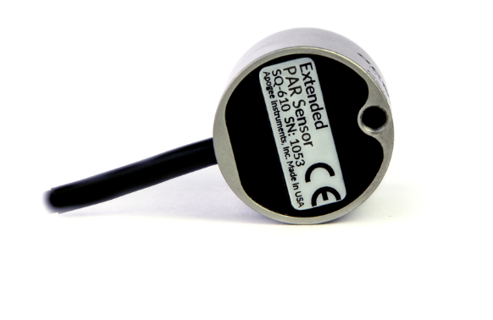
A sensor’s model number and serial number are located on the bottom of the sensor. If the manufacturing date of a specific sensor is required, please contact Apogee Instruments with the serial number of the sensor.

Specifications
 | SQ-616
Resolution | 0.1 µmol m⁻² s⁻¹
Calibration Factor | Custom for each sensor and stored in the firmware
Calibration Uncertainty | ± 5 % (see calibration Traceability below)
Measurement Range | 0 to 4000 µmol m⁻² s⁻¹
Measurement Repeatability | Less than 0.5 %
Long-term Drift  (Non-stability) | Less than 2 % per year
Non-linearity | Less than 1 % (up to 4000 µmol m⁻² s⁻¹)
Response Time | Software updates every second
Field of View | 180°
Spectral Range | Serial numbers 0001-1104: 383 to 757 nm ± 5 nm  Serial numbers 1105 and above: 394 to 747 nm ± 5 nm*  This range represents wavelengths with a response greater than 50 %  See the Spectral Response graph on the next page for a visual representation
Directional (Cosine) Response | ± 2 % at 45° zenith angle, ± 5 % at 75° zenith angle (see Cosine Response below)
Temperature Response | -0.11± 0.04 % per C
Azimuth Error | Less than 0.5 %
Tilt Error | Less than 0.5 %
Housing | Anodized aluminum body with acrylic diffuser
IP Rating | IP68
Operating Environment | -40 to 70 C, 0 to 100 % relative humidity, can be submerged in water up to depths of 30 m
Dimensions | 30.5 mm diameter, 37 mm height
Mass (with 5 m of cable) | 140 g
USB Cable | 4.5 m (15 ft)
Current Draw (when Logging) | 61 mA
*Apogee changed ePAR detectors in August 2024. To determine the proper specifications for your sensor, reference the serial number on the bottom of the sensor. Serial numbers 1105 and above use the new detector.

Calibration Traceability
Apogee Instruments SQ-600 series ePAR sensors are calibrated through side-by-side comparison to the mean of four transfer standard sensors under a reference lamp. The transfer standard sensors are recalibrated with a quartz halogen lamp traceable to the National Institute of Standards and Technology (NIST).
Spectral Response
Mean spectral response measurements of four replicate Apogee SQ-600 series ePAR Sensors. Incremental spectral response measurements were made at 10 nm increments across a wavelength range of 370 to 800 nm in a monochromator with an attached electric light source. Measured spectral data from each quantum sensor were refined and normalized by comparing measured spectral response of the monochromator/electric light combination to measured spectral differences from a quantum sensor reference.

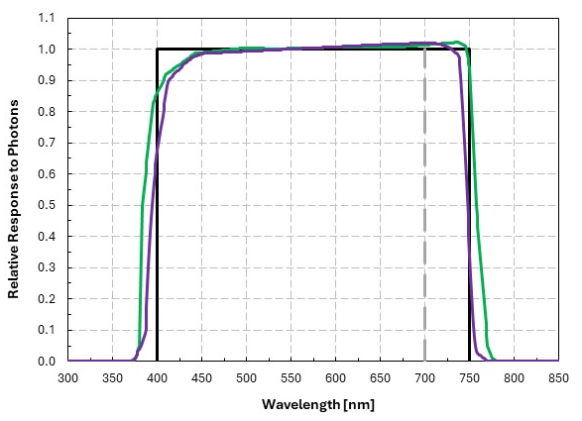

Old detector (SQ-616 sensors serial numbers 0001-1105)
New detector (SQ-616 sensors after serial number 1105)

Cosine Response
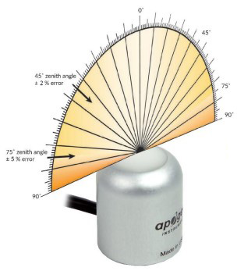
Directional, or cosine, response is defined as the measurement error at a specific angle of radiation incidence. Error for Apogee SQ-600 series ePAR Sensor is approximately ± 2 % and ± 5 % at solar zenith angles of 45° and 75°, respectively.

Mean directional (cosine) response of seven Apogee series quantum sensors. Directional response measurements were made on the rooftop of the Apogee building in Logan, Utah. Directional response was calculated as the relative difference of quantum sensors from the mean of replicate reference quantum sensors (LI-COR models LI-190 and LI-190R, Kipp & Zonen model PQS 1). Data were also collected in the laboratory using a reference lamp and positioning the sensor at varying angles.

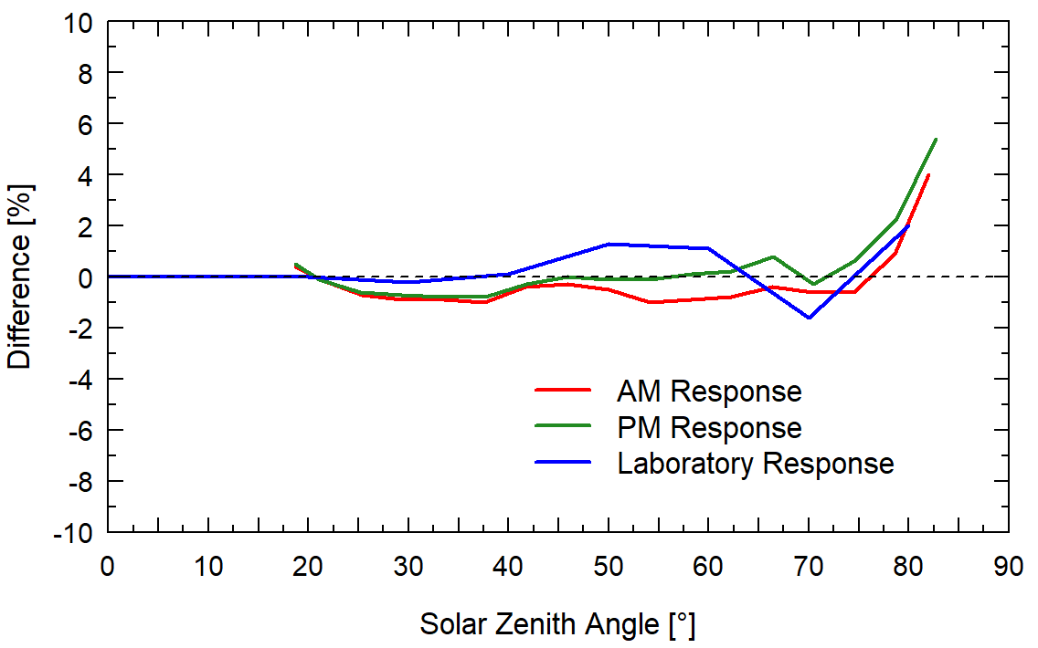

Deployment and Installation
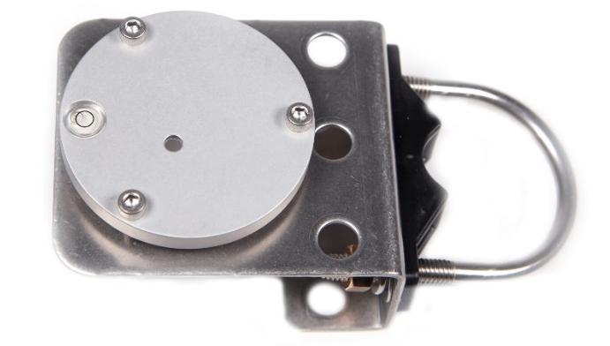
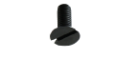
Mount the sensor to a solid surface with the nylon mounting screw provided. To accurately measure photon flux density incident on a horizontal surface, the sensor must be level. An Apogee Instruments model AL-100 leveling plate is recommended for this purpose. To facilitate mounting on a cross arm, an Apogee Instruments model AL-120 mounting bracket is recommended.
Model: AL-100
Nylon Screw: 10-32 x 5/8

Nylon Screw: 10-32 x 5/8
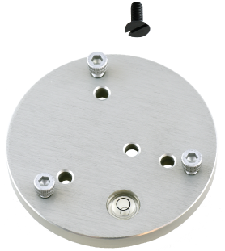
Model: AL-120
To minimize azimuth error, the sensor should be mounted with the cable pointing toward true north in the northern hemisphere or true south in the southern hemisphere. Azimuth error is typically less than 0.5 %, but it is easy to minimize by proper cable orientation.
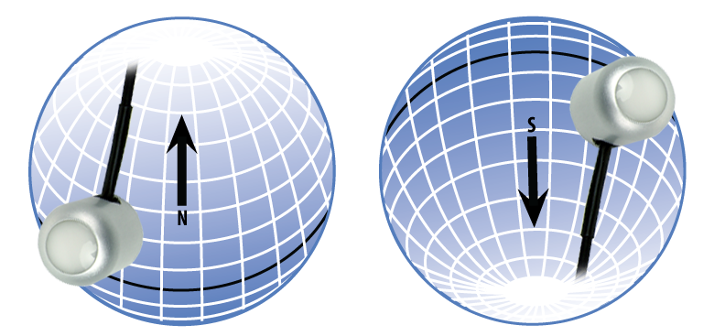
In addition to orienting the cable to point toward the nearest pole, the sensor should also be mounted such that obstructions (e.g., weather station tripod/tower or other instrumentation) do not shade the sensor. Once mounted, the blue cap should be removed from the sensor. The blue cap can be used as a protective covering for the sensor when it is not in use.

Software Installation
The most recent version of ApogeeConnect software can be downloaded at http://www.apogeeinstruments.com/downloads/.

Installing the software on a PC (Windows compatible, XP and later)

- Double click on the installer package:
- On the ‘Welcome’ screen, please click ‘Next’ to continue.
- Select the radio button next to “I Agree” to the UELA… and click ‘Next’ to continue.
- On the ‘Ready to Install the Program’ screen, click ‘Install’ to continue.
- Click ‘Finish’ to complete the installation. There are shortcuts on your desktop and in your start bar.
Installing the software on a Mac (Mac compatible, 10.10 and later)
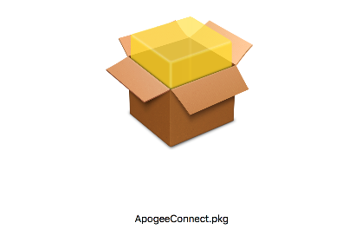

- Double click on the installer package
- On the ‘Introduction’ screen, please click ‘Continue’ to proceed.
- Select ‘Continue’ on the ‘Read Me’ screen to continue, this screen contains a history of updates made to the ApogeeConnect software versions.
- Select ‘Continue’ on the ‘License’ screen to receive a prompt to agree to the terms of the software license agreement. Click ‘Agree’ to continue once you receive the prompt.
- On the ‘Installation Type’ screen, click ‘Install’ to install the software. You can change the location the software installs to by clicking ‘Change Install Location…’. *Note: You may be prompted for an administrator password at this time. If you are, proceed by entering your respective password and clicking ‘Install Software’.
- Once you receive the message “The installation was successful.” on the ‘Summary’ screen click ‘Close’. Your software is now ready to be used.

Operation and Measurement
Underwater Measurements and Immersion Effect
When a radiation sensor is submerged in water, more of the incident radiation is backscattered out of the diffuser than when the sensor is in air (Smith, 1969; Tyler and Smith, 1970). This phenomenon is caused by the difference in the refractive index for air (1.00) and water (1.33) and is called the immersion effect. Without correction for the immersion effect, radiation sensors calibrated in air can only provide relative values underwater (Smith, 1969; Tyler and Smith, 1970). Immersion effect correction factors can be derived by making measurements in air and at multiple water depths at a constant distance from a lamp in a controlled laboratory setting.
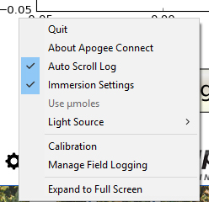
The SQ-616 sensor has an immersion effect correction factor of 1.25. The immersion effect correction factor can be automatically applied to SQ-616 measurements by turning on the immersion setting in the settings option of the ApogeeConnect software, as pictured. Once you are finished making your underwater measurements simply uncheck the immersion setting in the software to turn it off and continue making measurements in air like normal.
When making underwater measurements, only the sensor and cable can go in the water. The USB connector is not waterproof and must not get wet.
Further information on underwater measurements and the immersion effect can be found at http://www.apogeeinstruments.com/underwater-par-measurements/.
Smith, R.C., 1969. An underwater spectral irradiance collector. Journal of Marine Research 27:341-351.
Tyler, J.E., and R.C. Smith, 1970. Measurements of Spectral Irradiance Underwater. Gordon and Breach, New York, New York. 103 pages.
Spectral Error
Quantum sensors are the most common instrument for measuring PPFD, because they are about an order of magnitude lower cost the spectroradiometers, but spectral errors must be considered. The spectral errors in the table on the next page can be used as correction factors for individual radiation sources.

Spectral Errors for PPFD Measurements with Apogee SQ-610 Series ePAR Sensors
Radiation Source (Error Calculated Relative to Sun, Clear Sky) | SQ-610 Series  PPFD Error [%]  SQ-616 serial # after 1104 | SQ-610 Series  PPFD Error [%]  SQ-616 Serial # before 1105
Sun (Clear Sky) | -0.6 | 2.5
Sun (Cloudy Sky) | -0.9 | 2.6
Cool White Fluorescent (T5) | -0.1 | -0.5
Metal Halide | 0.1 | 0.7
Ceramic Metal Halide | 0.3 | 0.3
Mogul Base HPS | 0.5 | 0.3
Dual-ended HPS | 0.4 | 0.6
Cool White LED | -0.1 | -1.0
Warm White LED | 0.5 | -0.4
Blue LED (442 nm) | -2.5 | -2.7
Cyan LED (501 nm) | -0.5 | -0.7
Green LED (529 nm) | -0.1 | -0.7
Amber LED (598 nm) | 0.8 | -0.4
Red LED (666 nm) | 1.7 | -0.3
Far Red LED (737 nm) | -4.5 | 4.5
Note: Apogee changed ePAR detectors in August 2024. To determine the proper spectral errors for your sensor, reference the serial number on the bottom of the sensor. For SQ-616 sensors with serial numbers 1105 and above, use the left column. For SQ-616 sensors with serial numbers before 1105, use the right column.

Windows Software
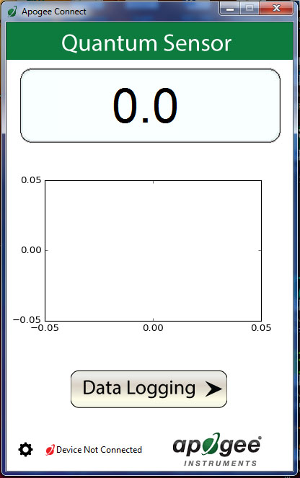
When the SQ-616 sensor is not plugged into the USB port, the software will display a message in the lower left corner, “Device Not Connected,” indicating it cannot establish communication with the sensor.

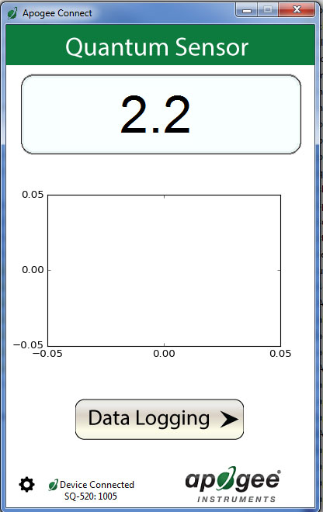
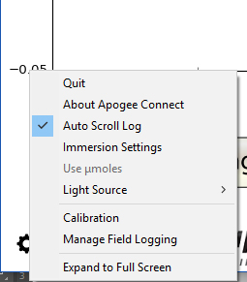
Plug the sensor into a USB port and allow some time for the sensor to automatically establish communication with the software. Once established, the message in the lower left corner will display “Device Connected-Model: SN ####” and real-time ePAR readings will update on the screen. Moving the sensor closer to a light source should increase the readings, while blocking all light from the sensor should drop the reading to zero.

Click the ‘Settings’ icon to display the software options.

Note the ‘Light Source’ function is not necessary for the SQ-616. The function is designed to give increased accuracy for the SQ-420.

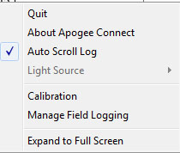

Clicking ‘Immersion Setting’ will automatically apply the sensor’s immersion effect correction factor of 1.25 to the sensor measurements. This setting should be used when the sensor is being used to take measurements underwater.

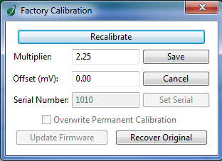
Clicking ‘Calibration’ will display the factory calibrated multiplier and offset values. These values are saved in firmware and can be recovered by clicking the ‘Recover Original’ button. Deriving a new calibration multiplier and offset is accomplished by clicking the ‘Recalibrate’ button. This is applicable if users want to calibrate the sensor to their own specific light source. Note that a reference ePAR value of the light source is required to complete a recalibration.

After clicking the ‘Recalibate’ button the user will be prompted to cover the sensor. Place a dark cap over the sensor and wait for the real-time ePAR reading to settle at zero. Click OK.

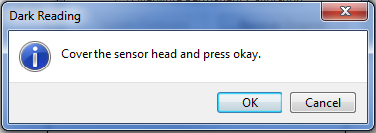

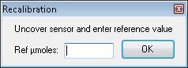
Uncover the sensor and wait for the ePAR reading to settle before entering the reference value. Click OK.

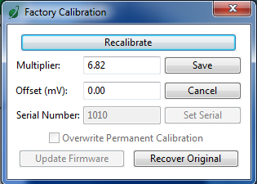
The multiplier and offset values will automatically calculate and update in the appropriate field. Be sure to click ‘Save’ to retain the new multiplier and offset.

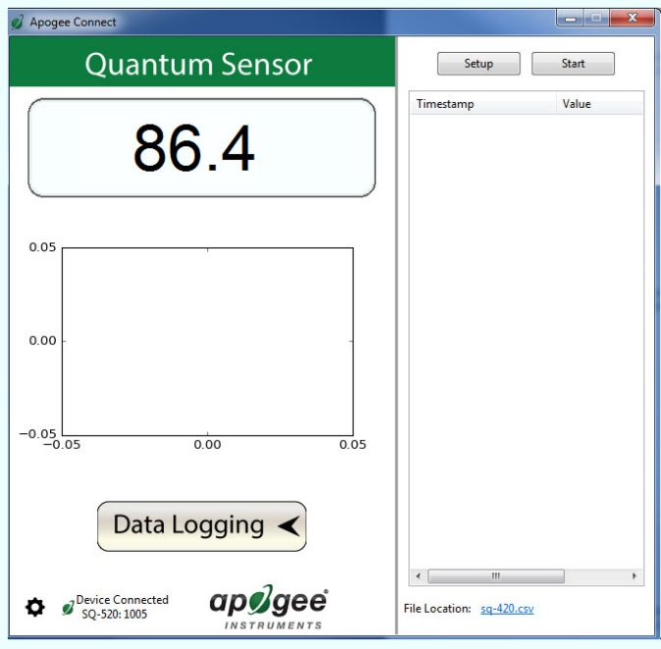
Clicking ‘Data Logging’ will allow the user to log interval measurements in a csv file while the software is open and communicating with the sensor.

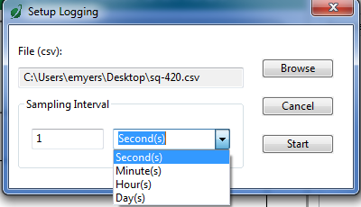

Click ‘Setup’ and the Setup Logging window appears. Click the ‘Browse’ button to create or select a csv file.
Select the desired sampling interval. Note that 1 second is the minimum interval allowed. Click ‘Start’.

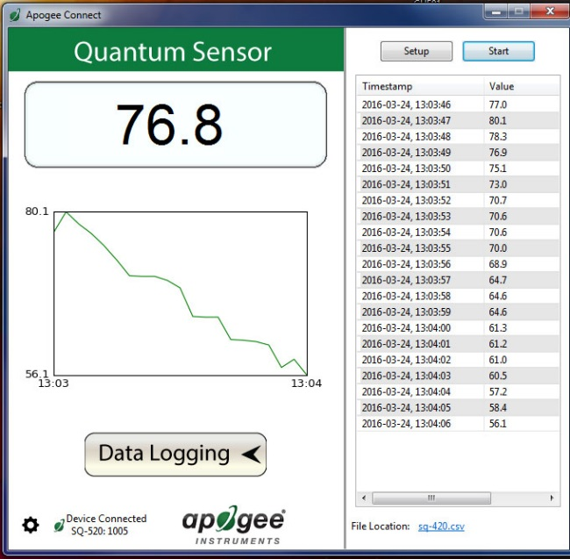
The data logging window will start to update at the specified sampling interval and display the Timestamp, Light Source, and Data Value. At the same time, data will be written to the csv file. Note that if the csv file is open in another program new data will not be saved to it.
The data logging window can be closed without affecting logged data by clicking the ‘Data Logging’ button. The ‘Stop’ button must be clicked to end data logging.

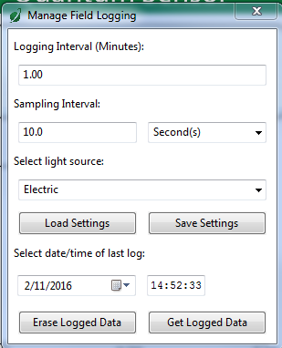
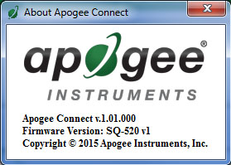
‘Manage Field Logging’ is used to setup the SQ-616 for use in the field. When the SQ-616 is supplied power from a USB power source (plug or select batteries) it will log data which you can retrieve. Choose the interval that data is saved, as well as the interval that data is sampled, and the light source used. The shortest sampling interval is 1 second. The longest sampling or logging interval is 1440 minutes (1 day). Click ‘Load Settings’ to see current settings and ‘Save Settings’ to save the settings you want to the sensor. Note: If you don’t click save the sensor won’t change the settings.
The about screen tells you the software and firmware versions. These can be used to help troubleshoot if problems arise.

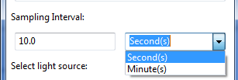
Set the sampling interval in minutes or seconds. The sampling interval is how often a measurement is taken and logging interval is how often the data is saved. The logged data is the average of the samples. The logging interval must be evenly divided by the sampling interval. For example, if the logging interval is 5 minutes and the sampling interval is 2 minutes it causes an error. But a sampling interval of 1 minute is acceptable.

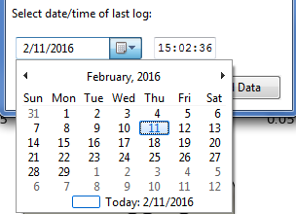
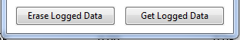
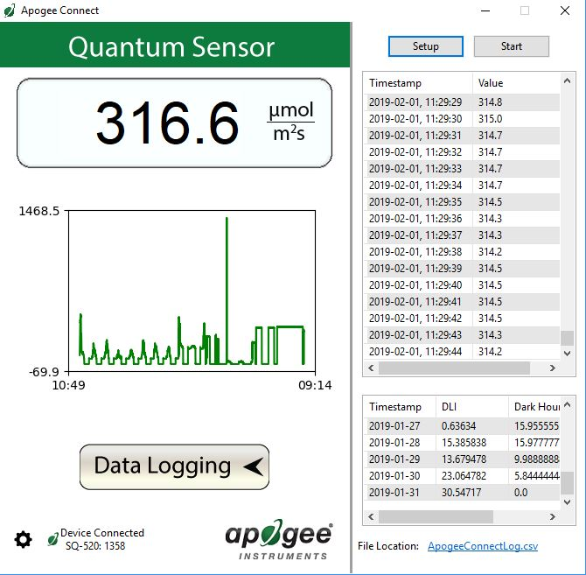
When the software is open and logging data from sensor model SQ-616, it will calculate daily light integral (DLI) in moles and Dark Hours in hours each day at 12:00 AM using ePAR values collected during the previous 36 hours. The Dark Hours value is calculated using the “Darkness Threshold” setting. The number of continuously logged ePAR values less than the Darkness Threshold are counted and multiplied by the logging interval to calculate the number of Dark Hours. This represents the longest continuous duration of darkness, not the total duration of darkness.

To use additional SQ-616 devices, open additional SQ-616 software windows. The device serial number will display in the lower left-hand corner of the corresponding software window. Devices may be selected by serial number in the tool bar.

Before clicking ‘Get Logged Data’ it is important to set the time of the last logged data point. This is used to back calculate the timestamps for the remaining data points. If you just unplugged the sensor and plugged it into the computer, the preloaded day and time should be sufficient.
Click ‘Get Logged Data’ to save the data to your computer. You will be asked where you want to save the data.
Click ‘Erase Data’ to erase all the saved data. This can’t be undone.

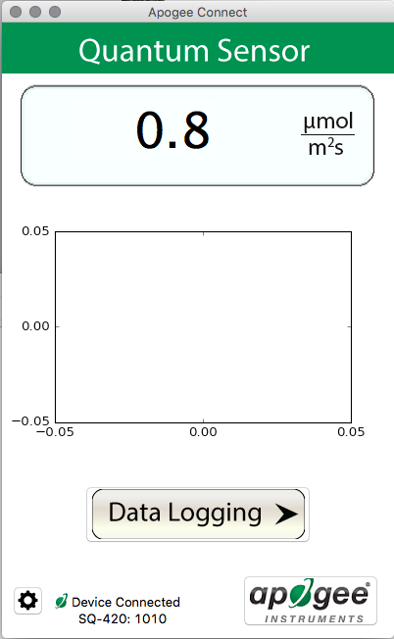
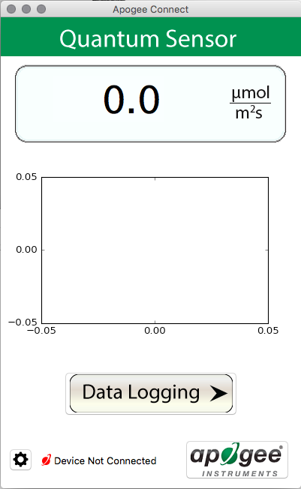
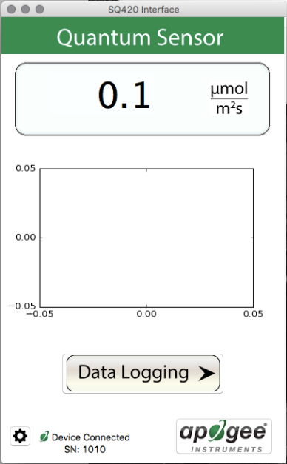
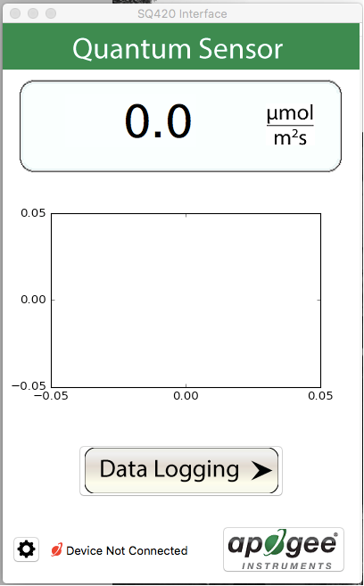
Mac Software
Plug the sensor into a USB port and allow some time for the sensor to automatically establish communication with the software. Once established, the message in the lower left corner will display “Device Connected SN: ####” and real-time ePAR readings will update on the screen. Moving the sensor closer to a light source should increase the readings, while blocking all light from the sensor should drop the reading to zero.

When the SQ-616 sensor is not plugged into the USB port, the software will display a message in the lower left corner, “Device Not Connected,” indicating it cannot establish communication with the sensor.

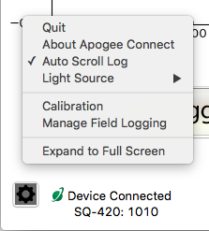
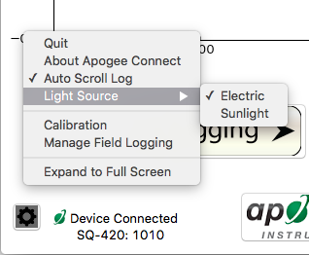
Clicking ‘Immersion Setting’ will automatically apply the sensor’s immersion effect correction factor of 1.25 to the sensor measurements. This setting should be used when the sensor is being used to take measurements underwater.

Note the ‘Light Source’ function is not necessary for the SQ-616. The function is designed to give increased accuracy for the SQ-420.

Click the ‘Settings’ icon to display the software options.

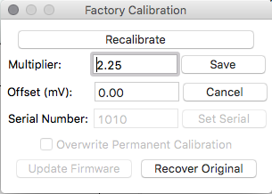
Clicking ‘Calibration’ will display the factory calibrated multiplier and offset values. These values are saved in firmware and can be recovered by clicking the ‘Recover Original’ button. Deriving a new calibration multiplier and offset is accomplished by clicking the ‘Recalibrate’ button. This is applicable if users want to calibrate the sensor to their own specific light source. Note that a reference ePAR value of the light source is required to complete a recalibration.

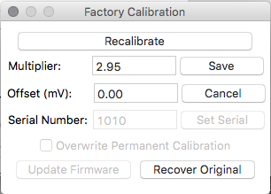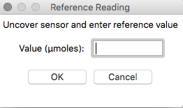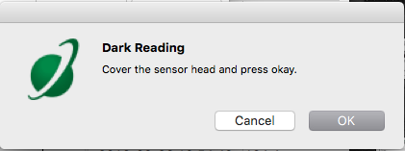
The multiplier and offset values will automatically calculate and update in the appropriate field. Be sure to click ‘Save’ to retain the new multiplier and offset.

Uncover the sensor and wait for the ePAR reading to settle before entering the reference value. Click OK.

After clicking the ‘Recalibrate’ button the user will be prompted to cover the sensor. Place a dark cap over the sensor and wait for the real-time ePAR reading to settle at zero. Click OK.

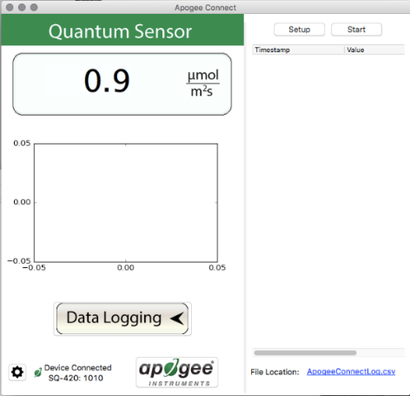
Clicking ‘Data Logging’ will allow the user to log interval measurements in a csv file while the software is open and communicating with the sensor.

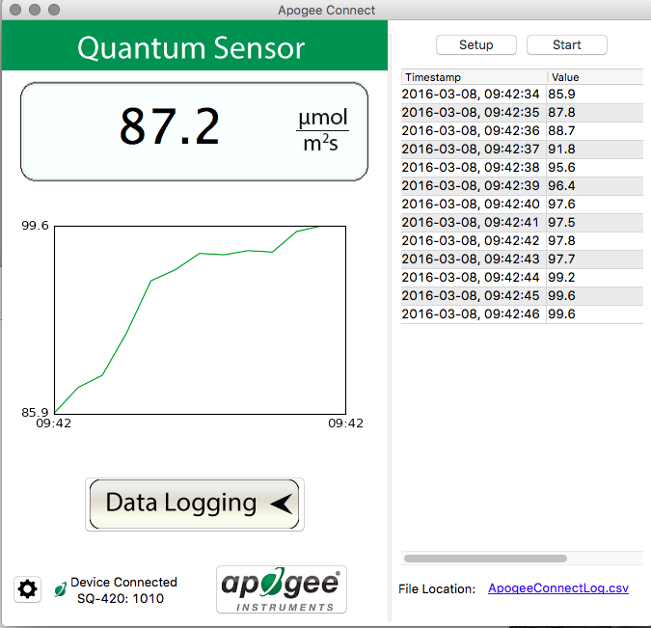
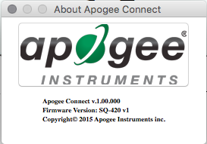
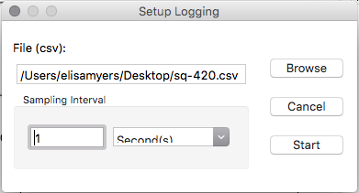
The “About” screen tells you the software and firmware versions. These can be used to help troubleshoot if problems arise.

The data logging window will start to update at the specified sampling interval and display the Timestamp, Light Source, and Data Value. At the same time, data will be written to the csv file. Note that if the csv file is open in another program new data will not be saved to it.
The data logging window can be closed without affecting logged data by clicking the ‘Exit’ button. The ‘Stop’ button must be clicked to end data logging.

Click ‘Setup’ and the Setup Logging window appears. Click the ‘Browse button to create or select a csv file.
Select the desired sampling interval. Note that 1 second is the minimum interval allowed. Click ‘Start’.

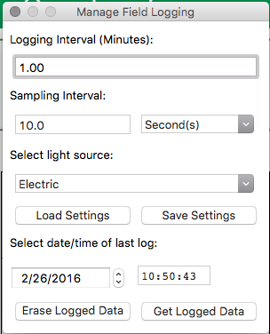
‘Manage Field Logging’ is used to setup the SQ-616 for the use in the field. When the SQ-616 is supplied power from a USB power source (plug or select batteries) it will log data which you can retrieve. Choose the interval the data is saved, as well as the interval that data is sampled, and the light source used. The shortest sampling interval is 1 second. The longest sampling or logging interval is 1440 minutes (1 day). Click ‘Load Settings’ to see current settings and ‘Save Setting’ to save the settings you want to the sensor. Note: If you don’t click save the sensor won’t change the settings.

Set the sampling interval in minutes or seconds. The sampling interval is how often a measurement is taken and logging interval is how often the data is saved. The logged data is the average of the samples. The logging interval must be evenly divided by the sampling interval. For example, if the logging interval is 5 minutes and the sampling interval is 2 minutes it causes an error. But a sampling interval of 1 minute is acceptable.

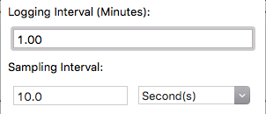

Before clicking ‘Get Logged Data’ it is important to set the time of the last logged data point. This is used to back calculate the timestamps for the remaining data points. If you just unplugged the sensor and plugged it into the computer, the preloaded day and time should be sufficient.

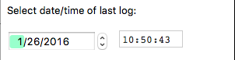

Click ‘Get Logged Data’ to save the data to your computer. You will be asked where you want to save the data.
Click ‘Erase Data’ to erase all the save data. This can’t be undone.

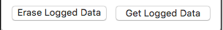

When the software is open and logging data from sensor model SQ-616, it will calculate daily light integral (DLI) in moles and Dark Hours in hours each day at 12:00 AM using ePAR values collected during the previous 36 hours. The Dark Hours value is calculated using the “Darkness Threshold” setting. The number of continuously logged ePAR values less than the Darkness Threshold are counted and multiplied by the logging interval to calculate the number of Dark Hours. This represents the longest continuous duration of darkness, not the total duration of darkness.

To use additional SQ-616 devices, open additional SQ-616 software windows. The device serial number will display in the lower left-hand corner of the corresponding software window. Devices may be selected by serial number in the tool bar.

Maintenance and Recalibration
Blocking of the optical path between the target and detector can cause low readings. Occasionally, accumulated materials on the diffuser of the upward-looking sensor can block the optical path in three common ways:
- Moisture or debris on the diffuser.
- Dust during periods of low rainfall.
- Salt deposit accumulation from evaporation of sea spray or sprinkler irrigation water.
Apogee Instruments upward-looking sensors have a domed diffuser and housing for improved self-cleaning from rainfall, but active cleaning may be necessary. Dust or organic deposits are best removed using water, or window cleaner, and a soft cloth or cotton swab. Salt deposits should be dissolved with vinegar and removed with a cloth or cotton swab. Salt deposits cannot be removed with solvents such as alcohol or acetone. Use only gentle pressure when cleaning the diffuser with a cotton swab or soft cloth to avoid scratching the outer surface. The solvent should be allowed to do the cleaning, not mechanical force. Never use abrasive material or cleaner on the diffuser.
It is recommended that two-band radiometers be recalibrated every two years. See the Apogee webpage for details regarding return of sensors for recalibration (http://www.apogeeinstruments.com/tech-support-recalibration-repairs/).

Troubleshooting and Customer Support
Cable Length
Fifteen feet is the maximum cable length that can be built into the sensor.
Modifying Cable Length
If you required a longer cable length an “active” USB extension cable is required. Please note, the connection between the cables must be made watertight prior to submersion.

Return and Warranty Policy

RETURN POLICY
Apogee Instruments will accept returns within 30 days of purchase as long as the product is in new condition (to be determined by Apogee). Returns are subject to a 10 % restocking fee.

WARRANTY POLICY
What is Covered
All products manufactured by Apogee Instruments are warranted to be free from defects in materials and craftsmanship for a period of four (4) years from the date of shipment from our factory. To be considered for warranty coverage an item must be evaluated by Apogee.
Products not manufactured by Apogee (spectroradiometers, chlorophyll content meters, EE08-SS probes) are covered for a period of one (1) year.
What is Not Covered
The customer is responsible for all costs associated with the removal, reinstallation, and shipping of suspected warranty items to our factory.
The warranty does not cover equipment that has been damaged due to the following conditions:
1. Improper installation, use, or abuse.
2. Operation of the instrument outside of its specified operating range.
3. Natural occurrences such as lightning, fire, etc.
4. Unauthorized modification.
5. Improper or unauthorized repair.
Please note that nominal accuracy drift is normal over time. Routine recalibration of sensors/meters is considered part of proper maintenance and is not covered under warranty.
Who is Covered
This warranty covers the original purchaser of the product or another party who may own it during the warranty period.
What Apogee Will Do
At no charge Apogee will:
1. Either repair or replace (at our discretion) the item under warranty.
2. Ship the item back to the customer by the carrier of our choice.
Different or expedited shipping methods will be at the customer’s expense.

How to Return an Item
1. Please do not send any products back to Apogee Instruments until you have received a Return Merchandise Authorization (RMA) number from our technical support department by submitting an online RMA form at www.apogeeinstruments.com/tech-support-recalibration-repairs/. We will use your RMA number for tracking of the service item. Call (435) 245-8012 or email techsupport@apogeeinstruments.com with questions.
2. For warranty evaluations, send all RMA sensors and meters back in the following condition: Clean the sensor’s exterior and cord. Do not modify the sensors or wires, including splicing, cutting wire leads, etc. If a connector has been attached to the cable end, please include the mating connector – otherwise the sensor connector will be removed in order to complete the repair/recalibration. Note: When sending back sensors for routine calibration that have Apogee’s standard stainless-steel connectors, you only need to send the sensor with the 30 cm section of cable and one-half of the connector. We have mating connectors at our factory that can be used for calibrating the sensor.
3. Please write the RMA number on the outside of the shipping container.
4. Return the item with freight pre-paid and fully insured to our factory address shown below. We are not responsible for any costs associated with the transportation of products across international borders.
Apogee Instruments, Inc.
721 West 1800 North Logan, UT
84321, USA
5. Upon receipt, Apogee Instruments will determine the cause of failure. If the product is found to be defective in terms of operation to the published specifications due to a failure of product materials or craftsmanship, Apogee Instruments will repair or replace the items free of charge. If it is determined that your product is not covered under warranty, you will be informed and given an estimated repair/replacement cost.

Products Beyond the Warranty Period
For issues with sensors beyond the warranty period, please contact Apogee at techsupport@apogeeinstruments.com to discuss repair or replacement options.

Other Terms
The available remedy of defects under this warranty is for the repair or replacement of the original product, and Apogee Instruments is not responsible for any direct, indirect, incidental, or consequential damages, including but not limited to loss of income, loss of revenue, loss of profit, loss of data, loss of wages, loss of time, loss of sales, accruement of debts or expenses, injury to personal property, or injury to any person or any other type of damage or loss.
This limited warranty and any disputes arising out of or in connection with this limited warranty ("Disputes") shall be governed by the laws of the State of Utah, USA, excluding conflicts of law principles and excluding the Convention for the International Sale of Goods. The courts located in the State of Utah, USA, shall have exclusive jurisdiction over any Disputes.
This limited warranty gives you specific legal rights, and you may also have other rights, which vary from state to state and jurisdiction to jurisdiction, and which shall not be affected by this limited warranty. This warranty extends only to you and cannot by transferred or assigned. If any provision of this limited warranty is unlawful, void, or unenforceable, that provision shall be deemed severable and shall not affect any remaining provisions. In case of any inconsistency between the English and other versions of this limited warranty, the English version shall prevail.
This warranty cannot be changed, assumed, or amended by any other person or agreement
APOGEE INSTRUMENTS, INC. | 721 WEST 1800 NORTH, LOGAN, UTAH 84321, USA
TEL: (435) 792-4700 | FAX: (435) 787-8268 | WEB: APOGEEINSTRUMENTS.COM
Copyright © 2024 Apogee Instruments, Inc.

